**MISO Introduction.**

**MYSQL , JAVA and APEX are free Oracle Products, lets not FEAR Oracle!**

**NetSuite and hundreds of other critical ERP/Financials systems are**

**Oracle run 70% of the worlds IT,**

We are going to demo, how to REST enable a schema and database objects in two ways,

1. Quick way (created AUTOMATIC RESTAPI for CRUD )
2. Right way (Lets you define them based on code you write)

Estimated Time: 10 minutes

**Background Information**

If it doesn’t already exist, then we will be creating the EMP and DEPT tables, REST enabling them, and then building an application all in the same schema. Normally, you would REST enable database objects in a remote database schema, and then utilize those REST endpoints to define REST Data Sources in an application, where APEX is installed, within the local database, as outlined below.

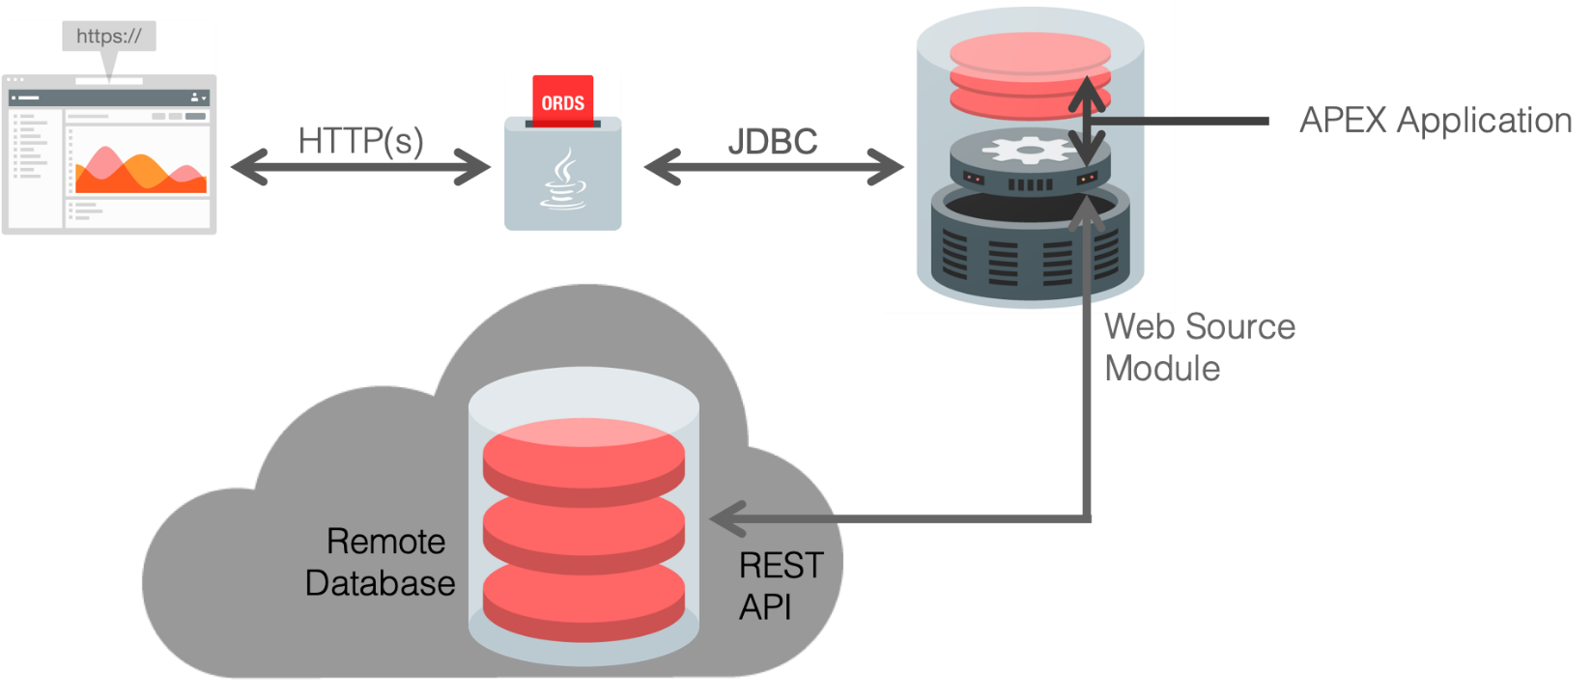

Once the REST Data Source is defined in an APEX application, rather than calling a local database object, the APEX Engine calls the REST endpoint, to retrieve the data from the remote database. If the PUT, POST, and DELETE handlers have also been defined, then APEX applications can also perform updates, inserts, and deletes on the remote database objects.

**Task 1: Creating the Sample Tables**

This lab utilizes the common EMP and DEPT tables. These can easily be installed using Sample Datasets.

1. Log into your workspace.
2. In the main menu, select **SQL Workshop**, select **Utilities**, click **Sample Datasets**.

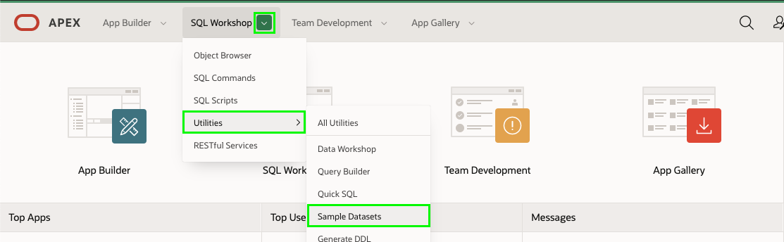

1. In the list of Sample Datasets, on the EMP / DEPT row, click **Install**.

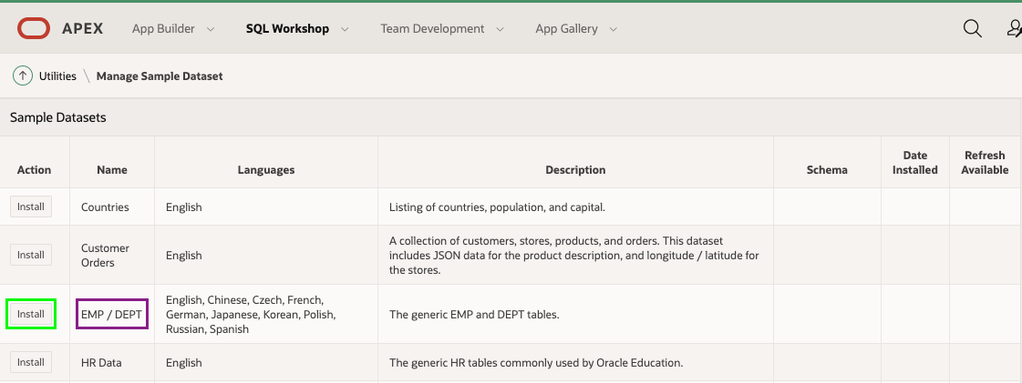

1. On the Manage Sample Dataset dialog, click **Next**.

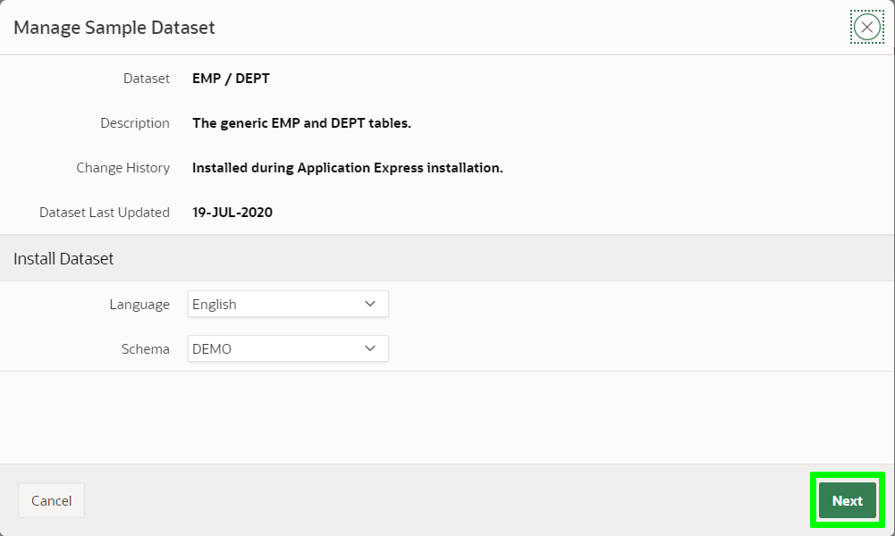

1. On the Load Sample Dataset dialog, click **Install Dataset**.

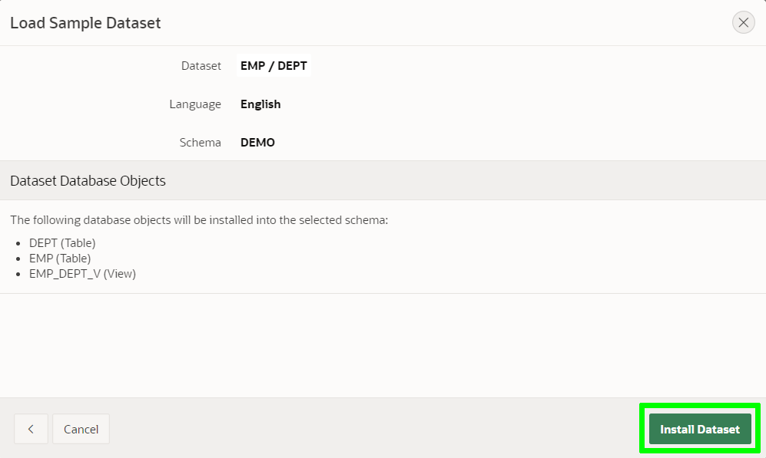

1. On the Load Sample Dataset - Results dialog, click **Exit**.

*Note: We do not want to create an application directly on the tables.*

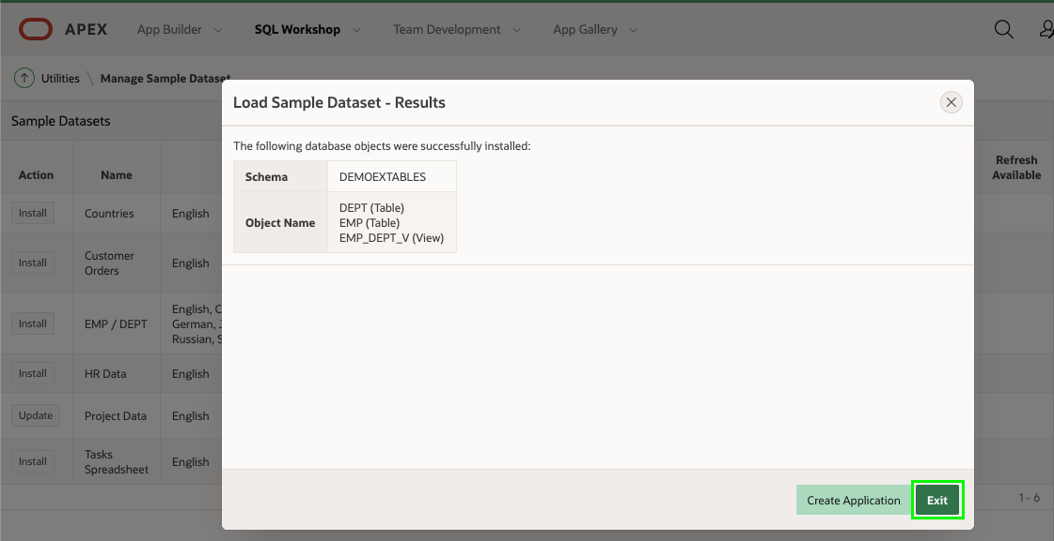

**IF (you had chosen to click on Create Application) the framework would have taken your table definitions and given you a Blueprint as below: ignore the blueprint, well discuss it later.**

|  |
| --- |
| {  "application": {    "name": "Demonstration - EMP / DEPT",    "appShortDescription": "Generated based on a Sample Dataset!",    "appDescription": "This application was generated directly from Sample Datasets. Go to SQL Workshop > Utilities > Sample Datasets to install tables and then create an application based on those tables.",    "schema": "MISODEVADMIN",    "features": {      "accessControl": true,      "activityReporting": true,      "configurationOptions": true,      "feedback": true,      "helpPages": true,      "themeSelection": true      },    "appearance": {      "themeStyle": "Vita",      "navigation": "SIDE",      "icon": "app-icon-people",      "iconBackgroundClass": "app-color-1",      "iconColorHEX": "#309FDB"      },    "settings": {      "baseTablePrefix": "",      "primaryLanguage": "en",      "authentication": "Application Express"      },    "pages": [      {        "page": "1",        "pageType": "blank",        "pageName": "Home",        "pageIcon": "fa-home",        "pageIsHomePage": true,        "help": ""      }      ,      {        "page": "2",        "pageType": "dashboard",        "pageName": "Dashboard",        "pageIcon": "fa-dashboard",        "help": "",        "dashboardWidgets": [        {          "name": "Employees per Department",          "type": "pie",          "table": "EMP_DEPT_V",          "labelColumn": "DNAME",          "valueColumn": "allColumns",          "valueDerivation": "count"        }        ,        {          "name": "Employees per Job",          "type": "pie",          "table": "EMP_DEPT_V",          "labelColumn": "JOB",          "valueColumn": "allColumns",          "valueDerivation": "count"        }        ,        {          "name": "Total Salary per Department",          "type": "bar",          "table": "EMP_DEPT_V",          "labelColumn": "DNAME",          "valueColumn": "SAL",          "valueDerivation": "sum"        }        ,        {          "name": "Total Salary per Job",          "type": "bar",          "table": "EMP_DEPT_V",          "labelColumn": "JOB",          "valueColumn": "SAL",          "valueDerivation": "sum"        }        ]      }      ,      {        "page": "3",        "pageType": "facetedSearch",        "pageName": "Employees",        "pageIcon": "fa-table-search",        "fsReportType": "CR",        "reportImplementation": "TABLE",        "table": "EMP",        "includeFormWithReport": true,        "help": ""      }      ,      {        "page": "4",        "pageType": "interactiveReport",        "pageName": "Departments",        "pageIcon": "fa-table",        "reportImplementation": "TABLE",        "table": "DEPT",        "includeFormWithReport": true,        "drillDownLinkColumn": "DNAME",        "drillDownLinkKey": "DEPTNO",        "linkToPage": "",        "linkToKey": "DEPTNO",        "help": ""      }      ],    "generalSettings": {      "builtWithLove": true,      "learnAppDefaults": false,      "version": "Release 1.0",      "logging": true,      "debugging": true      },    "globalizationSettings": {      "documentDirection": "left-to-right"      },    "securitySettings": {      "deepLinking": false,      "maximumSessionSeconds": "",      "maximumSessionIdleSeconds": ""      }    }  }  **Here is the UI based on the above json, build automatically with 1 CLICK !!** |

**If you were to click, “Create Application” then it would be so.**

**Here is what the development environment looks like.**

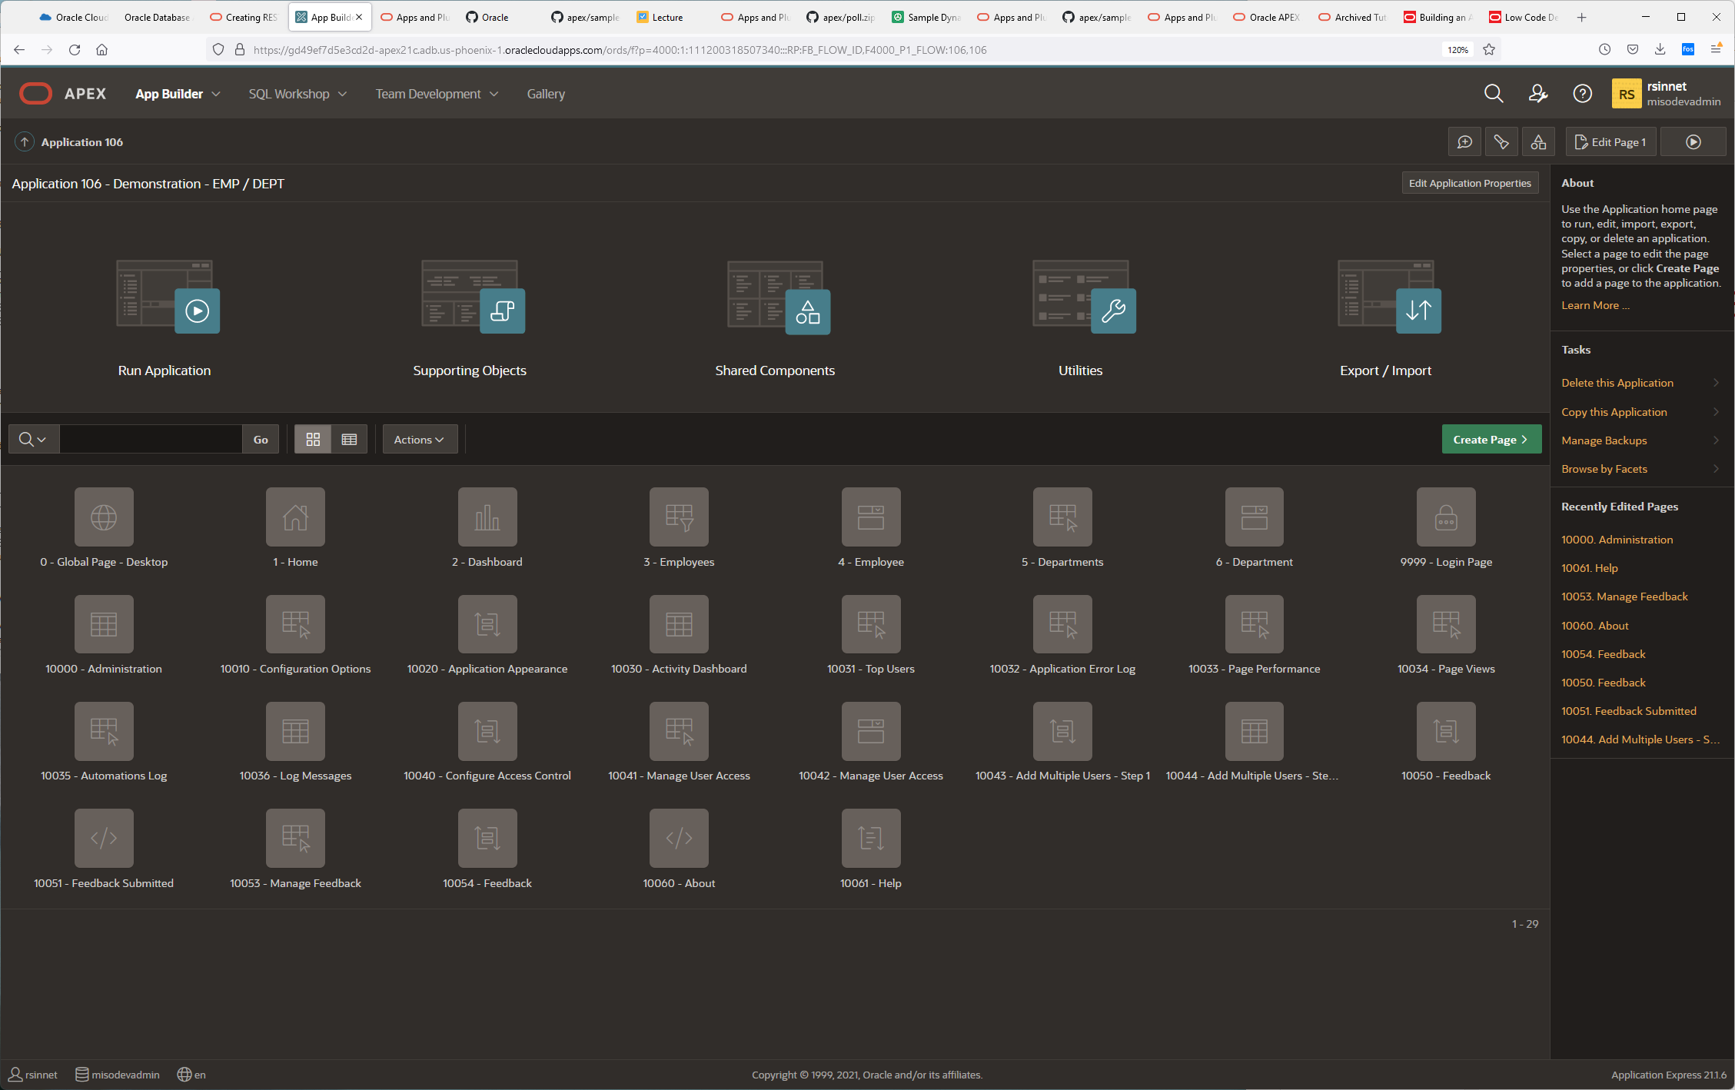

**Everything is bound inside of pages, the database stores state information, each page is rendered at real time and change is implemented, using data and metadata. If You click on the Run ICON, it will direct you to**

[**https://gd49ef7d5e3cd2d-apex21c.adb.us-phoenix-1.oraclecloudapps.com/ords/r/misodevadmin/demonstration-emp-dept**](https://gd49ef7d5e3cd2d-apex21c.adb.us-phoenix-1.oraclecloudapps.com/ords/r/misodevadmin/demonstration-emp-dept)

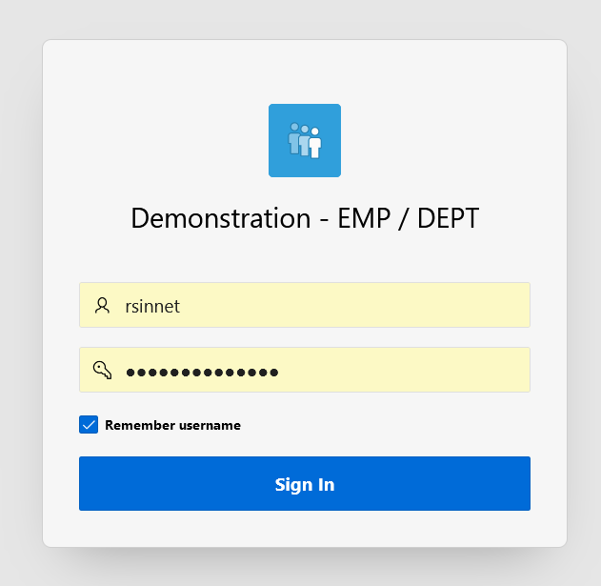

Users created nkosolobov/MisoSoup123!@#  
Users created rsinnet/MisoSoup123!@#  
Users created aplascencia/MisoSoup123!@#

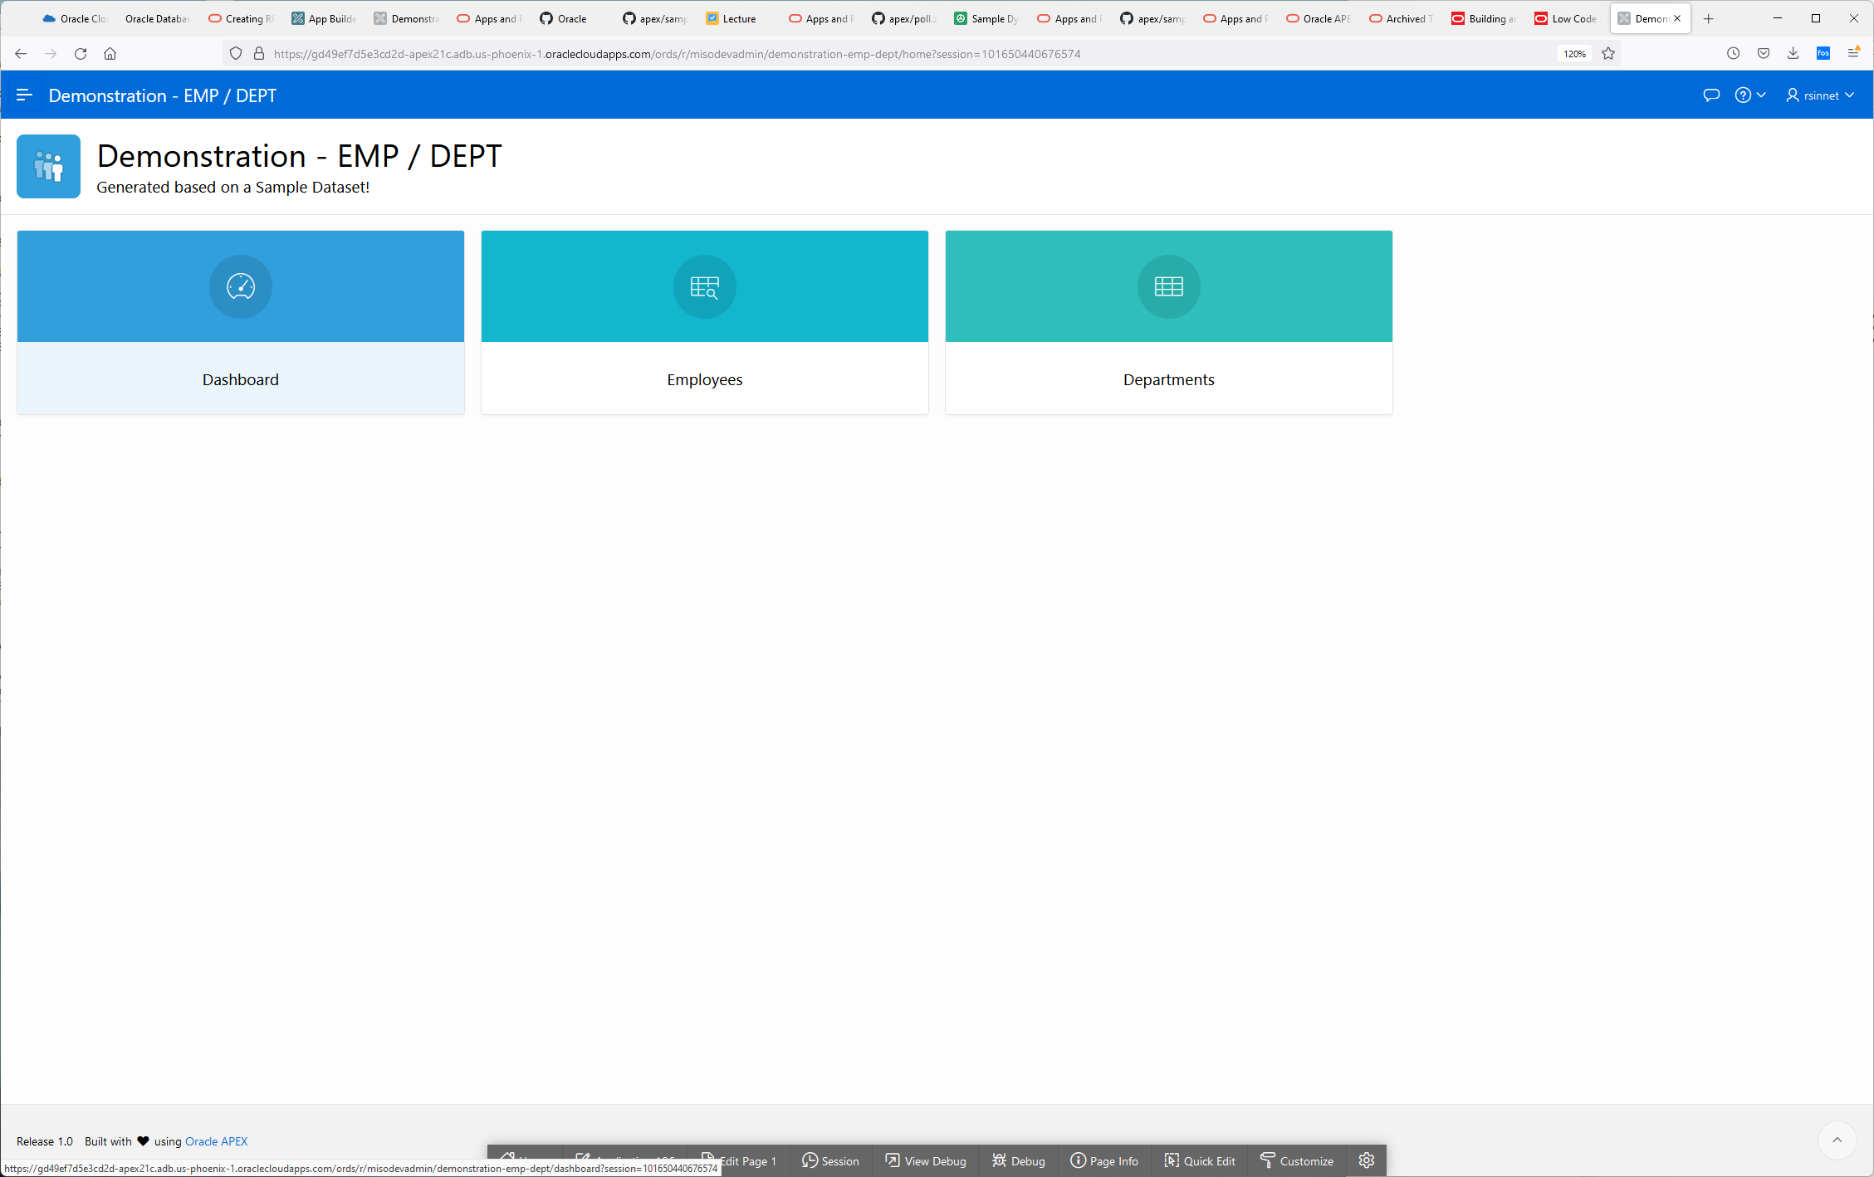

**Click on the Hamburger to the left of the word “Demonstration”**

**It exposes the menus**

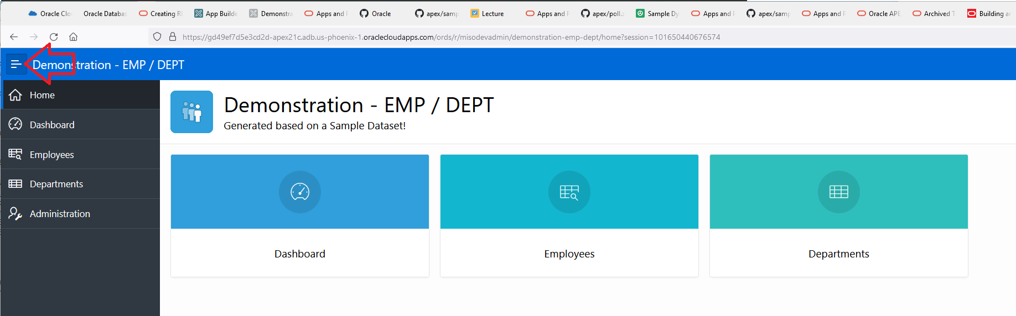

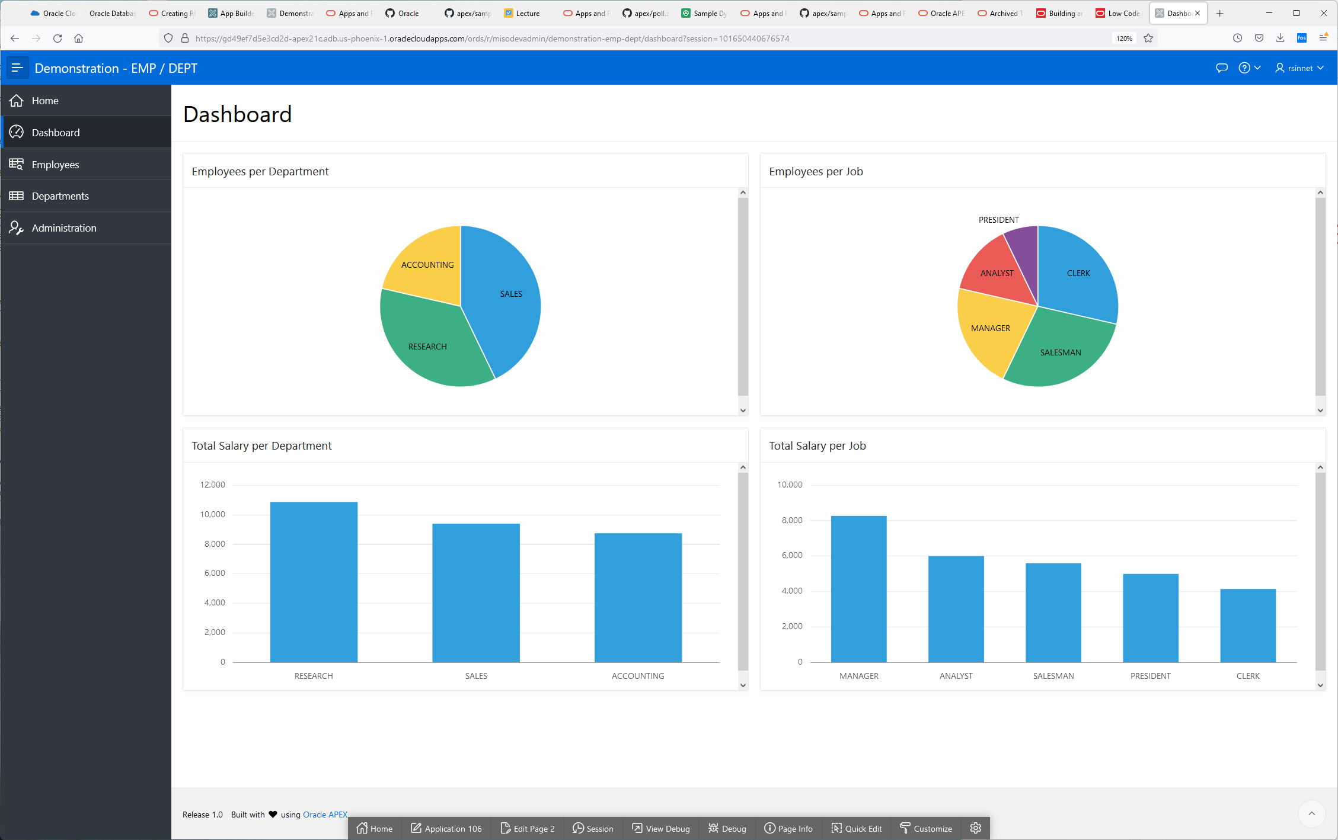

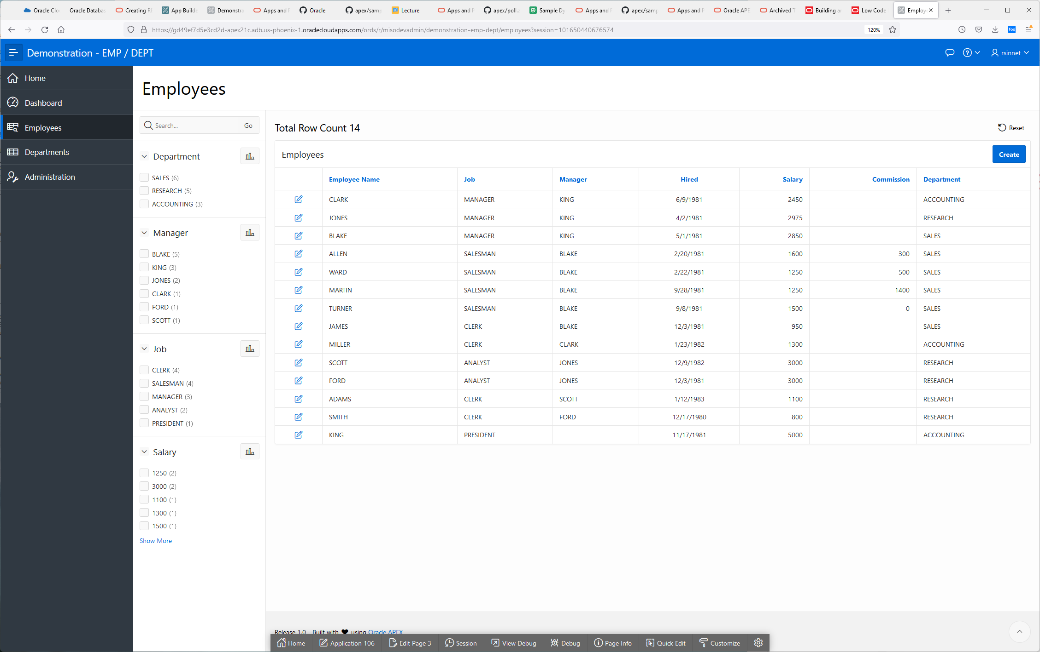

**Searchable, filterable fascets to drive user interface decisions.**

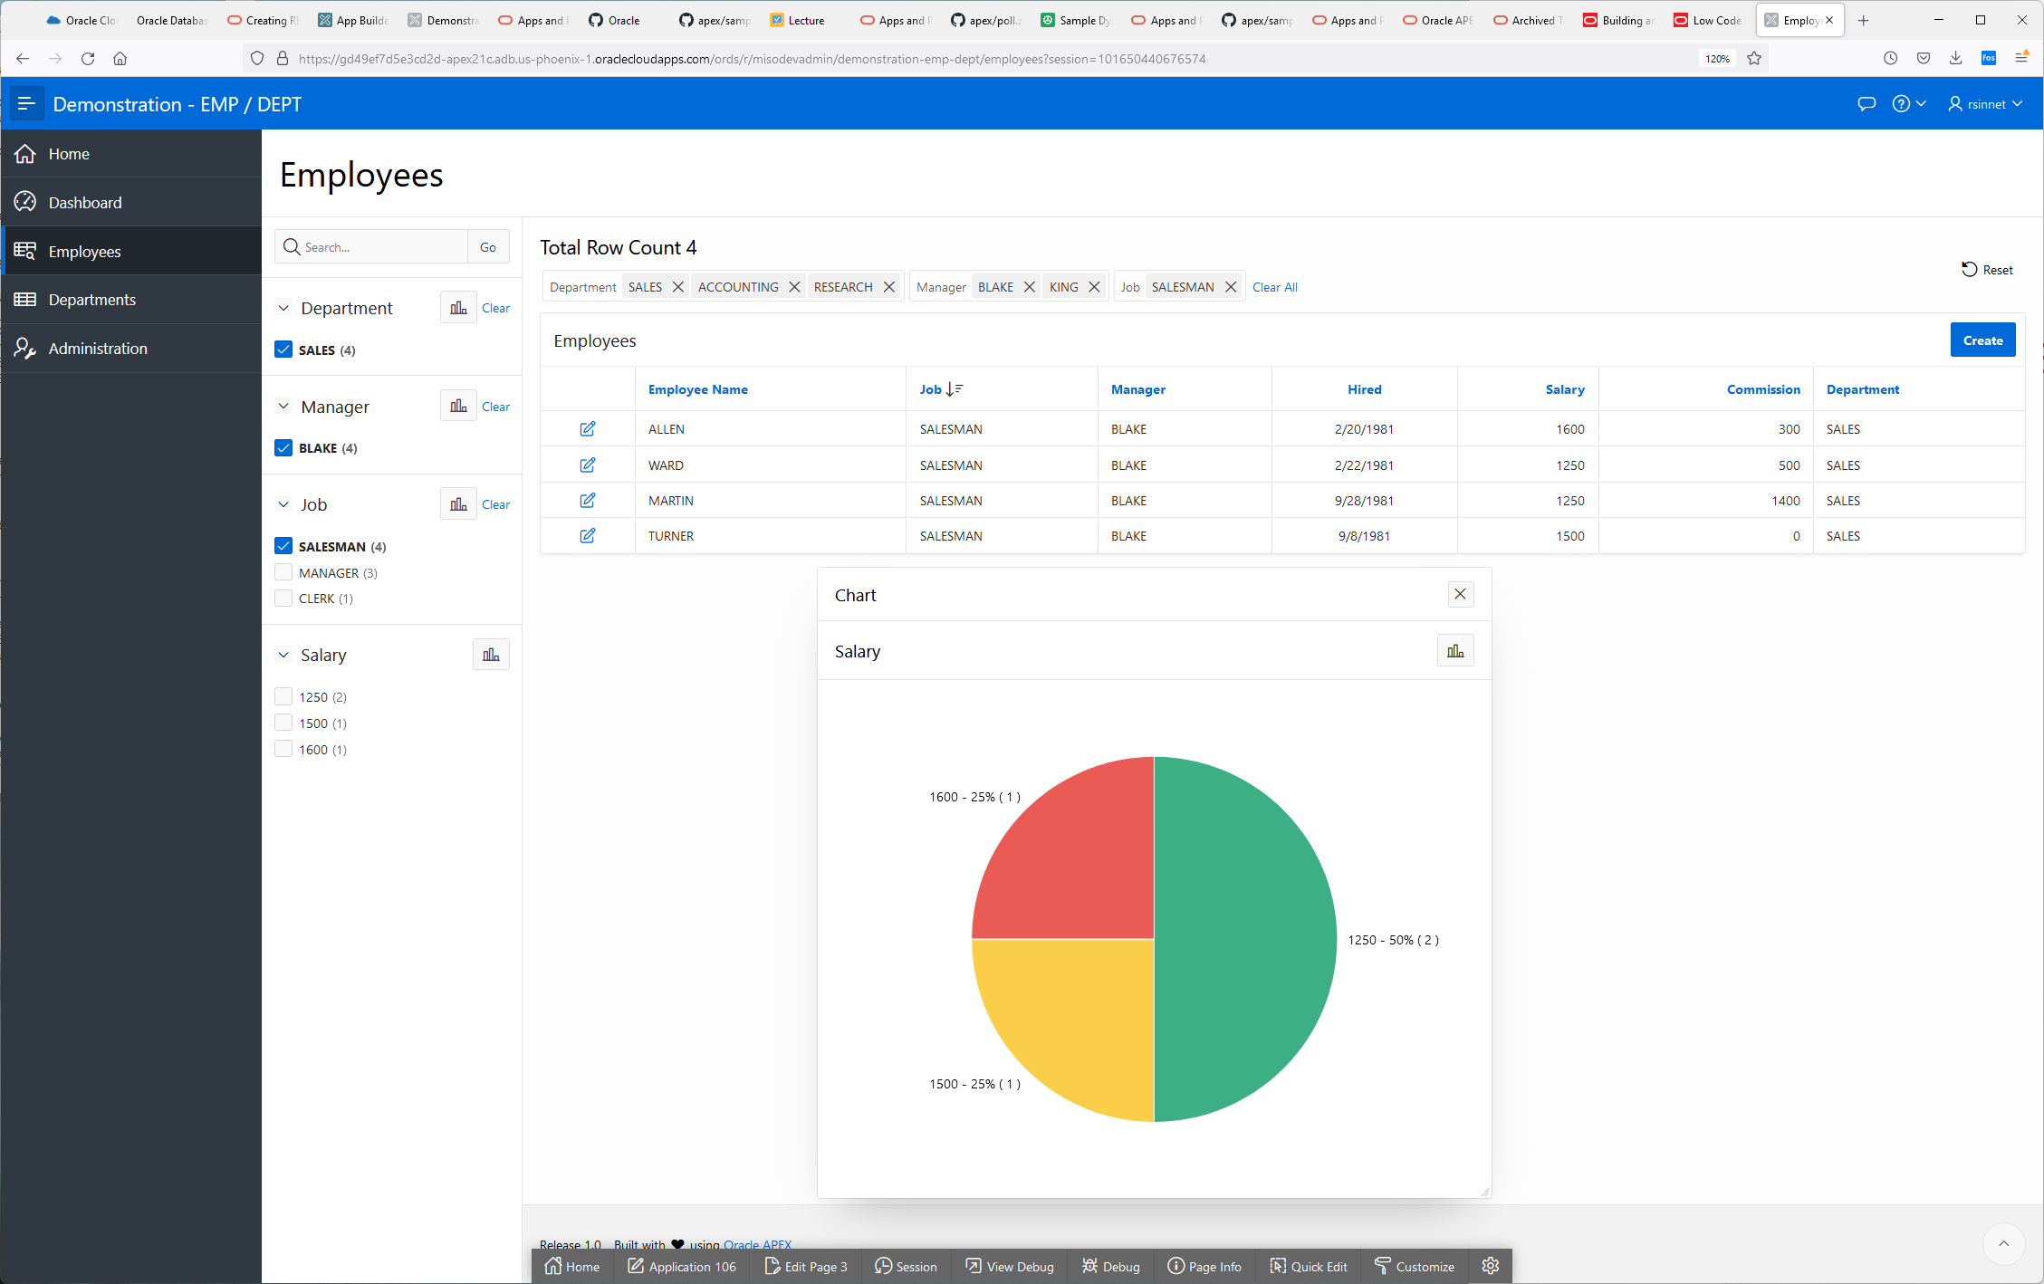

Click on Administration, it gives you metadata about what your users are doing with the system!

Your users and configure their own themes,in case they like their web pages to have funky colors.

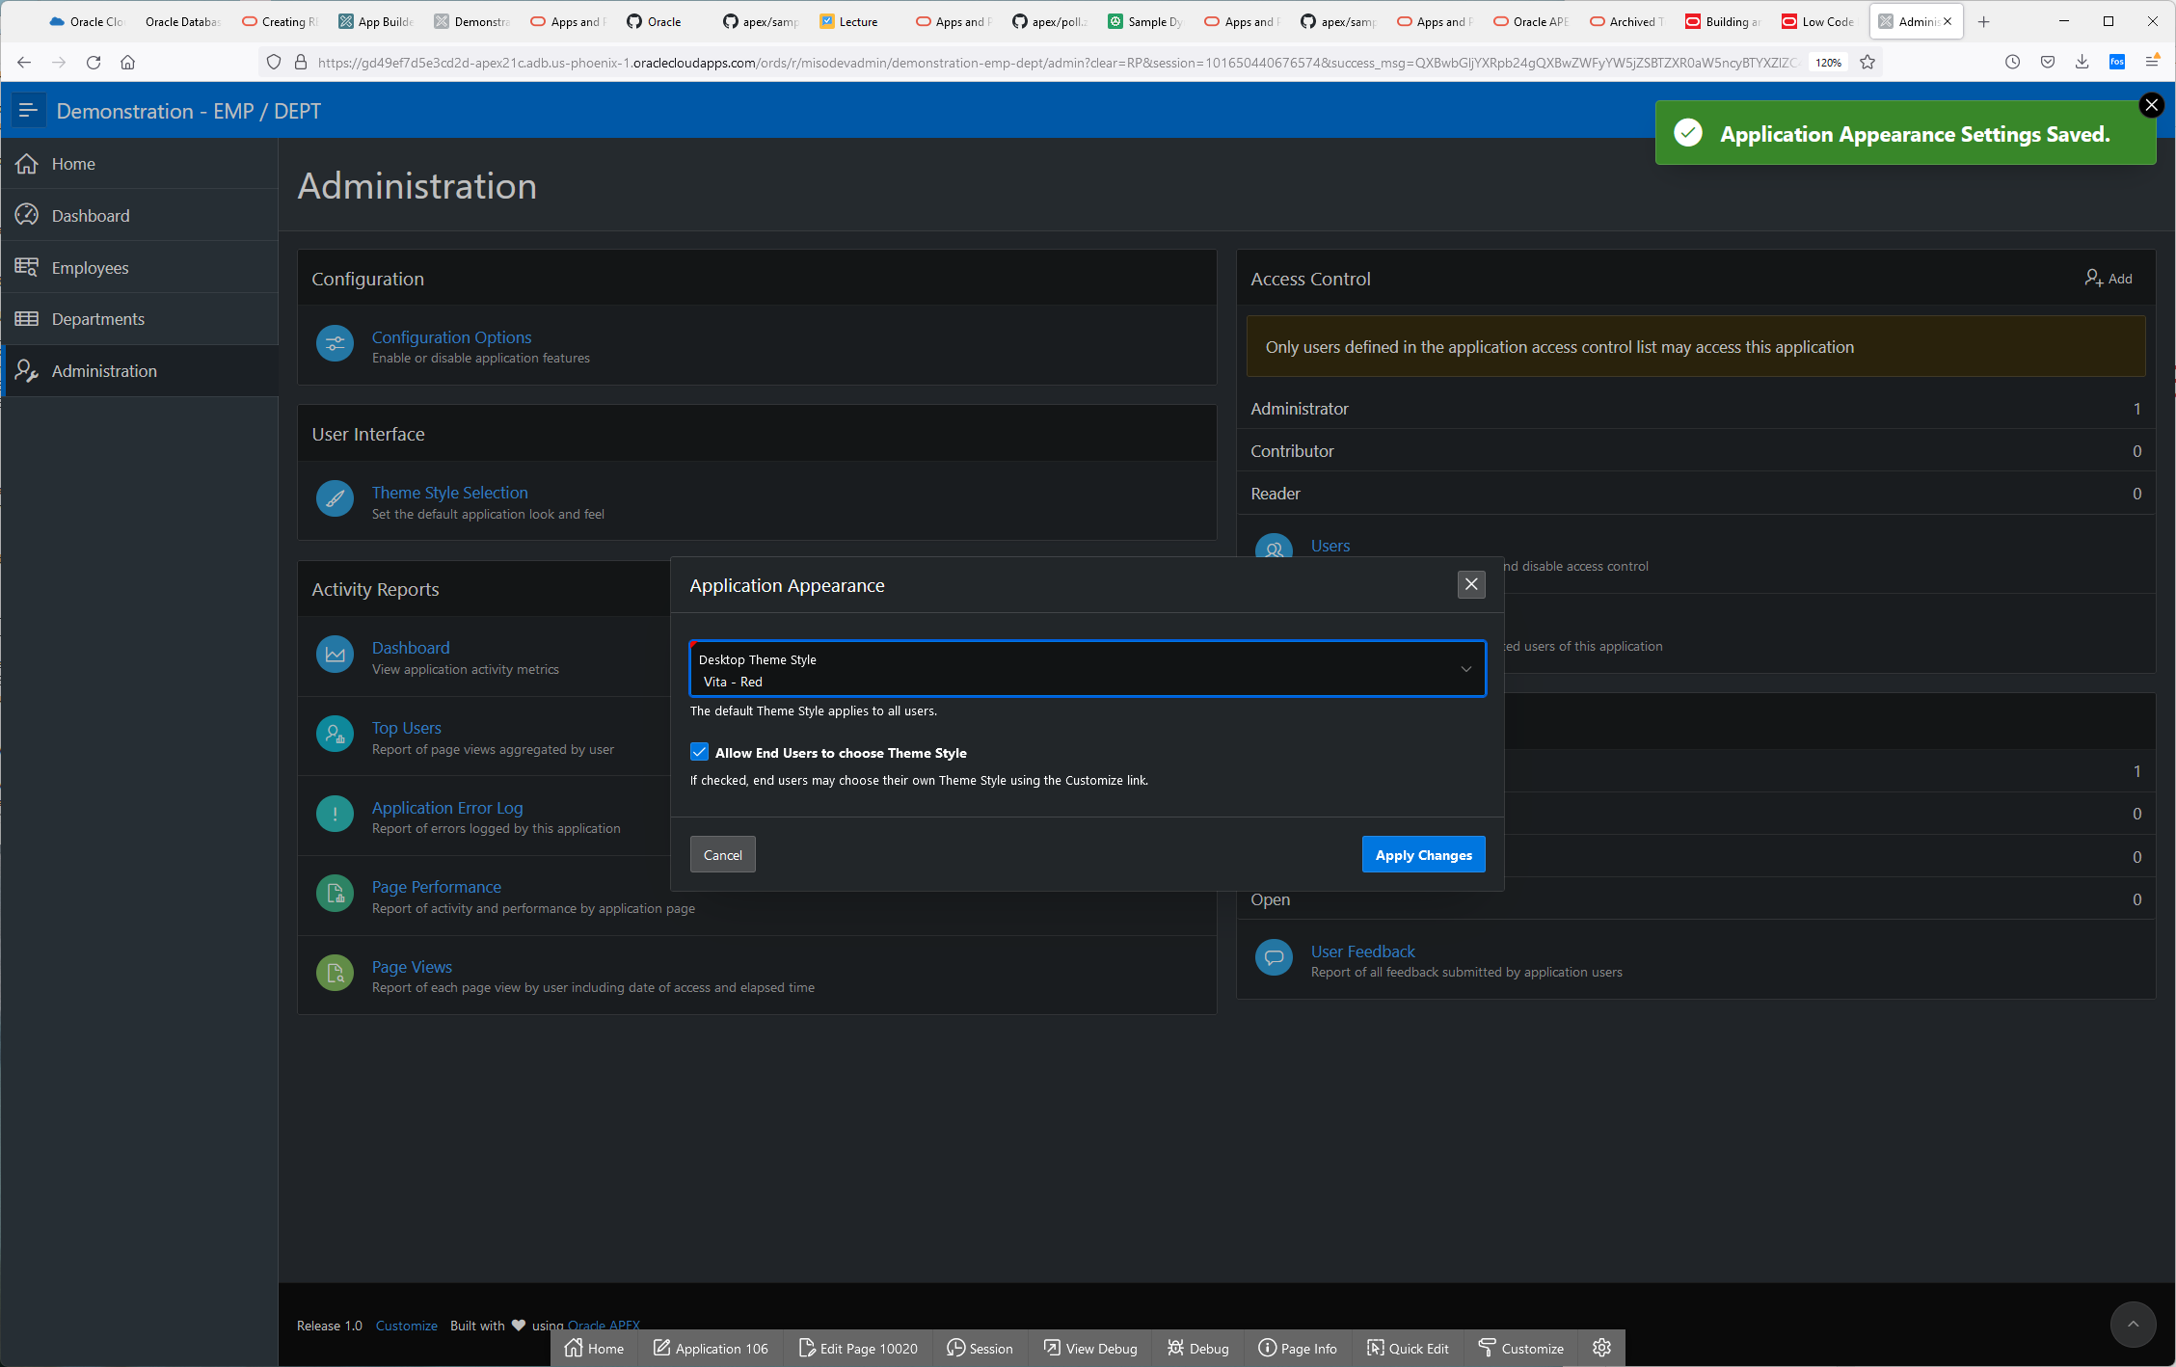

See how each page is doing.

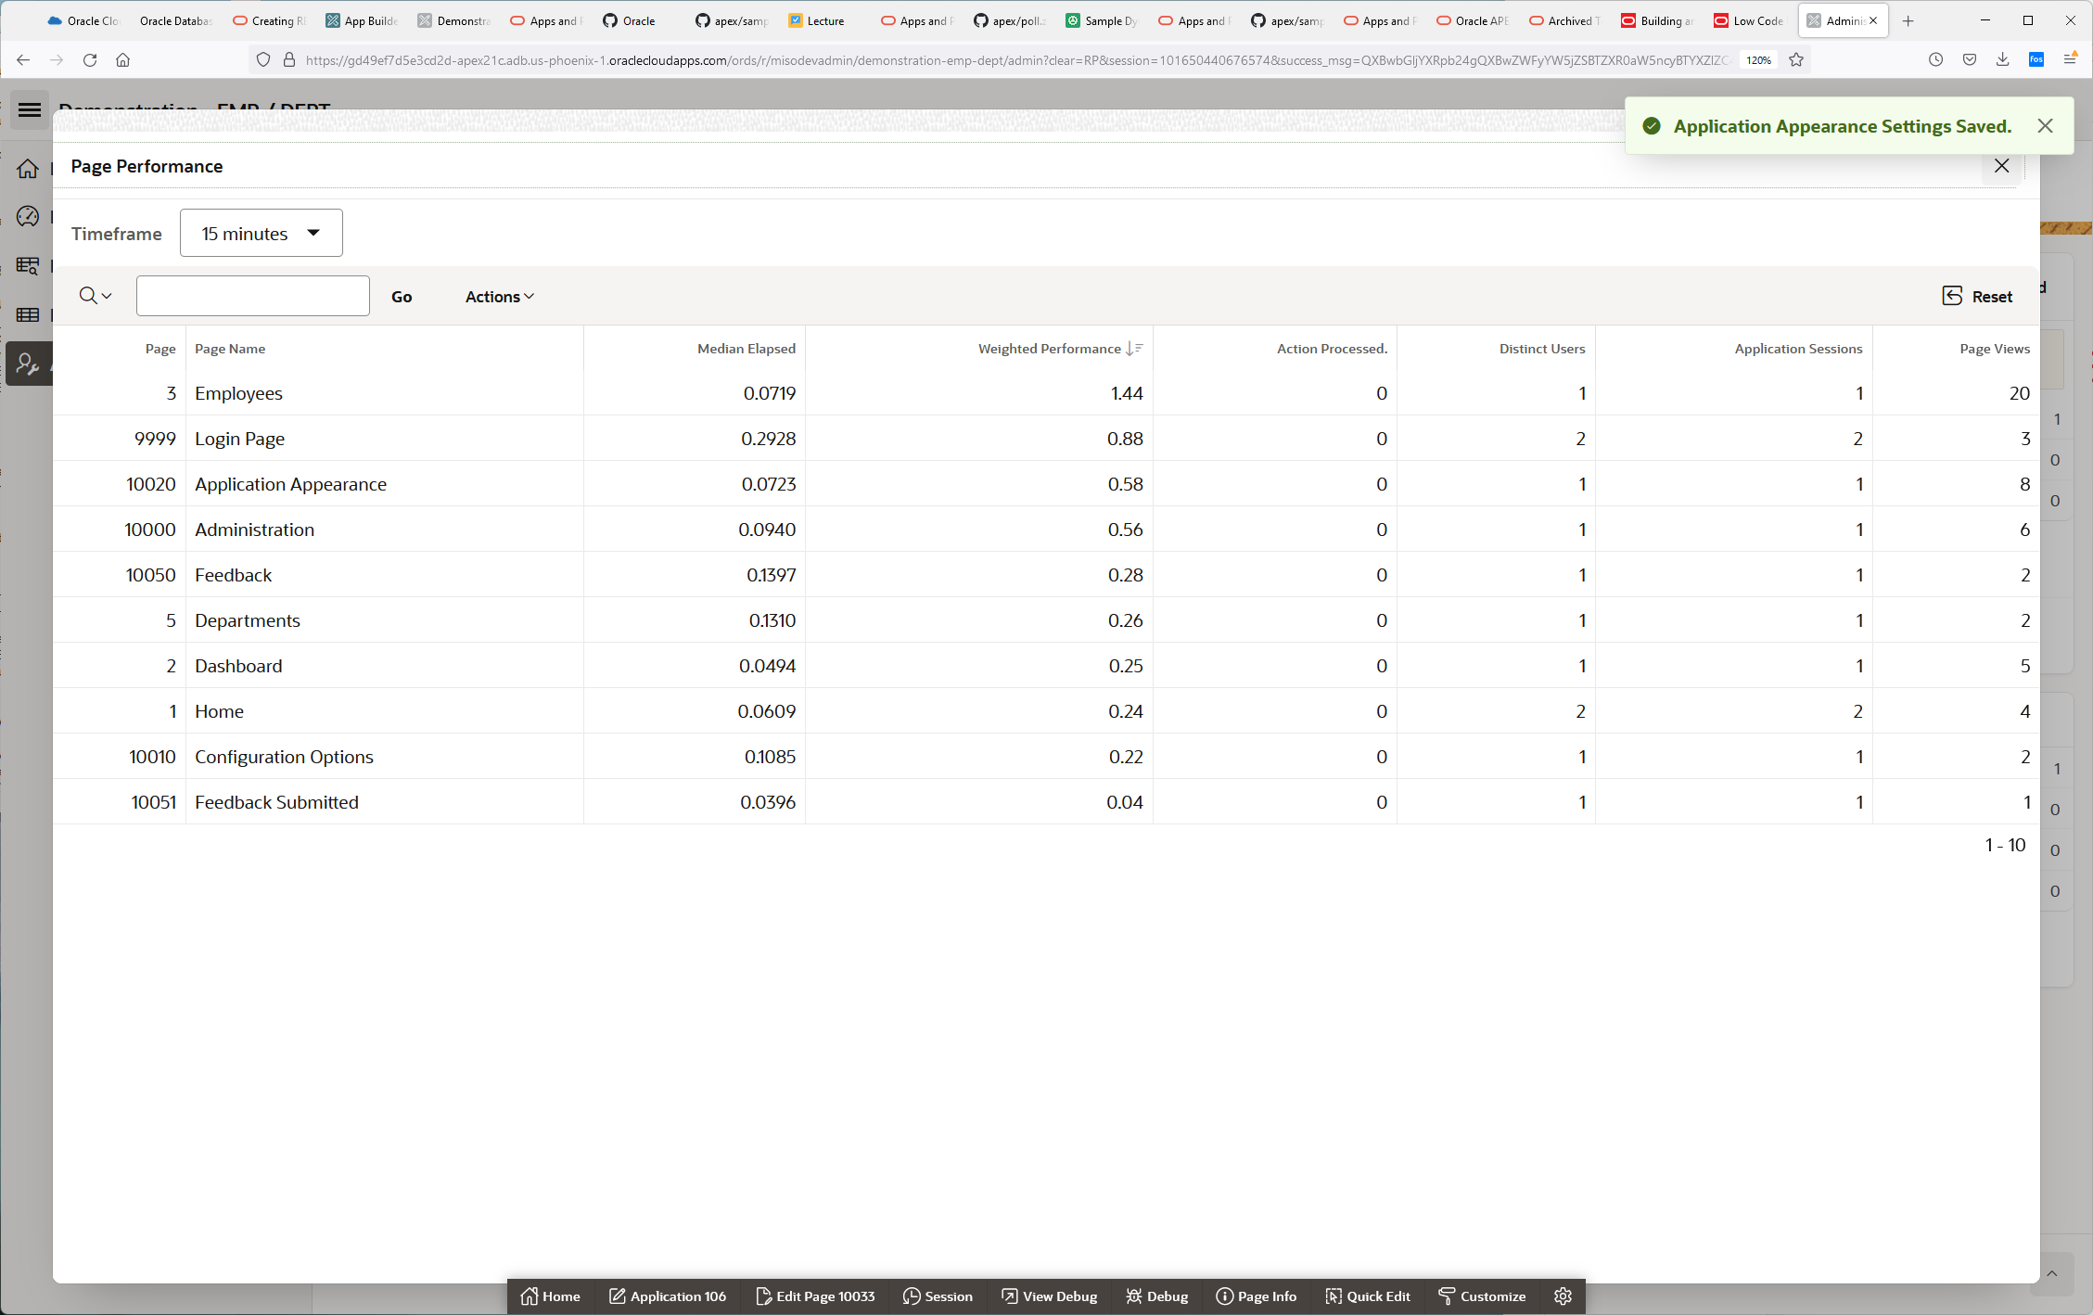

See what activites have been done by user.

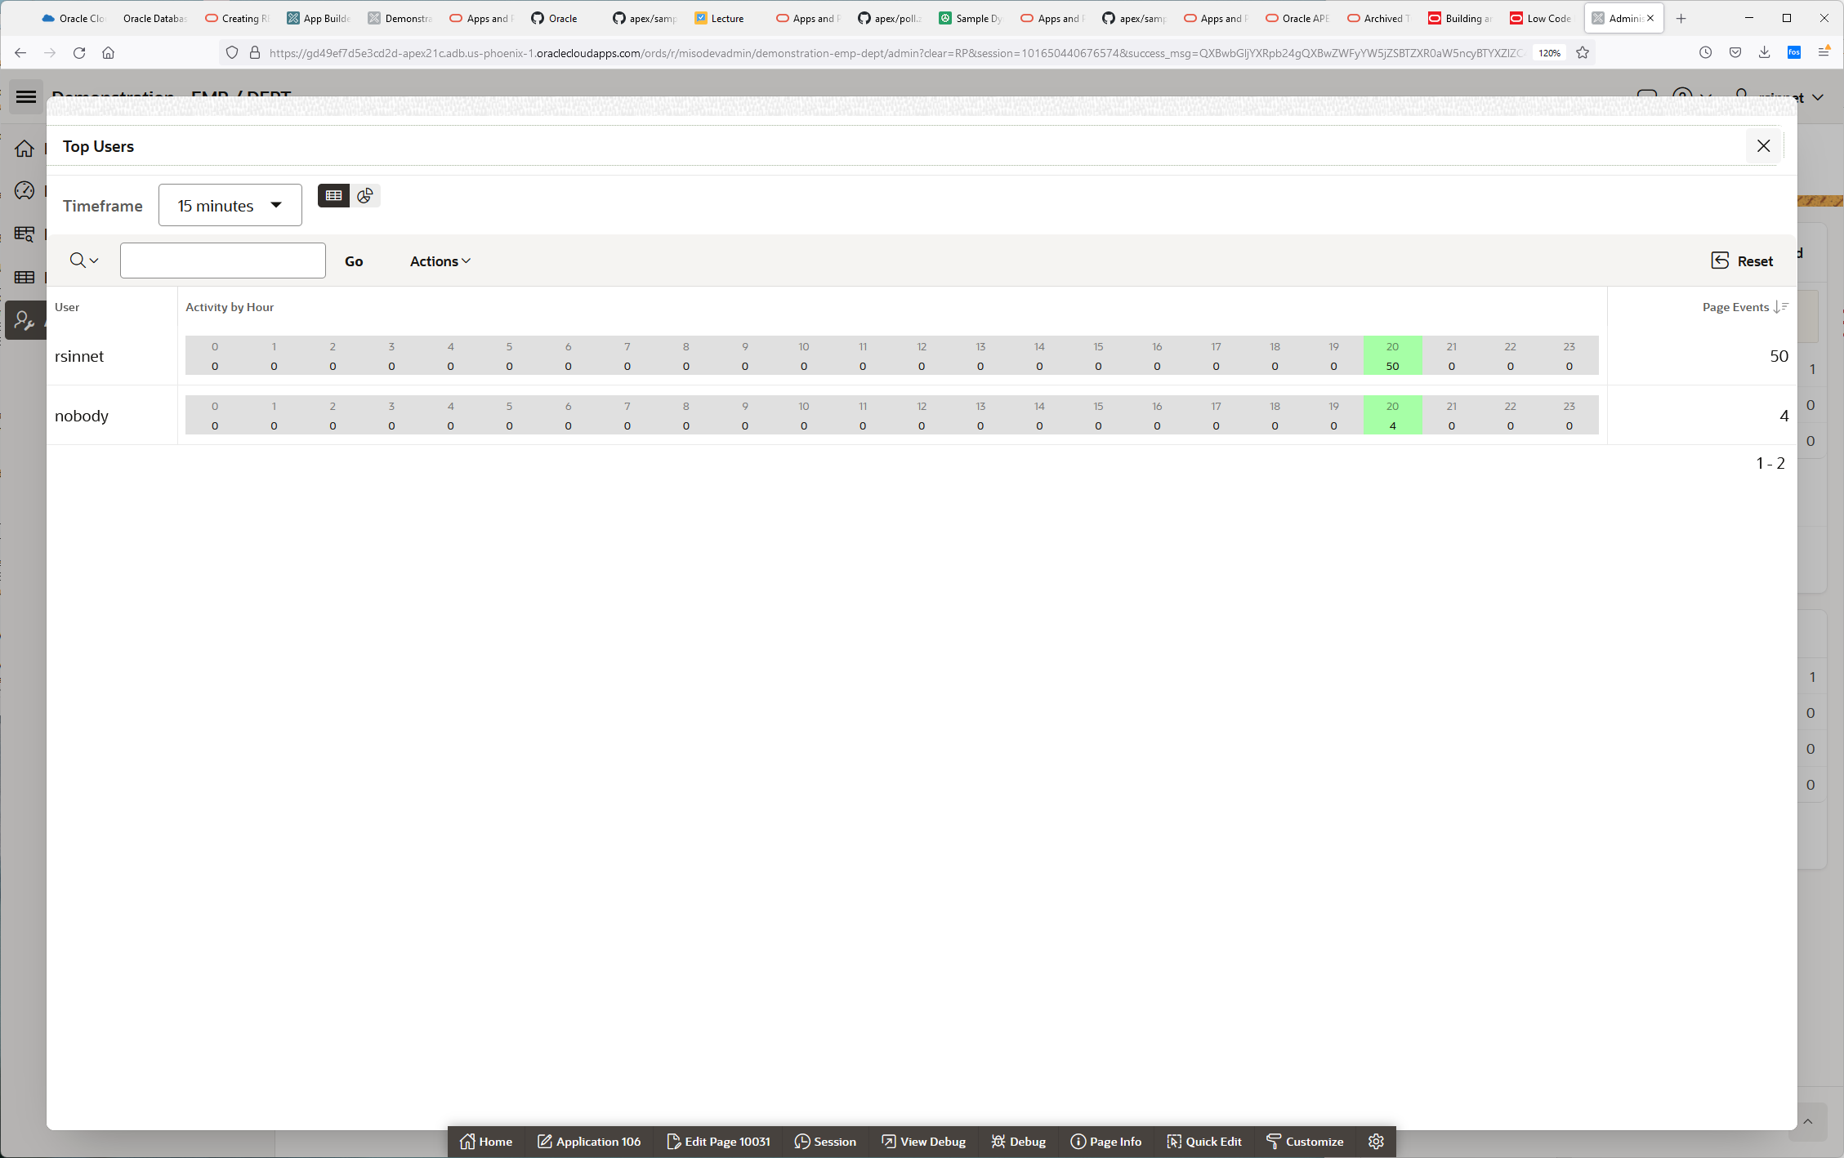

If you’re the administer, you can add user to use this app.

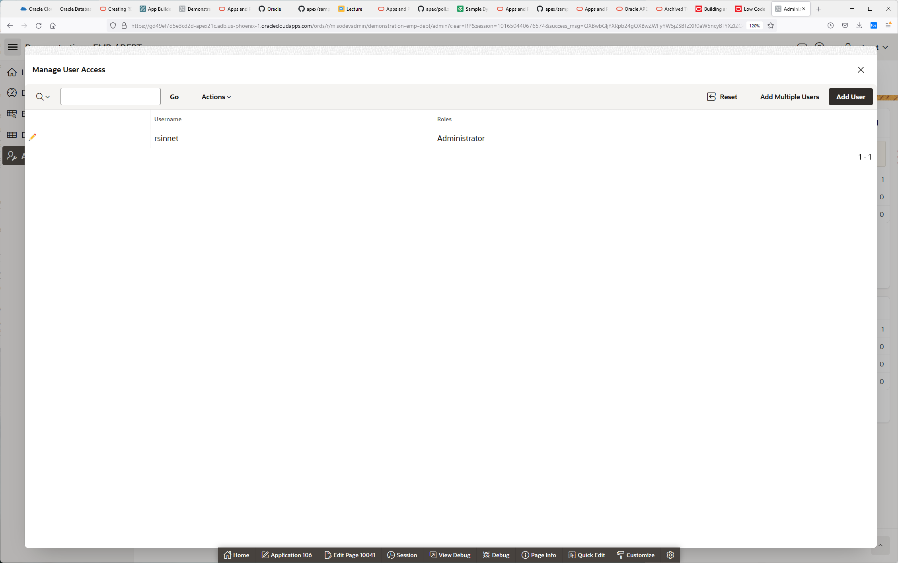

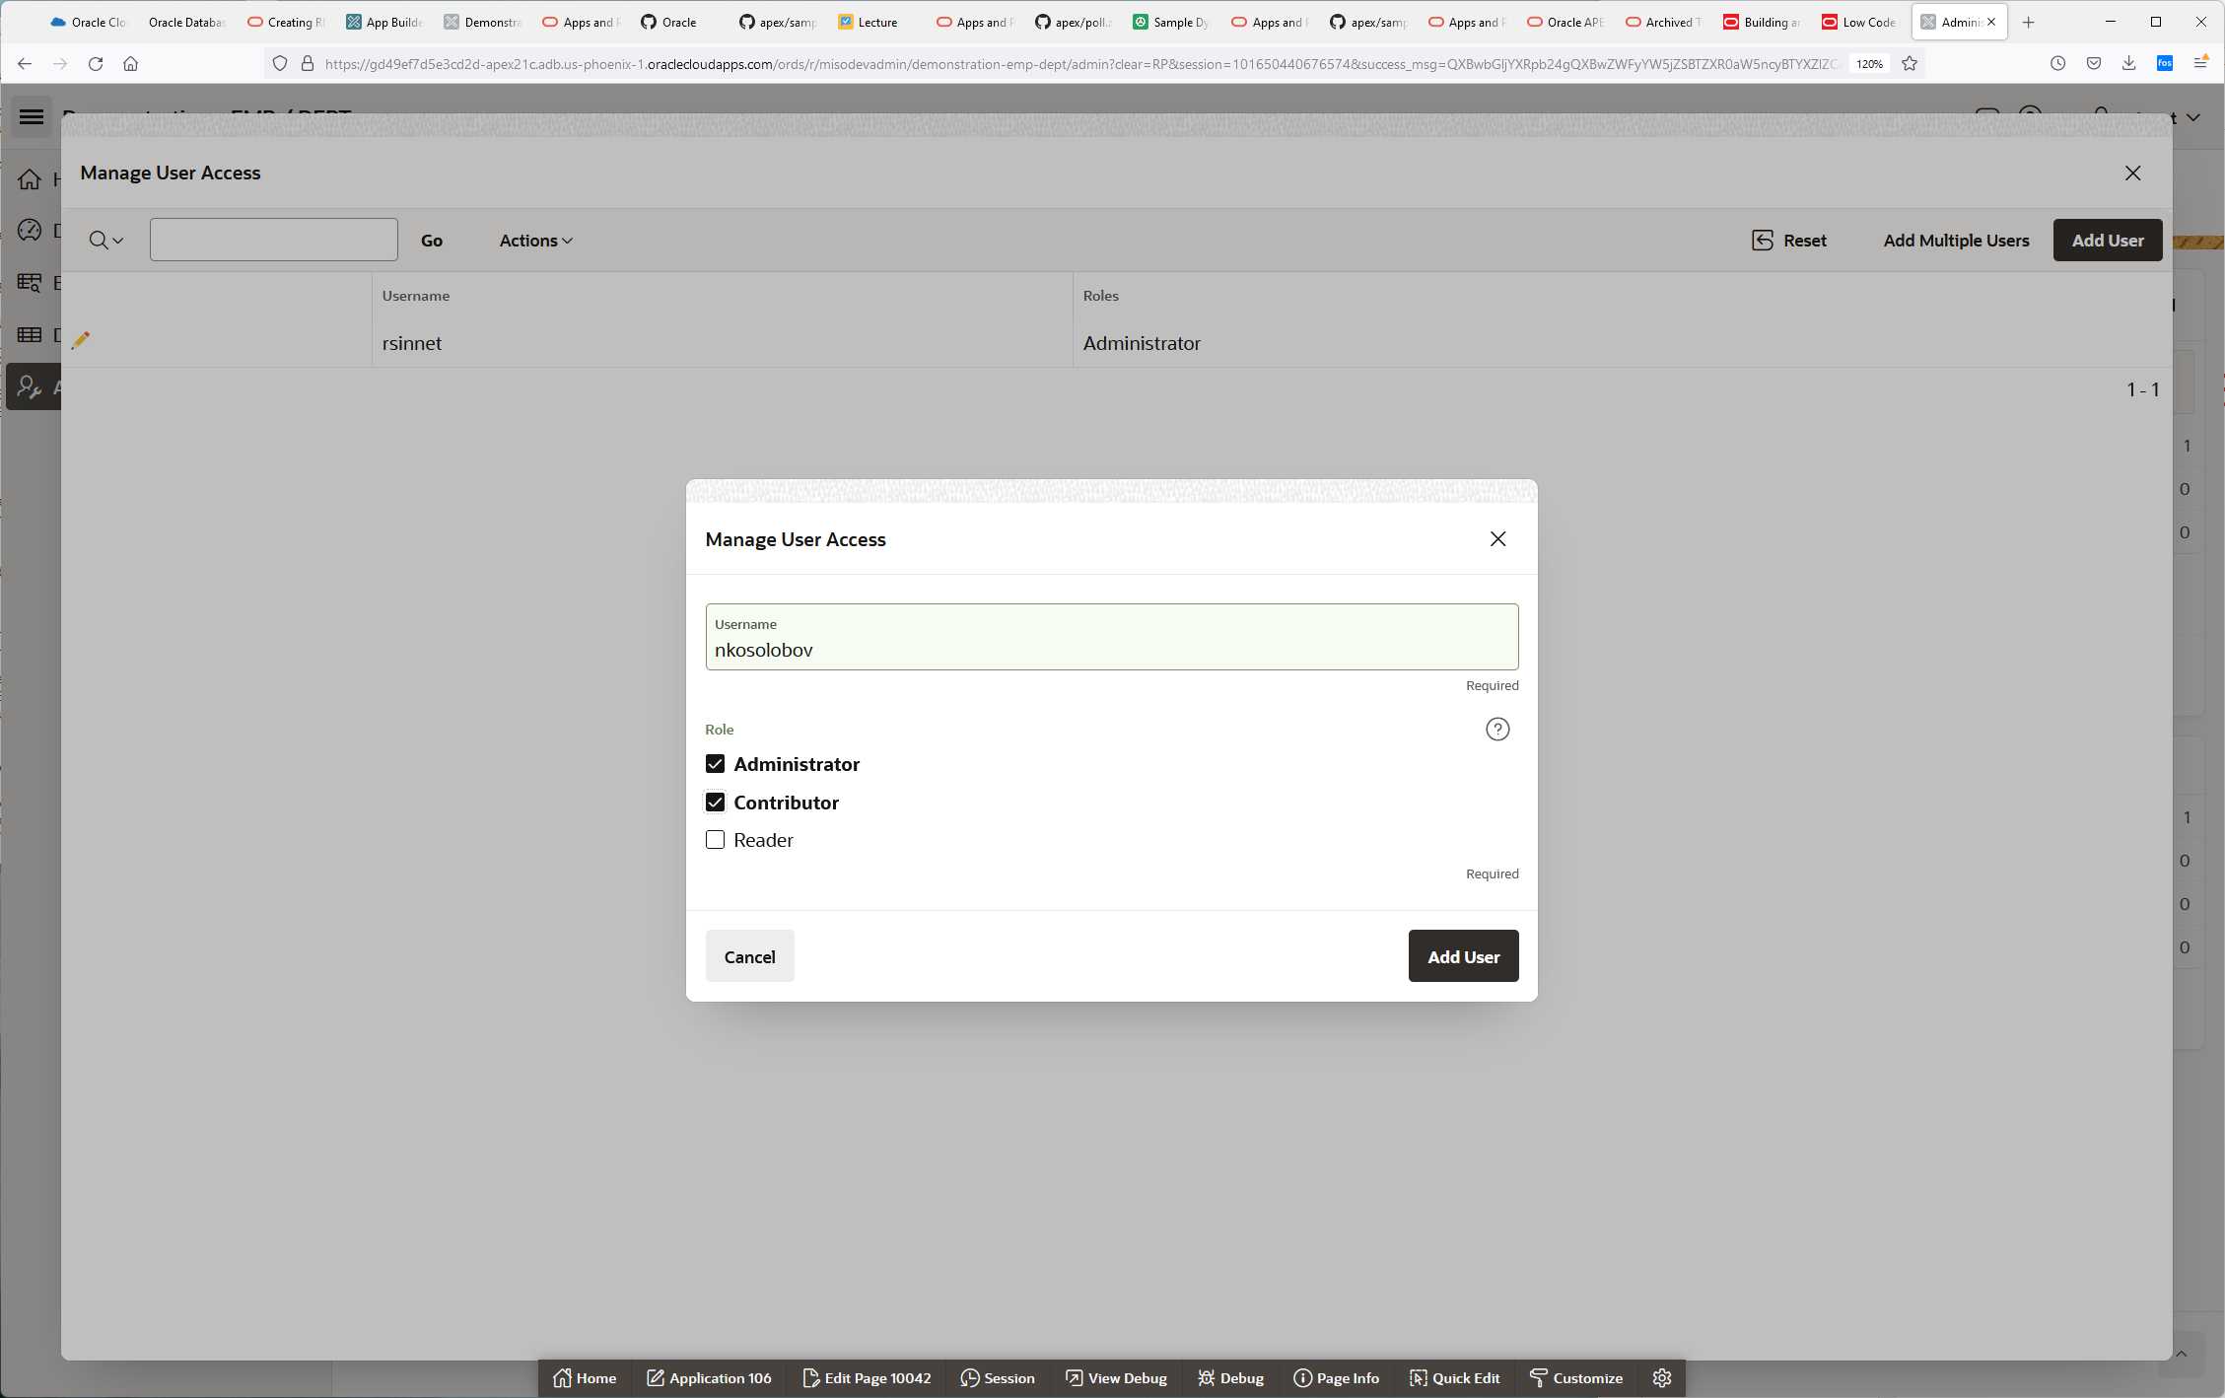

**Get page based feedback by clicking on the cloud to the left of your login info.**

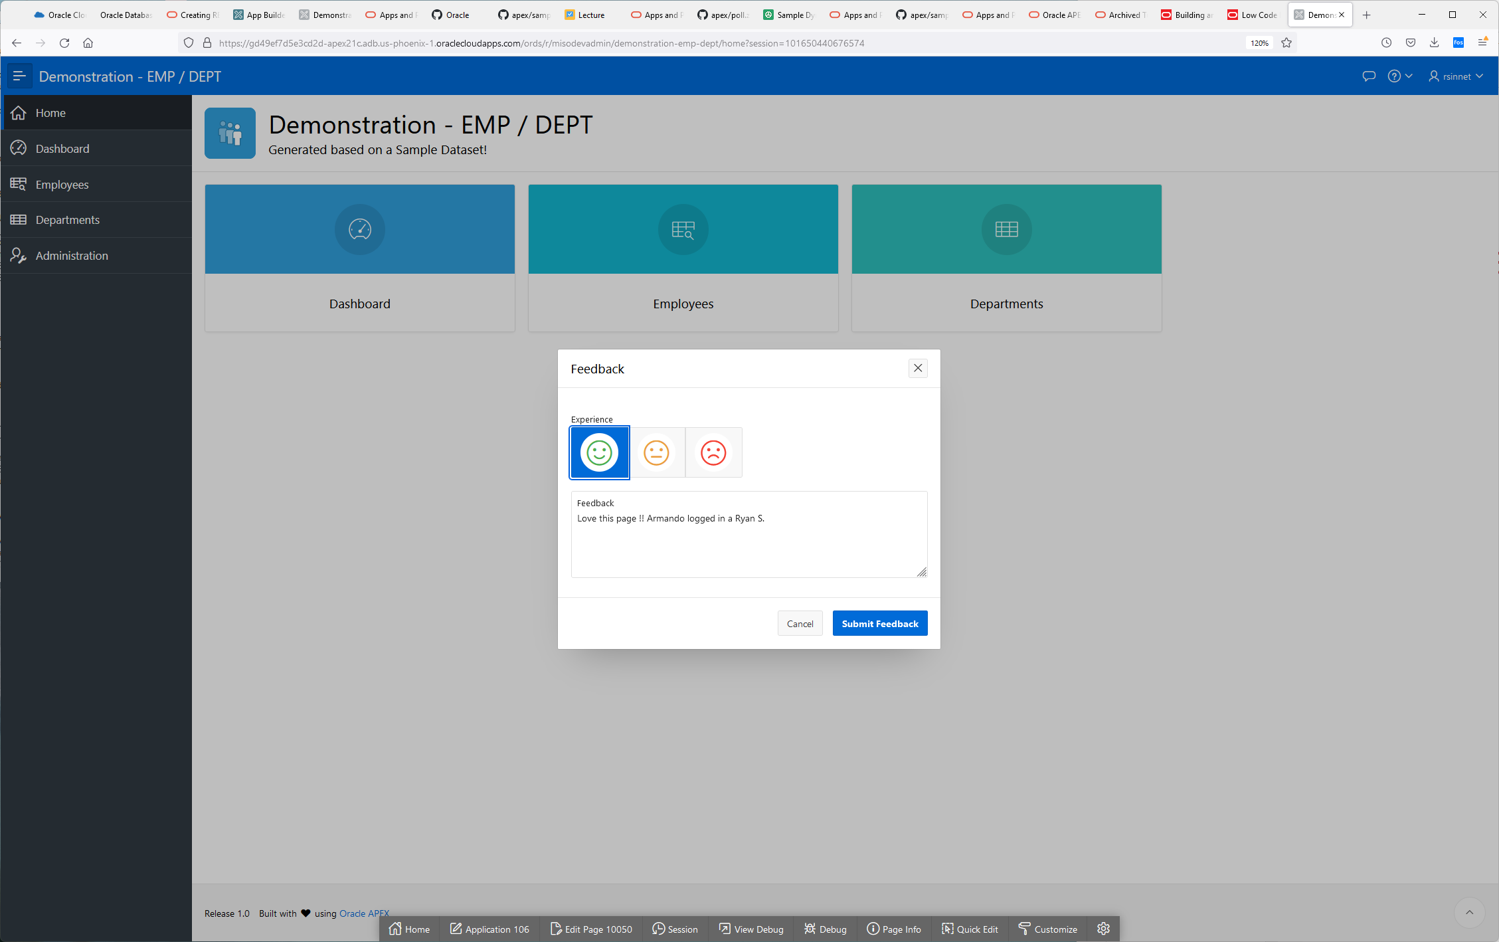

**If your developing the UI, you can make custom changes with your users until they find the appearance they like.**

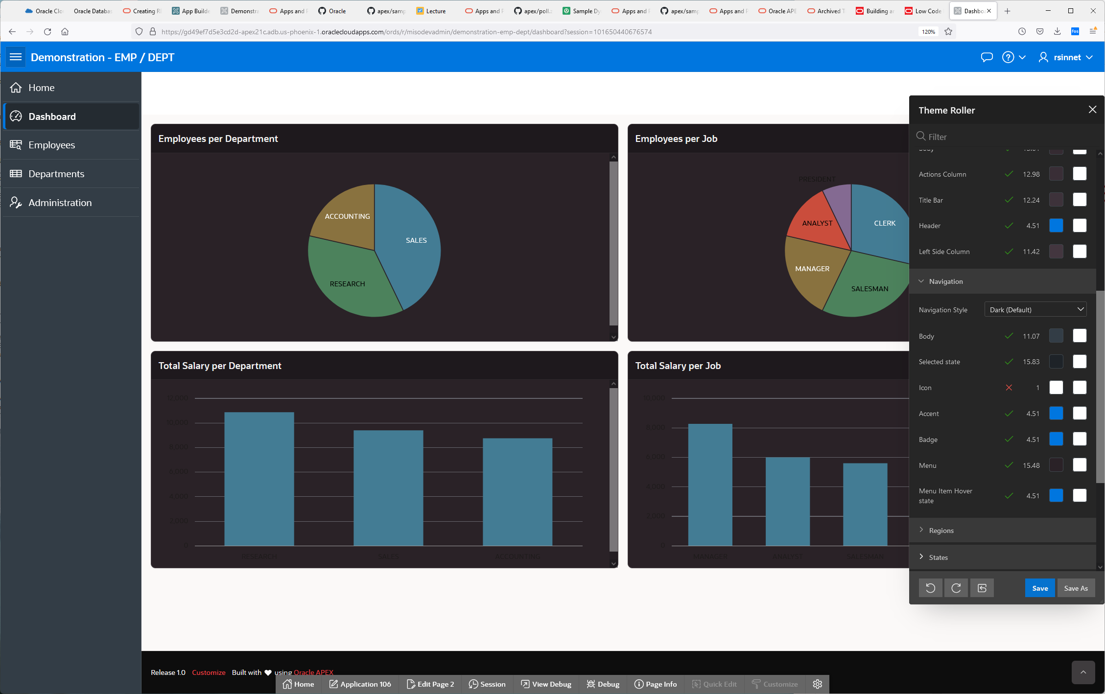

**Here is the sql we built an app around.**

|  |
| --- |
| CREATE TABLE "DEPT"  ( "DEPTNO" NUMBER(2,0) NOT NULL ENABLE,  "DNAME" VARCHAR2(50) COLLATE "USING_NLS_COMP",  "LOC" VARCHAR2(50) COLLATE "USING_NLS_COMP",  CONSTRAINT "DEPT_PK" PRIMARY KEY ("DEPTNO")  USING INDEX ENABLE  ) DEFAULT COLLATION "USING_NLS_COMP"  /  CREATE TABLE "EMP"  ( "EMPNO" NUMBER(4,0) NOT NULL ENABLE,  "ENAME" VARCHAR2(50) COLLATE "USING_NLS_COMP",  "JOB" VARCHAR2(50) COLLATE "USING_NLS_COMP",  "MGR" NUMBER(4,0),  "HIREDATE" DATE,  "SAL" NUMBER(7,2),  "COMM" NUMBER(7,2),  "DEPTNO" NUMBER(2,0),  CONSTRAINT "EMP_PK" PRIMARY KEY ("EMPNO")  USING INDEX ENABLE  ) DEFAULT COLLATION "USING_NLS_COMP"  /  ALTER TABLE "EMP" ADD CONSTRAINT "EMP_MGR_FK" FOREIGN KEY ("MGR")  REFERENCES "EMP" ("EMPNO") ENABLE  /  ALTER TABLE "EMP" ADD CONSTRAINT "EMP_DEPT_FK" FOREIGN KEY ("DEPTNO")  REFERENCES "DEPT" ("DEPTNO") ENABLE  /  CREATE OR REPLACE FORCE EDITIONABLE VIEW "EMP_DEPT_V" ("EMPNO", "ENAME", "JOB", "MGR", "HIREDATE", "SAL", "COMM", "DEPTNO", "DNAME", "LOC") DEFAULT COLLATION "USING_NLS_COMP" AS  select e.empno  , e.ename  , e.job  , (select m.ename from emp m where e.mgr = m.empno) mgr  , e.hiredate  , e.sal  , e.comm  , d.deptno  , d.dname  , d.loc  from emp e  , dept d  where e.deptno = d.deptno (+)  / |

**Task 2: REST Enabling the Database Objects, the EASY WAY ☹**

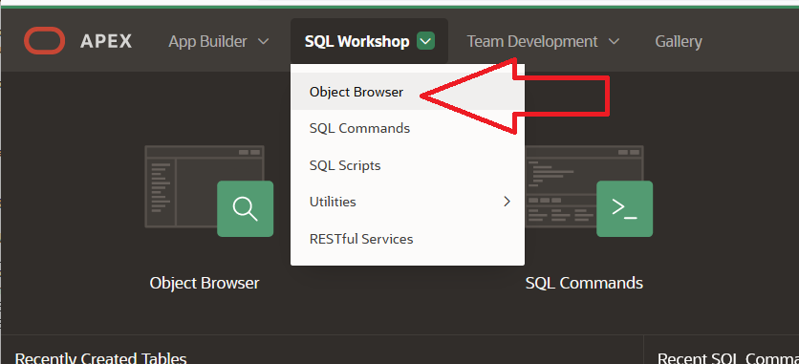

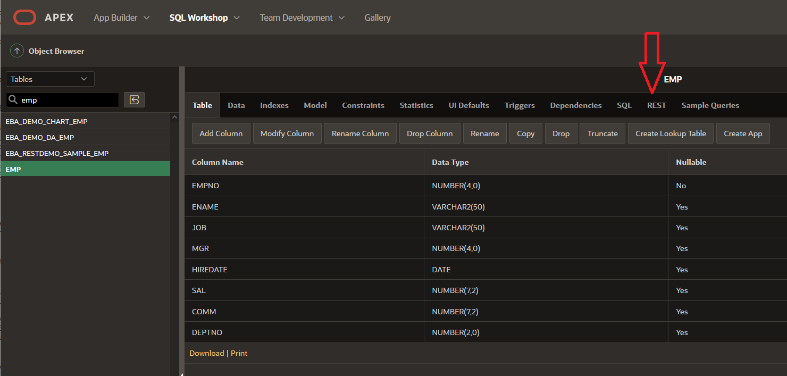

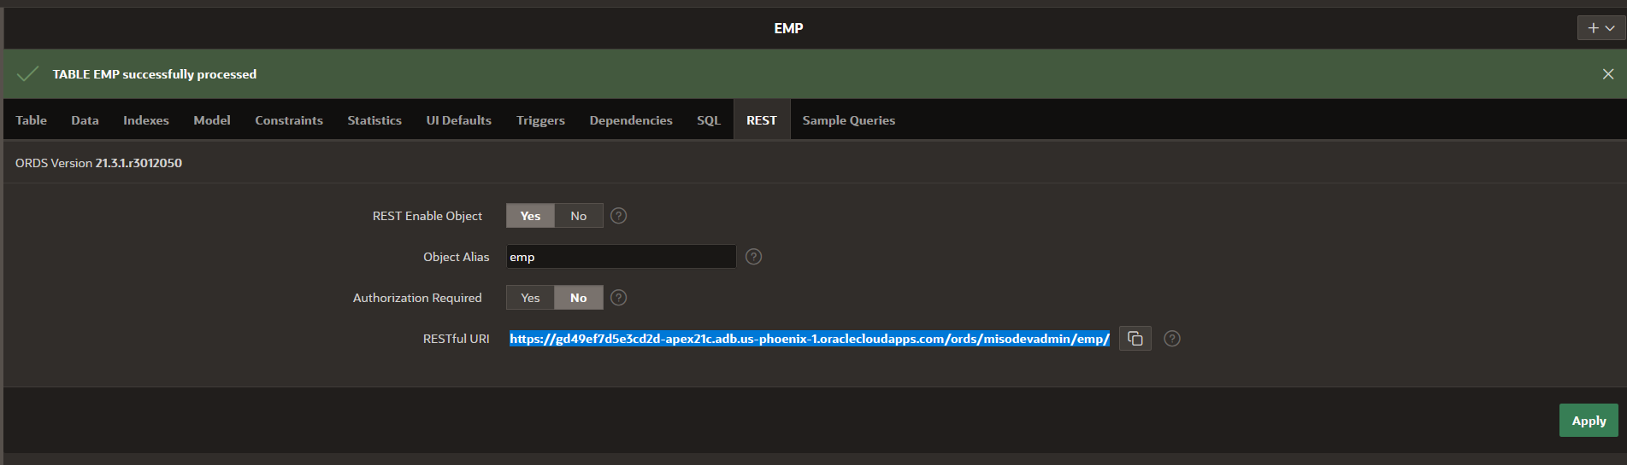

[**https://gd49ef7d5e3cd2d-apex21c.adb.us-phoenix-1.oraclecloudapps.com/ords/misodevadmin/emp/**](https://gd49ef7d5e3cd2d-apex21c.adb.us-phoenix-1.oraclecloudapps.com/ords/misodevadmin/emp/)

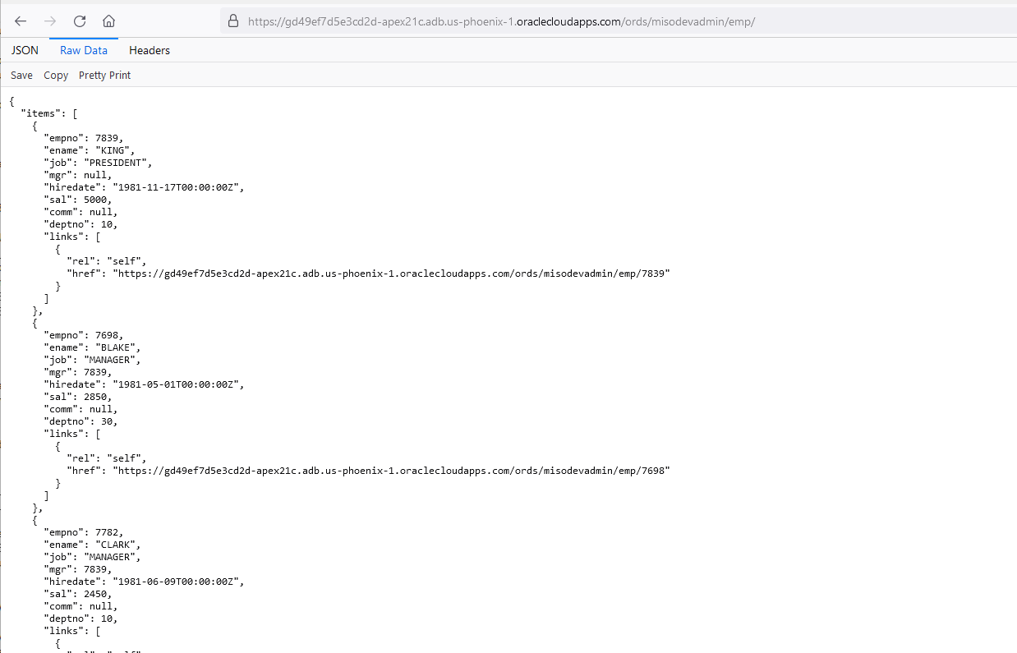

If we goto the admin pages for this schema.

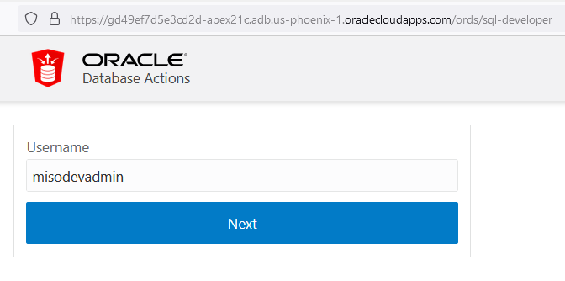

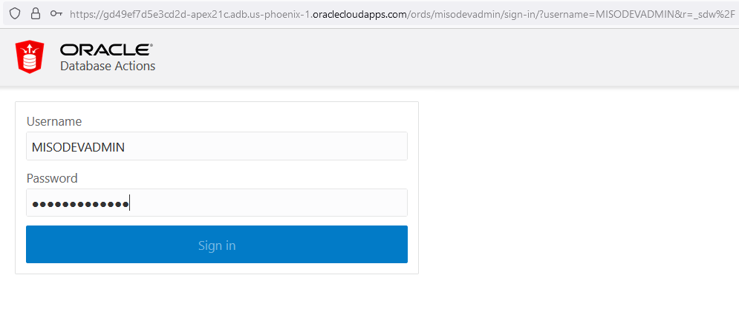

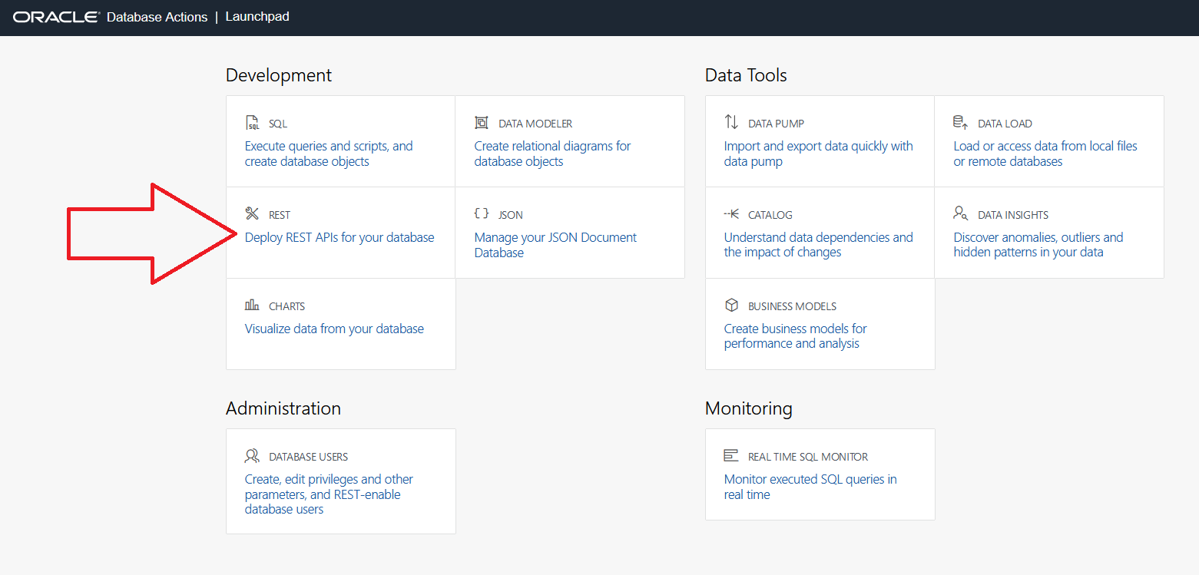

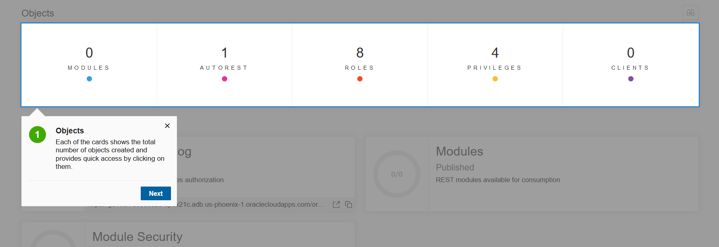

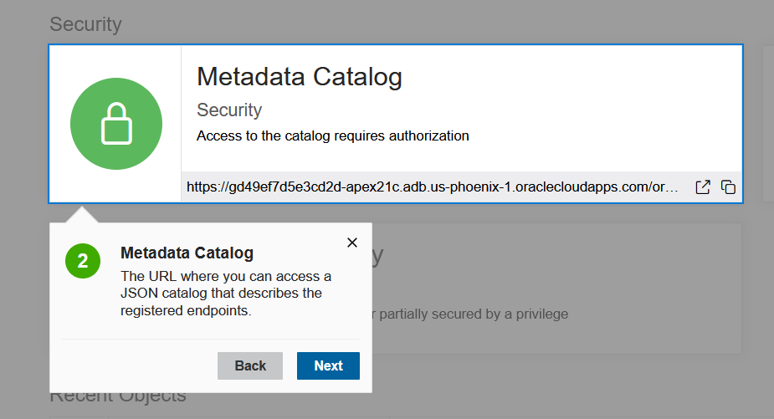

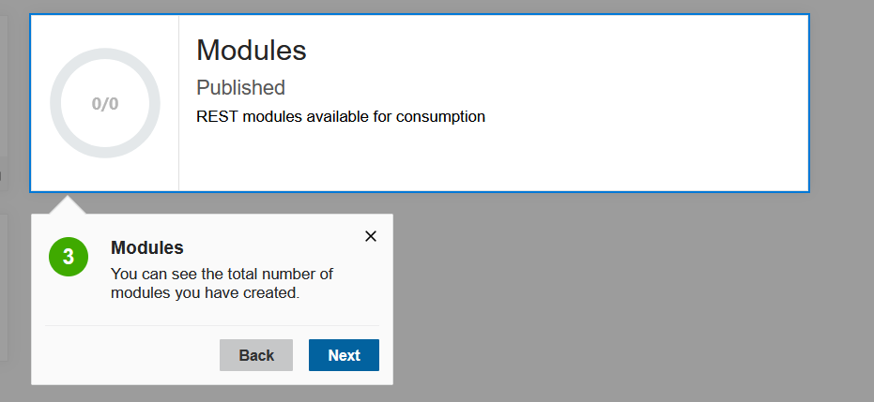

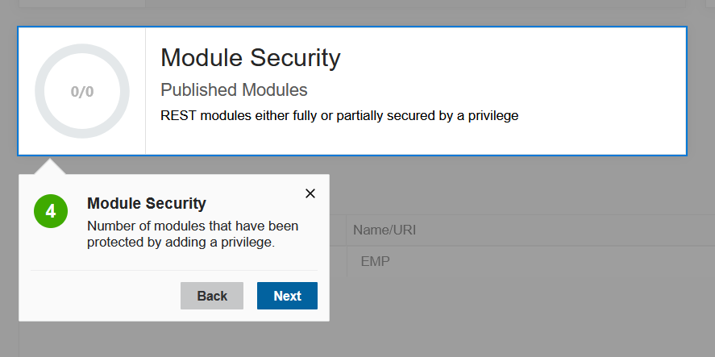

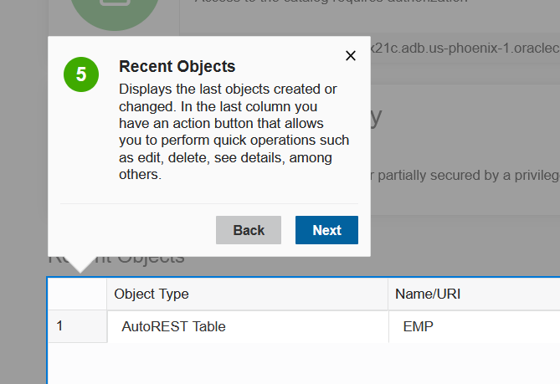

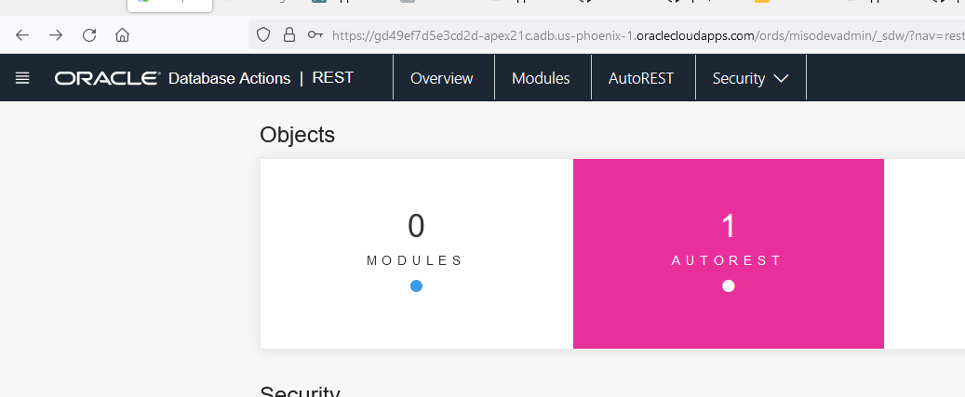

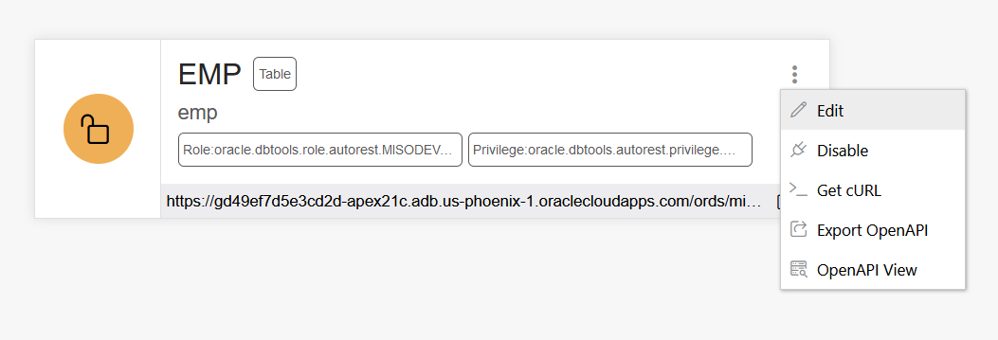

IF I click on Open API VIEW , I get this.

|  |  |  |  |  |  |  |  |  |  |  |  |  |  |  |  |  |  |  |  |  |  |  |  |  |  |  |  |  |  |  |  |  |  |  |  |  |  |  |  |  |  |  |  |  |  |  |  |  |  |  |  |  |  |  |  |  |  |  |  |  |  |  |  |  |
| --- | --- | --- | --- | --- | --- | --- | --- | --- | --- | --- | --- | --- | --- | --- | --- | --- | --- | --- | --- | --- | --- | --- | --- | --- | --- | --- | --- | --- | --- | --- | --- | --- | --- | --- | --- | --- | --- | --- | --- | --- | --- | --- | --- | --- | --- | --- | --- | --- | --- | --- | --- | --- | --- | --- | --- | --- | --- | --- | --- | --- | --- | --- | --- | --- |
| EMPTableemp  * Role:oracle.dbtools.role.autorest.MISODEVADMIN.EMP * Privilege:oracle.dbtools.autorest.privilege.MISODEVADMIN.EMP   https://gd49ef7d5e3cd2d-apex21c.adb.us-phoenix-1.oraclecloudapps.com/ords/misodevadmin/emp ORDS generated API for EMP **1.0.0**  Schemes default GET​/  Retrieve records from EMP Parameters No parameters Responses Response content type   | Code | Description | | --- | --- | | 200 | The queried record.   * Example Value * Model   {  "items": [  {  "empno": 0,  "ename": "string",  "job": "string",  "mgr": 0,  "hiredate": "2021-12-01T21:15:44.261Z",  "sal": 0,  "comm": 0,  "deptno": 0  }  ]  } |   POST​/  Create a new record on EMP Parameters  | **Name** | **Description** | | --- | --- | | payload *  (body) | * Example Value * Model   {  "empno": 0,  "ename": "string",  "job": "string",  "mgr": 0,  "hiredate": "2021-12-01T21:14:21.654Z",  "sal": 0,  "comm": 0,  "deptno": 0  }  Parameter content type |  Responses Response content type   | Code | Description | | --- | --- | | 201 | The successfully created record.   * Example Value * Model   {  "empno": 0,  "ename": "string",  "job": "string",  "mgr": 0,  "hiredate": "2021-12-01T21:15:44.270Z",  "sal": 0,  "comm": 0,  "deptno": 0  } |   POST​/batchload  Create new records on EMP Parameters  | **Name** | **Description** | | --- | --- | | payload *  (body) | * Example Value * Model   string  Parameter content type |  Responses Response content type   | Code | Description | | --- | --- | | 200 | The status of the processed records.   * Example Value * Model   string |   DELETE​/{id}  Remove a record from EMP Parameters  | **Name** | **Description** | | --- | --- | | id *  string  (path) | implicit |  Responses Response content type   | Code | Description | | --- | --- | | 204 | Deleted result.   * Example Value * Model   {  "empno": 0,  "ename": "string",  "job": "string",  "mgr": 0,  "hiredate": "2021-12-01T21:15:44.280Z",  "sal": 0,  "comm": 0,  "deptno": 0  } |   GET​/{id}  Retrieve a record from EMP Parameters  | **Name** | **Description** | | --- | --- | | id *  string  (path) | implicit |  Responses Response content type   | Code | Description | | --- | --- | | 200 | The queried record.   * Example Value * Model   {  "empno": 0,  "ename": "string",  "job": "string",  "mgr": 0,  "hiredate": "2021-12-01T21:15:44.286Z",  "sal": 0,  "comm": 0,  "deptno": 0  } |   PUT​/{id}  Create or update a record on EMP Parameters  | **Name** | **Description** | | --- | --- | | id *  string  (path) | implicit | | payload *  (body) | * Example Value * Model   {  "empno": 0,  "ename": "string",  "job": "string",  "mgr": 0,  "hiredate": "2021-12-01T21:15:29.806Z",  "sal": 0,  "comm": 0,  "deptno": 0  }  Parameter content type |  Responses Response content type   | Code | Description | | --- | --- | | 200 | The successfully updated record.   * Example Value * Model   {  "empno": 0,  "ename": "string",  "job": "string",  "mgr": 0,  "hiredate": "2021-12-01T21:15:44.292Z",  "sal": 0,  "comm": 0,  "deptno": 0  } | | 201 | The successfully created record.   * Example Value * Model   {  "empno": 0,  "ename": "string",  "job": "string",  "mgr": 0,  "hiredate": "2021-12-01T21:15:44.294Z",  "sal": 0,  "comm": 0,  "deptno": 0  } |  Models DATEstring($date-time) pattern: ^\d{4}-[01]\d-[0123]\dT[012]\d:[0-5]\d:[0-5]\d(.\d+)?(Z|([-+][012]\d:[0-5]\d))$  NUMBERnumber  VARCHAR2string  EMP_ITEM{   |  |  | | --- | --- | | empno | NUMBERnumber | | ename | VARCHAR2string | | job | VARCHAR2string | | mgr | NUMBERnumber | | hiredate | DATEstring($date-time) pattern: ^\d{4}-[01]\d-[0123]\dT[012]\d:[0-5]\d:[0-5]\d(.\d+)?(Z|([-+][012]\d:[0-5]\d))$ | | sal | NUMBERnumber | | comm | NUMBERnumber | | deptno | NUMBERnumber |   } |

No lets generate curl

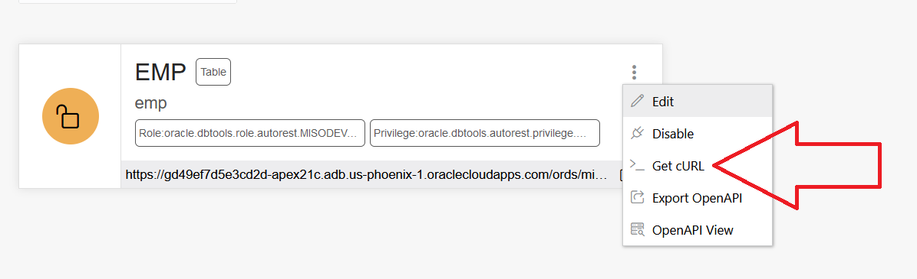

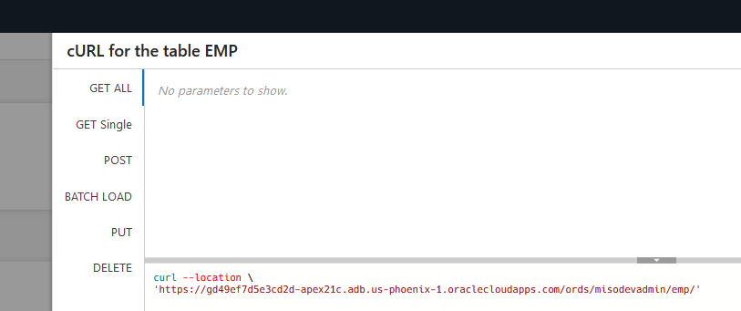

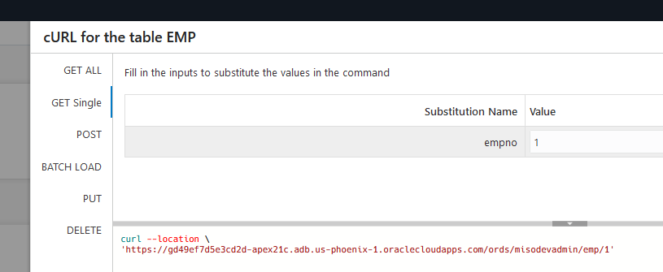

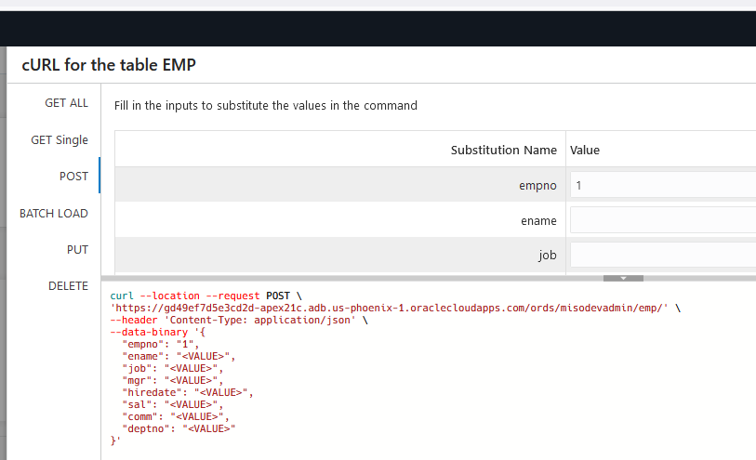

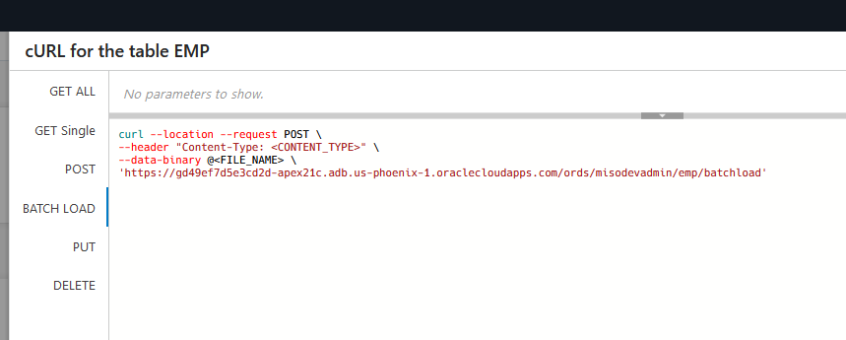

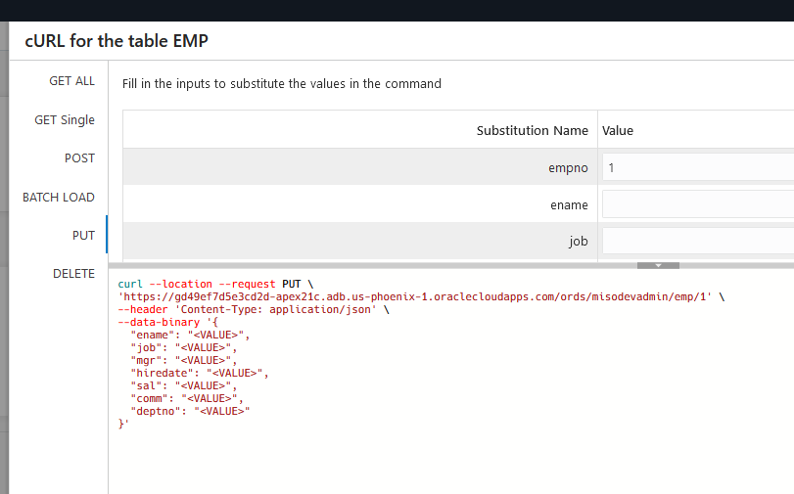

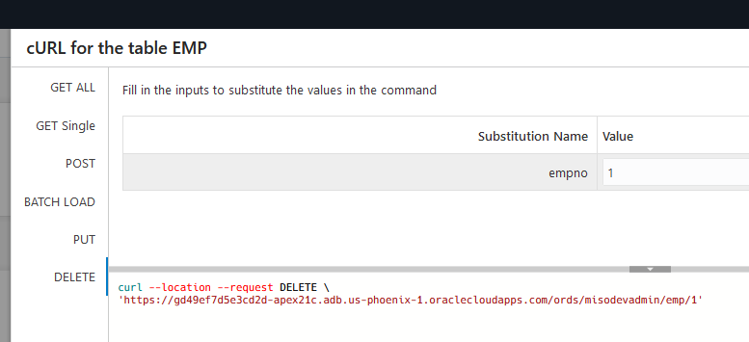

C:\Users\rmand>curl --location "https://gd49ef7d5e3cd2d-apex21c.adb.us-phoenix-1.oraclecloudapps.com/ords/misodevadmin/emp/" --ssl-no-revoke

C:\Users\rmand>curl --location "https://gd49ef7d5e3cd2d-apex21c.adb.us-phoenix-1.oraclecloudapps.com/ords/misodevadmin/emp/" --ssl-no-revoke > a.a

% Total % Received % Xferd Average Speed Time Time Time Current

Dload Upload Total Spent Left Speed

100 4148 0 4148 0 0 4148 0 --:--:-- --:--:-- --:--:-- 8863

C:\Users\rmand>type a.a

{"items":[{"empno":7839,"ename":"KING","job":"PRESIDENT","mgr":null,"hiredate":"1981-11-17T00:00:00Z","sal":5000,"comm":null,"deptno":10,"links":[{"rel":"self","href":"https://gd49ef7d5e3cd2d-apex21c.adb.us-phoenix-1.oraclecloudapps.com/ords/misodevadmin/emp/7839"}]},{"empno":7698,"ename":"BLAKE","job":"MANAGER","mgr":7839,"hiredate":"1981-05-01T00:00:00Z","sal":2850,"comm":null,"deptno":30,"links":[{"rel":"self","href":"https://gd49ef7d5e3cd2d-apex21c.adb.us-phoenix-1.oraclecloudapps.com/ords/misodevadmin/emp/7698"}]},{"empno":7782,"ename":"CLARK","job":"MANAGER","mgr":7839,"hiredate":"1981-06-09T00:00:00Z","sal":2450,"comm":null,"deptno":10,"links":[{"rel":"self","href":"https://gd49ef7d5e3cd2d-apex21c.adb.us-phoenix-1.oraclecloudapps.com/ords/misodevadmin/emp/7782"}]},{"empno":7566,"ename":"JONES","job":"MANAGER","mgr":7839,"hiredate":"1981-04-02T00:00:00Z","sal":2975,"comm":null,"deptno":20,"links":[{"rel":"self","href":"https://gd49ef7d5e3cd2d-apex21c.adb.us-phoenix-1.oraclecloudapps.com/ords/misodevadmin/emp/7566"}]},{"empno":7788,"ename":"SCOTT","job":"ANALYST","mgr":7566,"hiredate":"1982-12-09T00:00:00Z","sal":3000,"comm":null,"deptno":20,"links":[{"rel":"self","href":"https://gd49ef7d5e3cd2d-apex21c.adb.us-phoenix-1.oraclecloudapps.com/ords/misodevadmin/emp/7788"}]},{"empno":7902,"ename":"FORD","job":"ANALYST","mgr":7566,"hiredate":"1981-12-03T00:00:00Z","sal":3000,"comm":null,"deptno":20,"links":[{"rel":"self","href":"https://gd49ef7d5e3cd2d-apex21c.adb.us-phoenix-1.oraclecloudapps.com/ords/misodevadmin/emp/7902"}]},{"empno":7369,"ename":"SMITH","job":"CLERK","mgr":7902,"hiredate":"1980-12-17T00:00:00Z","sal":800,"comm":null,"deptno":20,"links":[{"rel":"self","href":"https://gd49ef7d5e3cd2d-apex21c.adb.us-phoenix-1.oraclecloudapps.com/ords/misodevadmin/emp/7369"}]},{"empno":7499,"ename":"ALLEN","job":"SALESMAN","mgr":7698,"hiredate":"1981-02-20T00:00:00Z","sal":1600,"comm":300,"deptno":30,"links":[{"rel":"self","href":"https://gd49ef7d5e3cd2d-apex21c.adb.us-phoenix-1.oraclecloudapps.com/ords/misodevadmin/emp/7499"}]},{"empno":7521,"ename":"WARD","job":"SALESMAN","mgr":7698,"hiredate":"1981-02-22T00:00:00Z","sal":1250,"comm":500,"deptno":30,"links":[{"rel":"self","href":"https://gd49ef7d5e3cd2d-apex21c.adb.us-phoenix-1.oraclecloudapps.com/ords/misodevadmin/emp/7521"}]},{"empno":7654,"ename":"MARTIN","job":"SALESMAN","mgr":7698,"hiredate":"1981-09-28T00:00:00Z","sal":1250,"comm":1400,"deptno":30,"links":[{"rel":"self","href":"https://gd49ef7d5e3cd2d-apex21c.adb.us-phoenix-1.oraclecloudapps.com/ords/misodevadmin/emp/7654"}]},{"empno":7844,"ename":"TURNER","job":"SALESMAN","mgr":7698,"hiredate":"1981-09-08T00:00:00Z","sal":1500,"comm":0,"deptno":30,"links":[{"rel":"self","href":"https://gd49ef7d5e3cd2d-apex21c.adb.us-phoenix-1.oraclecloudapps.com/ords/misodevadmin/emp/7844"}]},{"empno":7876,"ename":"ADAMS","job":"CLERK","mgr":7788,"hiredate":"1983-01-12T00:00:00Z","sal":1100,"comm":null,"deptno":20,"links":[{"rel":"self","href":"https://gd49ef7d5e3cd2d-apex21c.adb.us-phoenix-1.oraclecloudapps.com/ords/misodevadmin/emp/7876"}]},{"empno":7900,"ename":"JAMES","job":"CLERK","mgr":7698,"hiredate":"1981-12-03T00:00:00Z","sal":950,"comm":null,"deptno":30,"links":[{"rel":"self","href":"https://gd49ef7d5e3cd2d-apex21c.adb.us-phoenix-1.oraclecloudapps.com/ords/misodevadmin/emp/7900"}]},{"empno":7934,"ename":"MILLER","job":"CLERK","mgr":7782,"hiredate":"1982-01-23T00:00:00Z","sal":1300,"comm":null,"deptno":10,"links":[{"rel":"self","href":"https://gd49ef7d5e3cd2d-apex21c.adb.us-phoenix-1.oraclecloudapps.com/ords/misodevadmin/emp/7934"}]}],"hasMore":false,"limit":25,"offset":0,"count":14,"links":[{"rel":"self","href":"https://gd49ef7d5e3cd2d-apex21c.adb.us-phoenix-1.oraclecloudapps.com/ords/misodevadmin/emp/"},{"rel":"edit","href":"https://gd49ef7d5e3cd2d-apex21c.adb.us-phoenix-1.oraclecloudapps.com/ords/misodevadmin/emp/"},{"rel":"describedby","href":"https://gd49ef7d5e3cd2d-apex21c.adb.us-phoenix-1.oraclecloudapps.com/ords/misodevadmin/metadata-catalog/emp/"},{"rel":"first","href":"https://gd49ef7d5e3cd2d-apex21c.adb.us-phoenix-1.oraclecloudapps.com/ords/misodevadmin/emp/"}]}

**Task 2: REST Enabling the Database Objects, the RIGHT WAY**

Running the SQL Script below will REST Enable the schema and also create modules for the EMP and DEPT tables and the EMP_DEPT_V view, together with the appropriate handlers.

Alternatively, you could go to SQL Workshop > RESTful Services and REST enabled the schema. Then go to SQL Workshop > Object Browser, clicked on each table/view and then selected REST to define the REST services. However, the handlers created using the SQL Workshop > Object Browser will utilize Data Dictionary lookups each time they are called. This is less efficient then the manually created services you will create, especially on services, such as apex.oracle.com, which have an extremely large data dictionary. On apex.oracle.com there are over 20,000 schemas.

1. In the main menu, select **SQL Workshop**, click **SQL Scripts**.

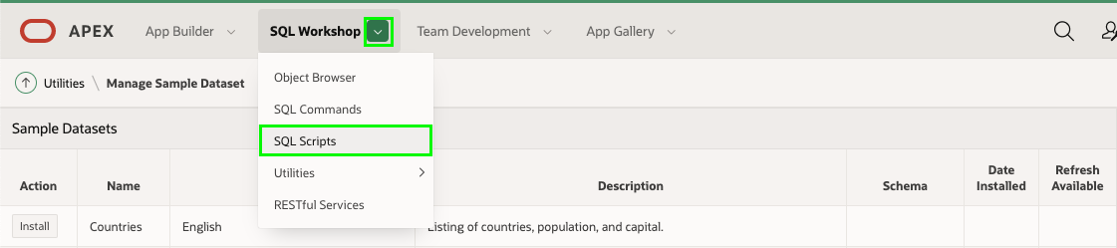

1. On the SQL Scripts page, click **Create**.

<https://gd49ef7d5e3cd2d-apex21c.adb.us-phoenix-1.oraclecloudapps.com/ords/misodevadmin>

**The metadata catalog is a self describing API, it will tell you what is available and you can use it to inspect the attributes as well:**

[**https://gd49ef7d5e3cd2d-apex21c.adb.us-phoenix-1.oraclecloudapps.com/ords/misodevadmin/metadata-catalog/emp/**](https://gd49ef7d5e3cd2d-apex21c.adb.us-phoenix-1.oraclecloudapps.com/ords/misodevadmin/metadata-catalog/emp/)

**provide the data types and links**

|  |
| --- |
| [**https://gd49ef7d5e3cd2d-apex21c.adb.us-phoenix-1.oraclecloudapps.com/ords/misodevadmin/metadata-catalog/emp/**](https://gd49ef7d5e3cd2d-apex21c.adb.us-phoenix-1.oraclecloudapps.com/ords/misodevadmin/metadata-catalog/emp/) |

|  |
| --- |
| <https://gd49ef7d5e3cd2d-apex21c.adb.us-phoenix-1.oraclecloudapps.com/ords/misodevadmin/metadata-catalog/>  or use  [**https://gd49ef7d5e3cd2d-apex21c.adb.us-phoenix-1.oraclecloudapps.com/ords/misodevadmin/open-api-catalog/**](https://gd49ef7d5e3cd2d-apex21c.adb.us-phoenix-1.oraclecloudapps.com/ords/misodevadmin/open-api-catalog/)  {  "items": [  {  "name": "dept.rest",  "links": [  {  "rel": "describes",  "href": "https://gd49ef7d5e3cd2d-apex21c.adb.us-phoenix-1.oraclecloudapps.com/ords/misodevadmin/dept/hol/"  },  {  "rel": "canonical",  "href": "https://gd49ef7d5e3cd2d-apex21c.adb.us-phoenix-1.oraclecloudapps.com/ords/misodevadmin/metadata-catalog/dept/hol/",  "mediaType": "application/json"  },  {  "rel": "alternate",  "href": "https://gd49ef7d5e3cd2d-apex21c.adb.us-phoenix-1.oraclecloudapps.com/ords/misodevadmin/open-api-catalog/dept/",  "mediaType": "application/openapi+json"  }  ]  },  {  "name": "EMP",  "links": [  {  "rel": "describes",  "href": "https://gd49ef7d5e3cd2d-apex21c.adb.us-phoenix-1.oraclecloudapps.com/ords/misodevadmin/emp/"  },  {  "rel": "canonical",  "href": "https://gd49ef7d5e3cd2d-apex21c.adb.us-phoenix-1.oraclecloudapps.com/ords/misodevadmin/metadata-catalog/emp/",  "mediaType": "application/json"  },  {  "rel": "alternate",  "href": "https://gd49ef7d5e3cd2d-apex21c.adb.us-phoenix-1.oraclecloudapps.com/ords/misodevadmin/open-api-catalog/emp/",  "mediaType": "application/openapi+json"  }  ]  },  {  "name": "emp.rest",  "links": [  {  "rel": "describes",  "href": "https://gd49ef7d5e3cd2d-apex21c.adb.us-phoenix-1.oraclecloudapps.com/ords/misodevadmin/emp/hol/"  },  {  "rel": "canonical",  "href": "https://gd49ef7d5e3cd2d-apex21c.adb.us-phoenix-1.oraclecloudapps.com/ords/misodevadmin/metadata-catalog/emp/hol/",  "mediaType": "application/json"  },  {  "rel": "alternate",  "href": "https://gd49ef7d5e3cd2d-apex21c.adb.us-phoenix-1.oraclecloudapps.com/ords/misodevadmin/open-api-catalog/emp/",  "mediaType": "application/openapi+json"  }  ]  },  {  "name": "empdeptv.rest",  "links": [  {  "rel": "describes",  "href": "https://gd49ef7d5e3cd2d-apex21c.adb.us-phoenix-1.oraclecloudapps.com/ords/misodevadmin/empdeptv/hol/"  },  {  "rel": "canonical",  "href": "https://gd49ef7d5e3cd2d-apex21c.adb.us-phoenix-1.oraclecloudapps.com/ords/misodevadmin/metadata-catalog/empdeptv/hol/",  "mediaType": "application/json"  },  {  "rel": "alternate",  "href": "https://gd49ef7d5e3cd2d-apex21c.adb.us-phoenix-1.oraclecloudapps.com/ords/misodevadmin/open-api-catalog/empdeptv/",  "mediaType": "application/openapi+json"  }  ]  }  ],  "hasMore": false,  "limit": 25,  "offset": 0,  "count": 4,  "links": [  {  "rel": "self",  "href": "https://gd49ef7d5e3cd2d-apex21c.adb.us-phoenix-1.oraclecloudapps.com/ords/misodevadmin/metadata-catalog/"  },  {  "rel": "first",  "href": "https://gd49ef7d5e3cd2d-apex21c.adb.us-phoenix-1.oraclecloudapps.com/ords/misodevadmin/metadata-catalog/"  }  ]  } |

|  |
| --- |
| Begin  ords.enable_schema;  end;  /  /*  ** --Attributes like the below can be added  **\*\* begin**  **\*\* ORDS.DEFINE_MODULE(**  **\*\* ….**  **\*\* p_items_per_page => 999999999, /* means no pagination at all, be careful will large gets !!! */**  **\*\* p_status => 'PUBLISHED',**  **\*\* p_comments => 'GET ALL' ) ;**  **\*\* end;**  **\*\*/**  **\*\* Commit;**  **/  begin  ords.delete_module(  p_module_name => 'emp.rest' );  ords.define_module(  p_module_name => 'emp.rest',  p_base_path => '/emp/' );  ords.define_template(  p_module_name => 'emp.rest',  p_pattern => 'hol/' );  ords.define_template(  p_module_name => 'emp.rest',  p_pattern => 'hol/:empno' );  ords.define_handler(  p_module_name => 'emp.rest',  p_pattern => 'hol/',  p_method => 'GET',  p_source_type => ords.source_type_collection_feed,  p_source => 'select * from emp' );  ords.define_handler(  p_module_name => 'emp.rest',  p_pattern => 'hol/:empno',  p_method => 'GET',  p_source_type => ords.source_type_collection_item,  p_source => 'select * from emp where empno = :empno' );  ords.define_handler(  p_module_name => 'emp.rest',  p_pattern => 'hol/',  p_method => 'POST',  p_source_type => ords.source_type_plsql,  p_source => 'begin insert into emp (empno, ename, job, mgr, hiredate, sal, comm, deptno) values (:empno,:ename,:job,:mgr,:hiredate,:sal,:comm,:deptno);:forward_location:=:empno;:status_code:=201;end;' );  ords.define_handler(  p_module_name => 'emp.rest',  p_pattern => 'hol/:empno',  p_method => 'PUT',  p_source_type => ords.source_type_plsql,  p_source => 'begin update emp set ename=:ename,job=:job,mgr=:mgr,hiredate=:hiredate,sal=:sal,comm=:comm,deptno=:deptno where empno=:empno; :forward_location:=:empno;:status_code:=200;end;' );  ords.define_handler(  p_module_name => 'emp.rest',  p_pattern => 'hol/:empno',  p_method => 'DELETE',  p_source_type => ords.source_type_plsql,  p_source => 'begin delete emp where empno=:empno;:status_code:=200;end;' );  end;  /  begin  ords.delete_module(  p_module_name => 'dept.rest' );  ords.define_module(  p_module_name => 'dept.rest',  p_base_path => '/dept/' );  ords.define_template(  p_module_name => 'dept.rest',  p_pattern => 'hol/' );  ords.define_template(  p_module_name => 'dept.rest',  p_pattern => 'hol/:deptno' );  ords.define_handler(  p_module_name => 'dept.rest',  p_pattern => 'hol/',  p_method => 'GET',  p_source_type => ords.source_type_collection_feed,  p_source => 'select * from dept' );  ords.define_handler(  p_module_name => 'dept.rest',  p_pattern => 'hol/:deptno',  p_method => 'GET',  p_source_type => ords.source_type_collection_item,  p_source => 'select * from dept where deptno = :deptno' );  ords.define_handler(  p_module_name => 'dept.rest',  p_pattern => 'hol/',  p_method => 'POST',  p_source_type => ords.source_type_plsql,  p_source => 'begin insert into dept (deptno, dname, loc) values (:deptno,:dname,:loc);:forward_location:=:deptno;:status_code:=201;end;' );  ords.define_handler(  p_module_name => 'dept.rest',  p_pattern => 'hol/:deptno',  p_method => 'PUT',  p_source_type => ords.source_type_plsql,  p_source => 'begin update dept set dname=:dname,loc=:loc where deptno=:deptno; :forward_location:=:deptno;:status_code:=200;end;' );  ords.define_handler(  p_module_name => 'dept.rest',  p_pattern => 'hol/:deptno',  p_method => 'DELETE',  p_source_type => ords.source_type_plsql,  p_source => 'begin delete dept where deptno=:deptno;:status_code:=200;end;' );  end;  /  begin  ords.delete_module(  p_module_name => 'empdeptv.rest' );  ords.define_module(  p_module_name => 'empdeptv.rest',  p_base_path => '/empdeptv/' );  ords.define_template(  p_module_name => 'empdeptv.rest',  p_pattern => 'hol/' );  ords.define_template(  p_module_name => 'empdeptv.rest',  p_pattern => 'hol/:empno' );  ords.define_handler(  p_module_name => 'empdeptv.rest',  p_pattern => 'hol/',  p_method => 'GET',  p_source_type => ords.source_type_collection_feed,  p_source => 'select * from emp_dept_v' );  ords.define_handler(  p_module_name => 'empdeptv.rest',  p_pattern => 'hol/:empno',  p_method => 'GET',  p_source_type => ords.source_type_collection_item,  p_source => 'select * from emp_dept_v where empno = :empno' );  end;  / |

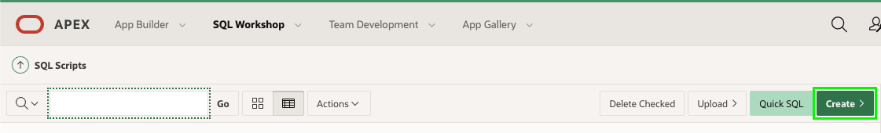

1. In the Script Editor, enter the following.
   * **Script Name:** Enter **Define REST Endpoints for EMP and DEPT**.
   * **Script Editor:** Cut and paste the following.

Click **Run**.

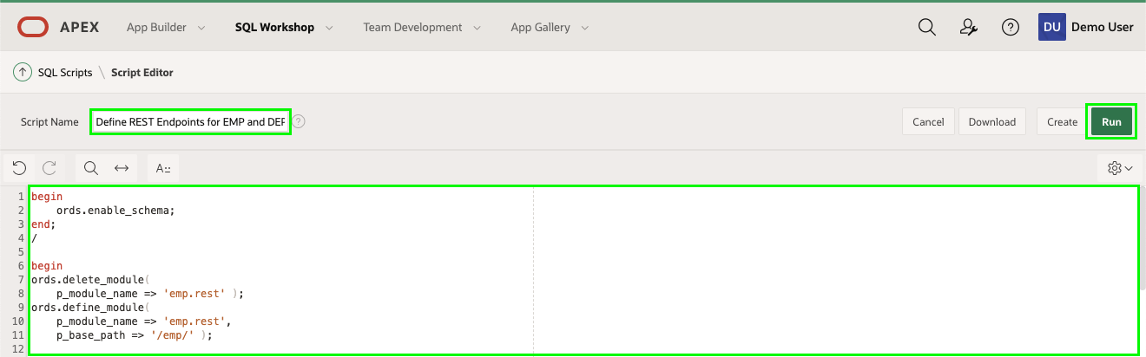

1. On the Run Script page, click **Run Now**.
2. Results should show 4 statements processed successfully.

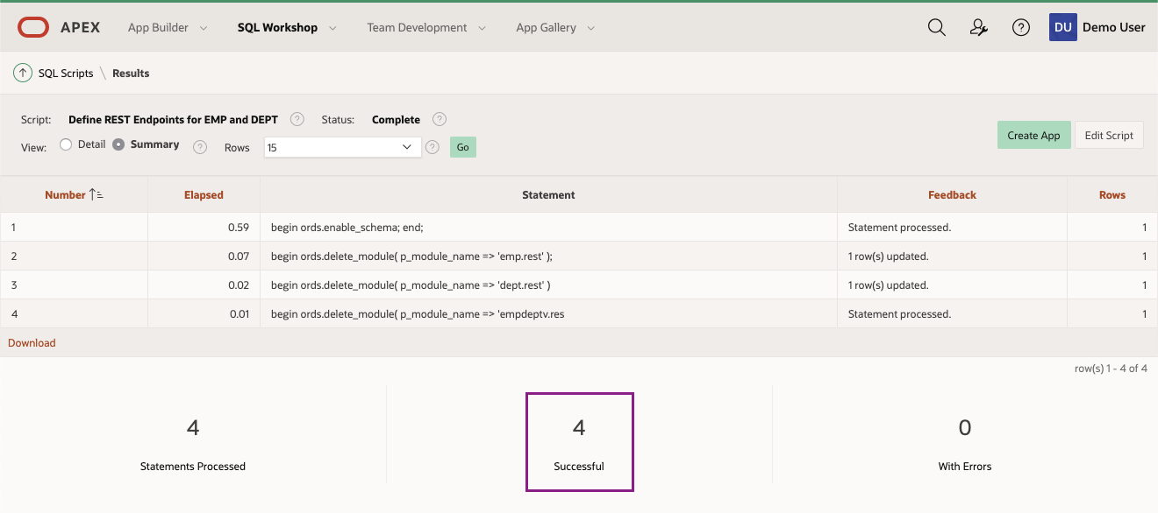

**Task 3: Reviewing the REST Services**

1. In the main menu, select **SQL Workshop**, click **RESTful Services**.

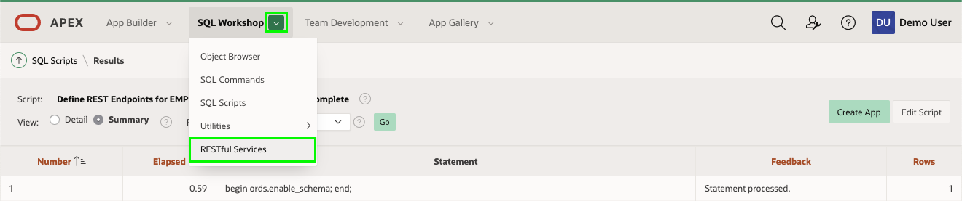

1. In the ORDS RESTful Services page,

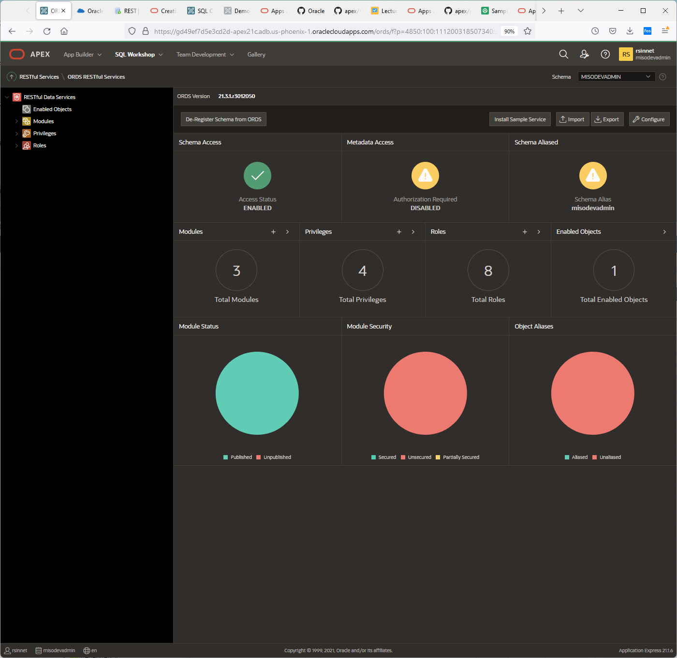

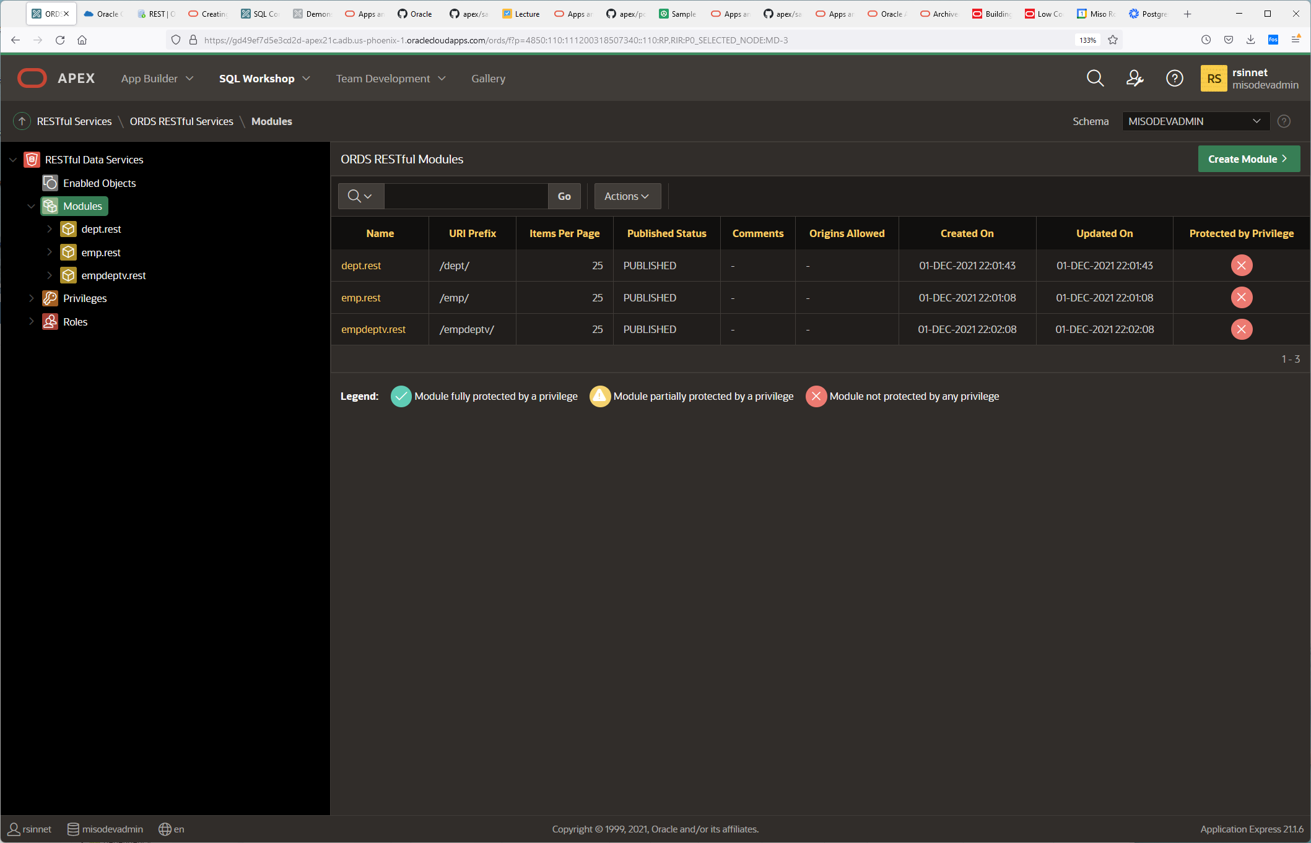

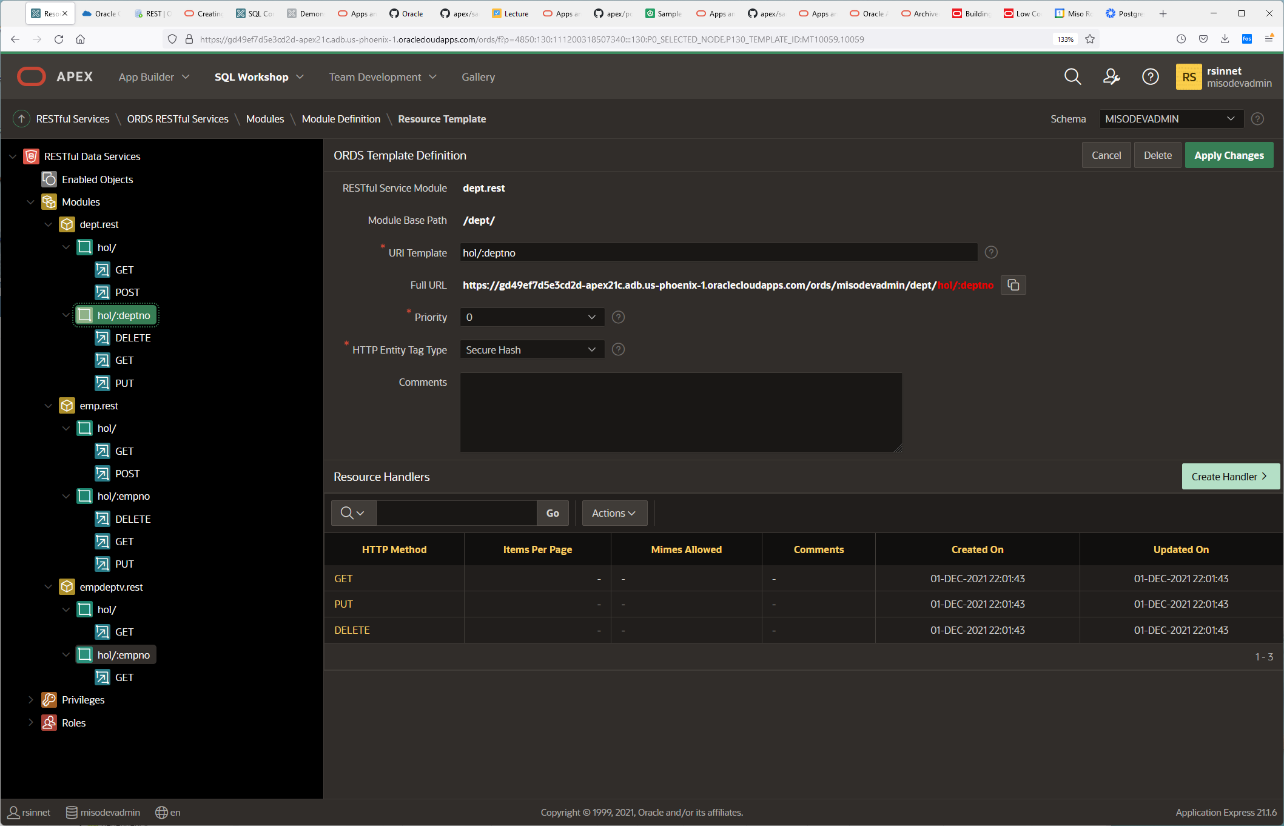

1. expand **Modules**, expand **emp.rest**, and then expand **hol/**.  
   Click on **GET**.

Click on the Copy to Clipboard icon (or manually copy the Full URL).

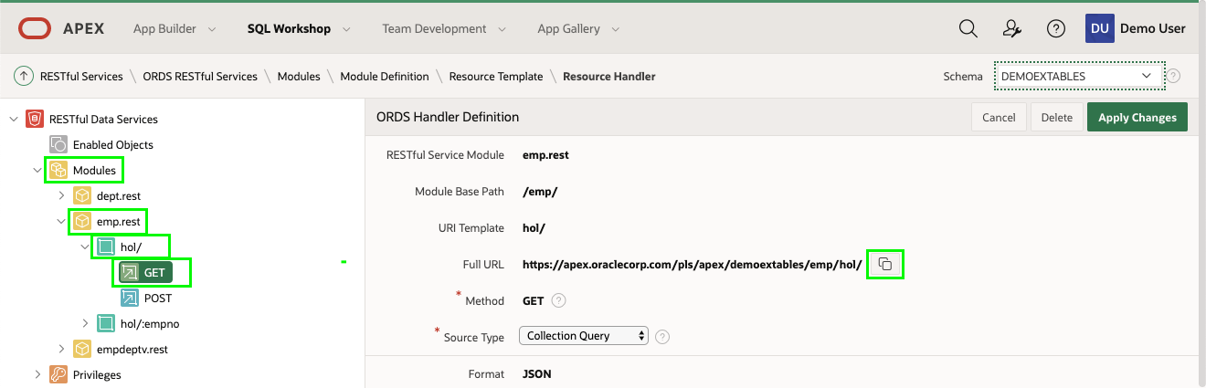

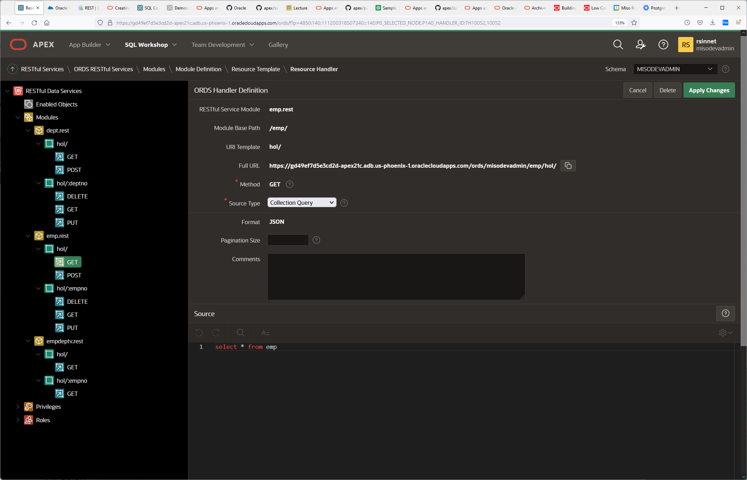

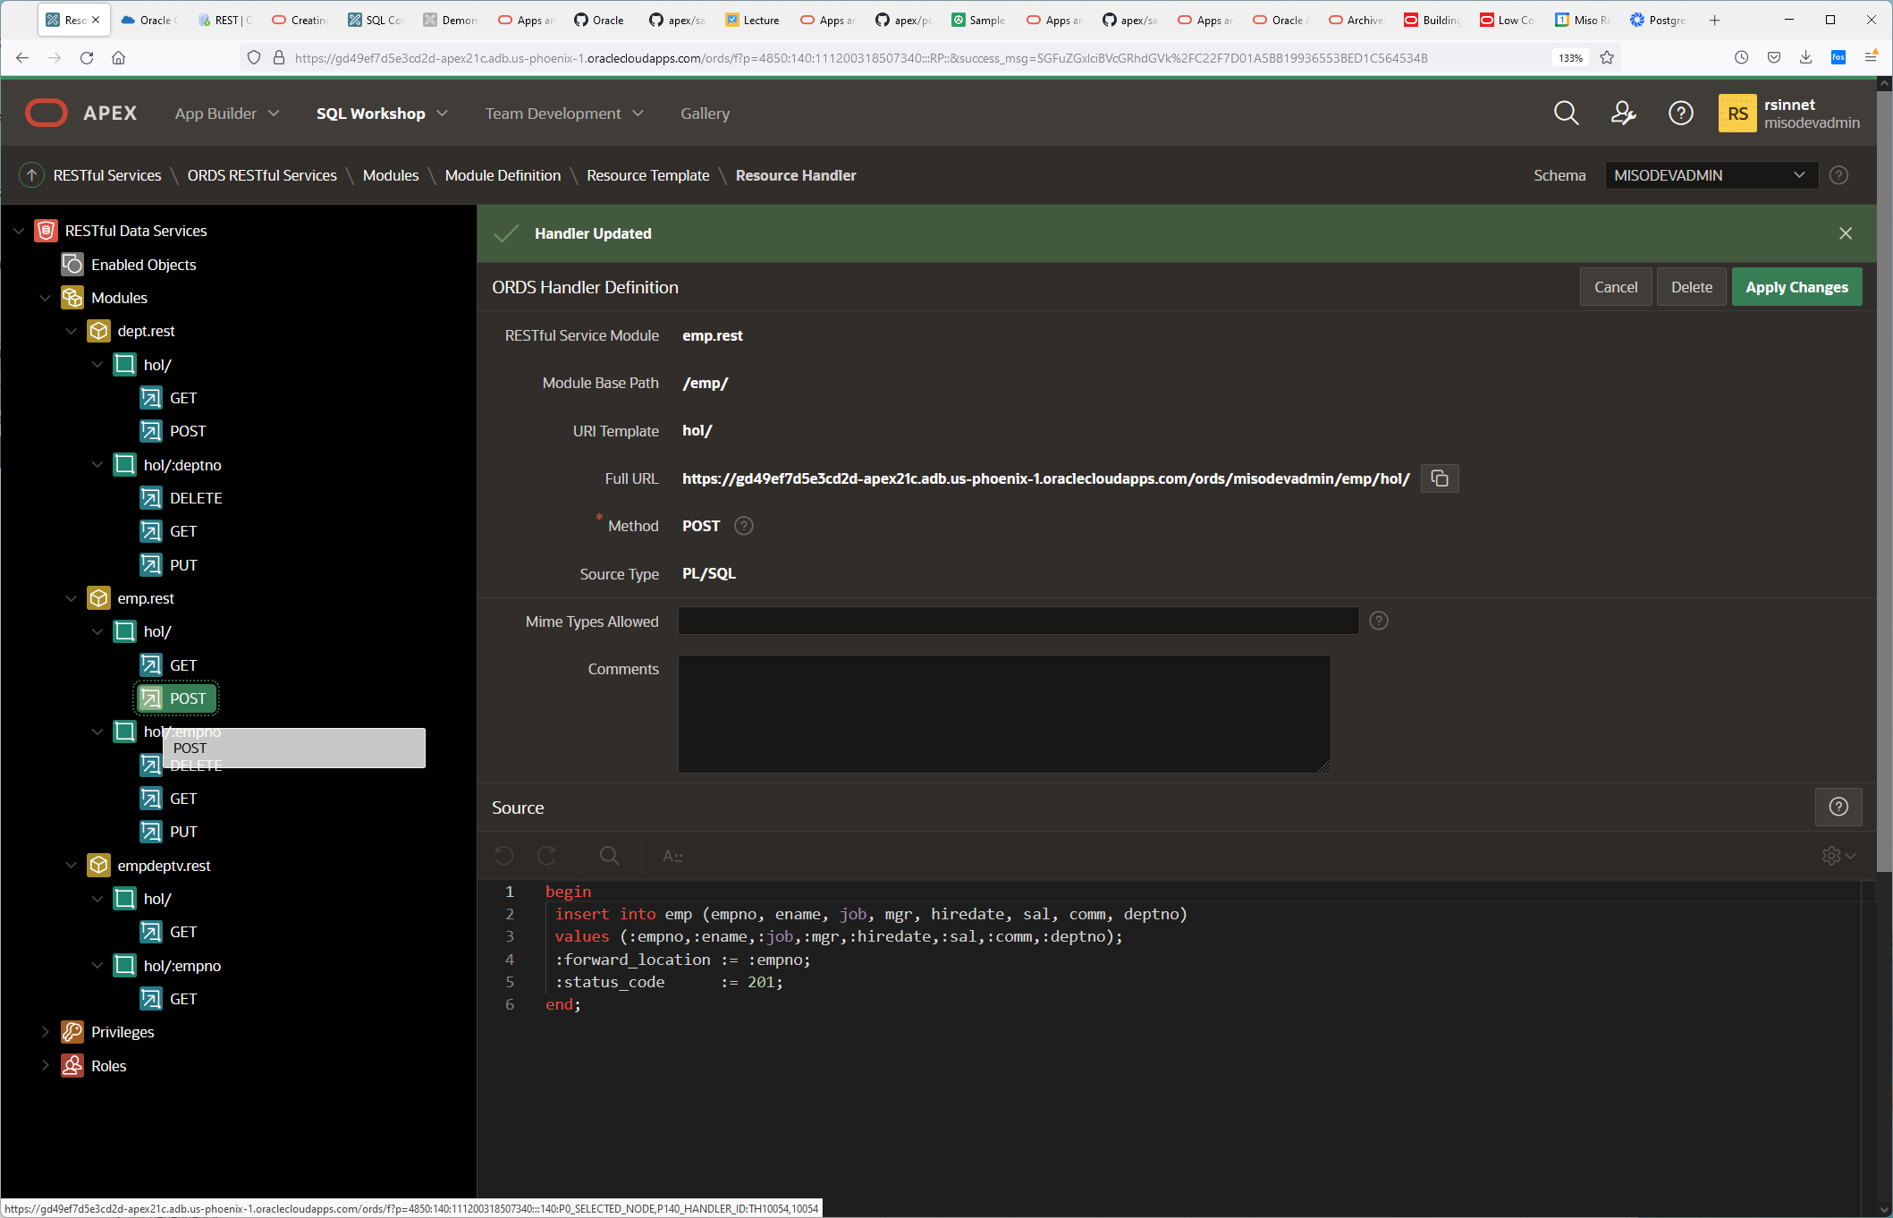

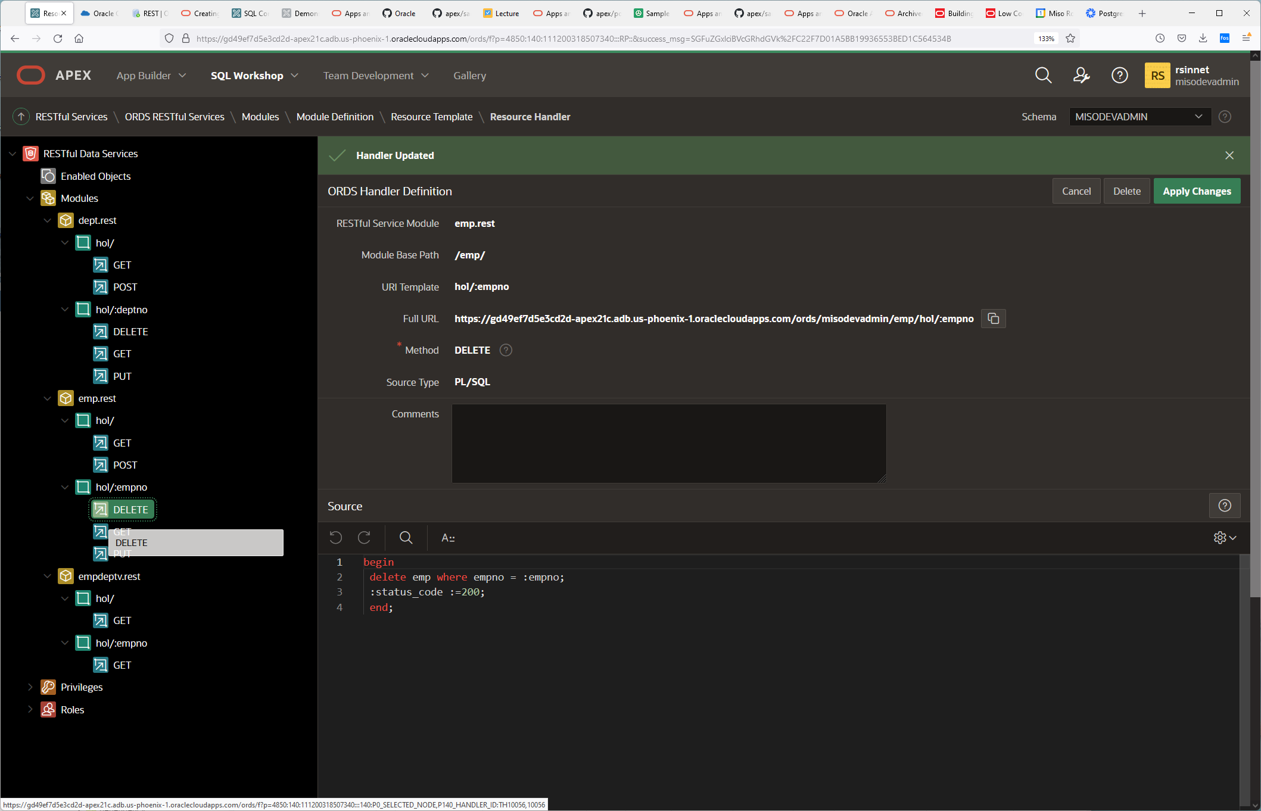

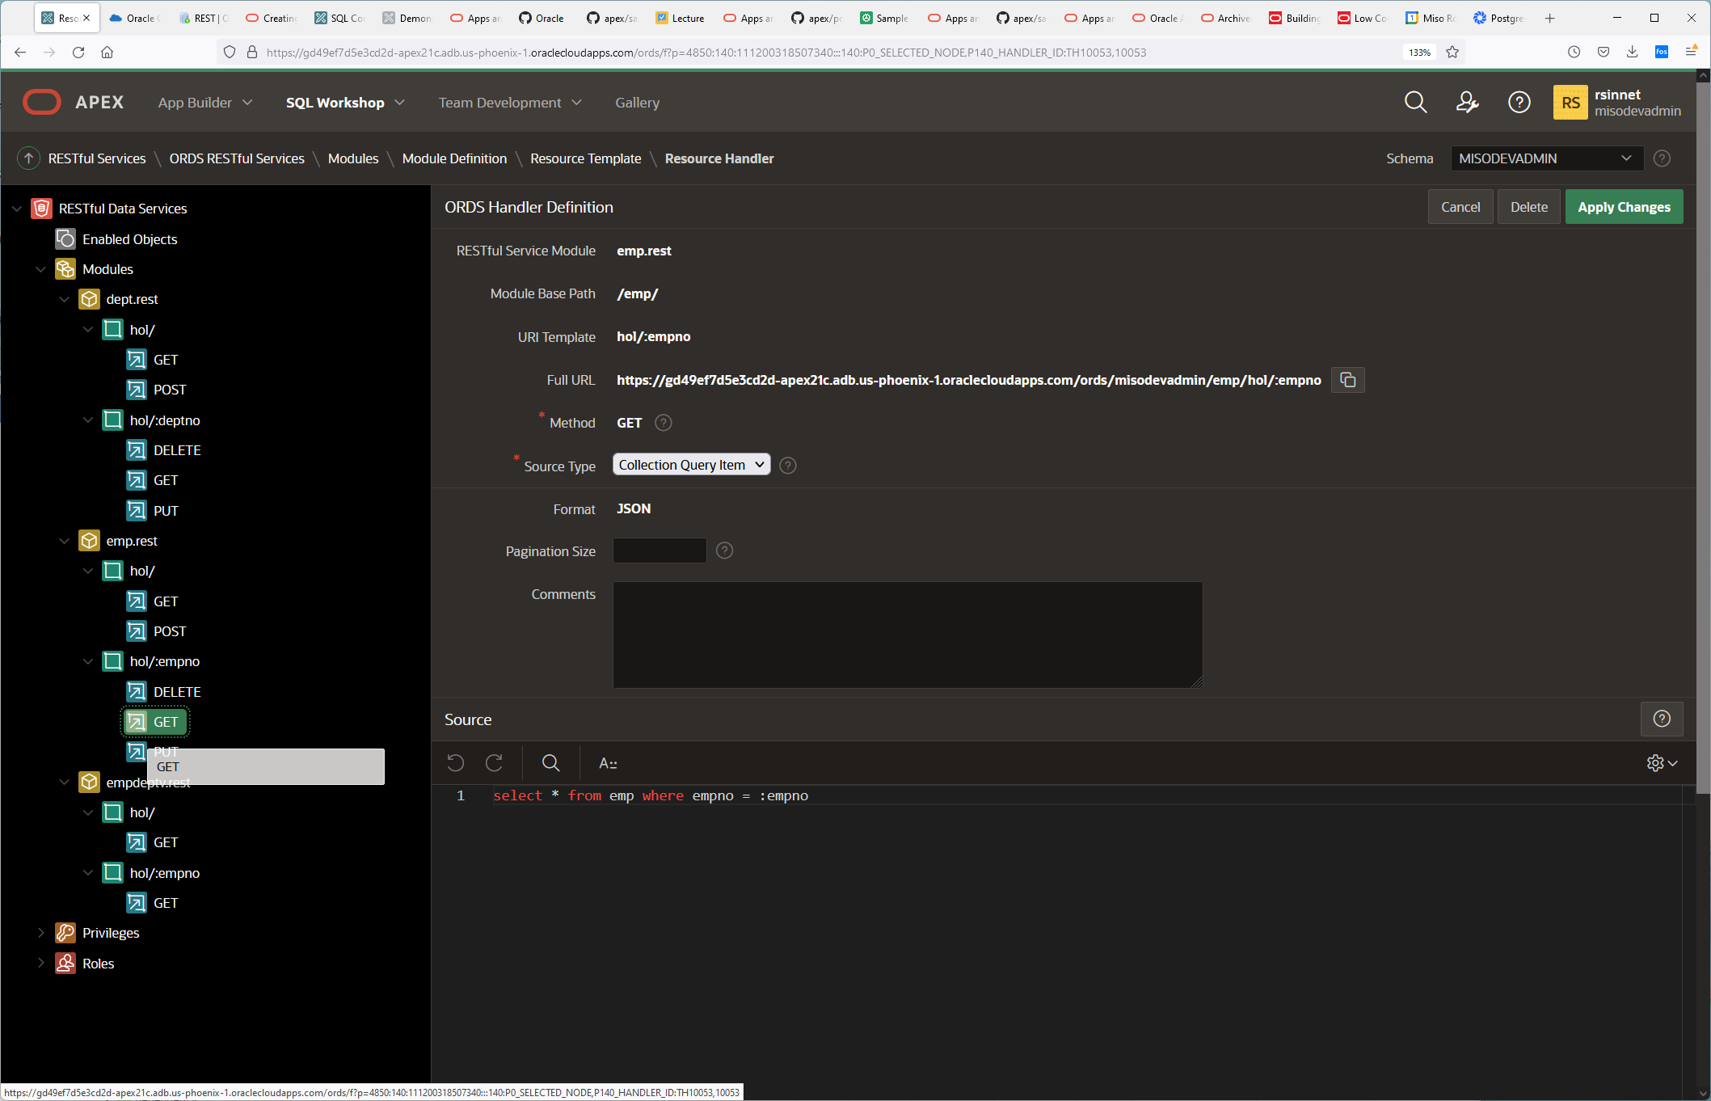

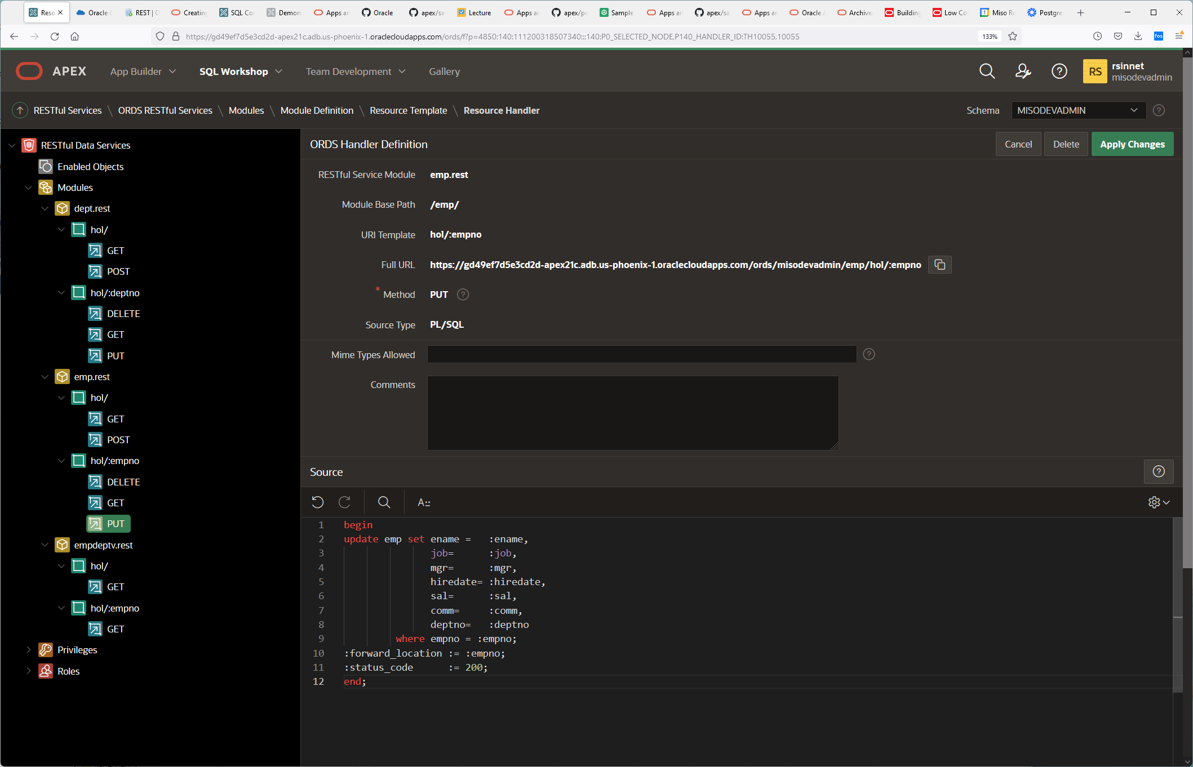

1. Open a new tab/window in your browser and paste the Full URL. Keep this tab open or make a note of this URL because you will need it later.

At the module level , I will set pagination to Zero to get all rows instead.

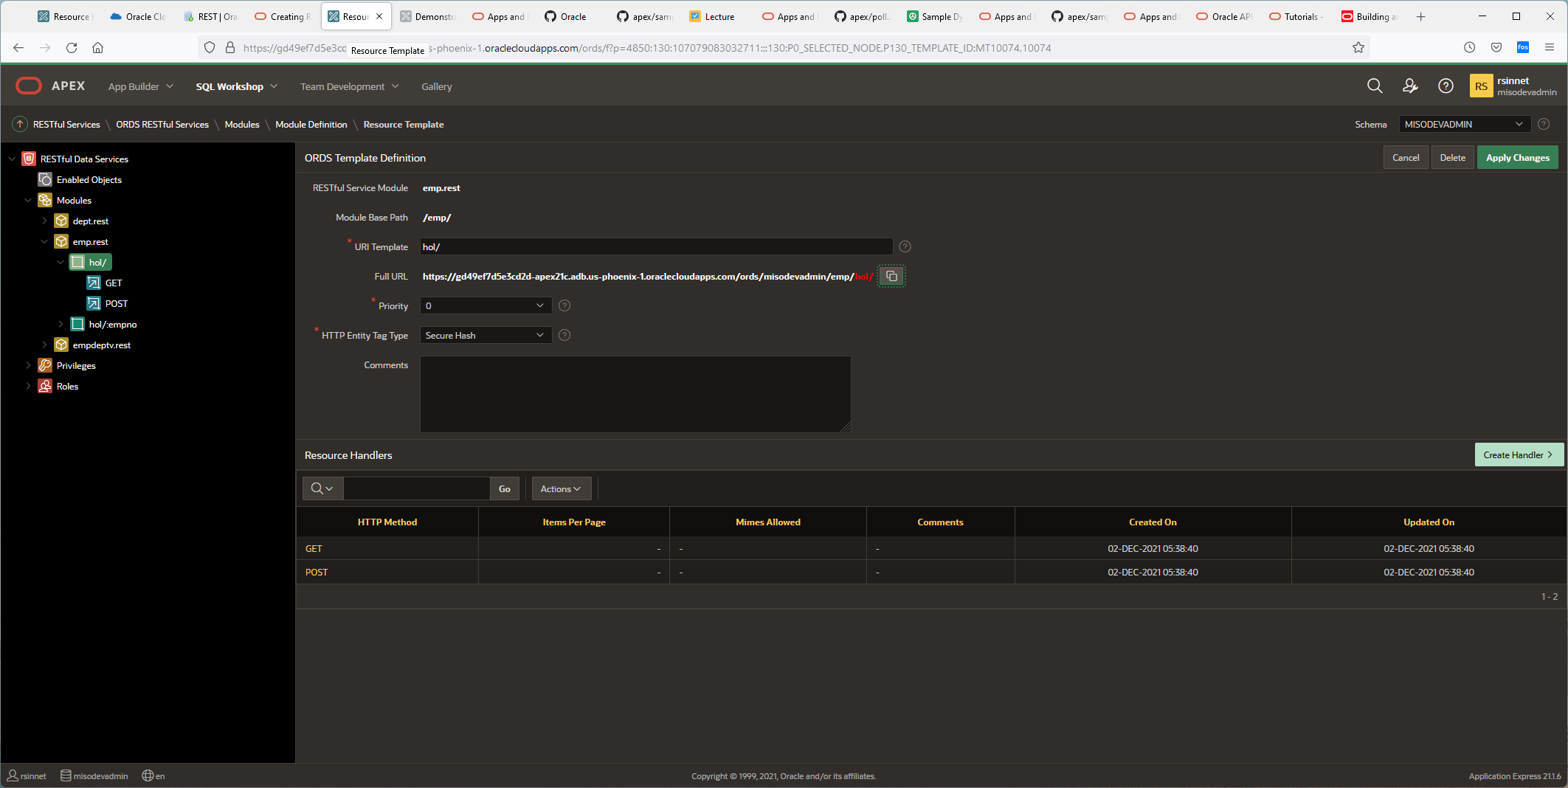

Because I have URI Template handle to accept parameters, I can pass in the PK value and get just that row.

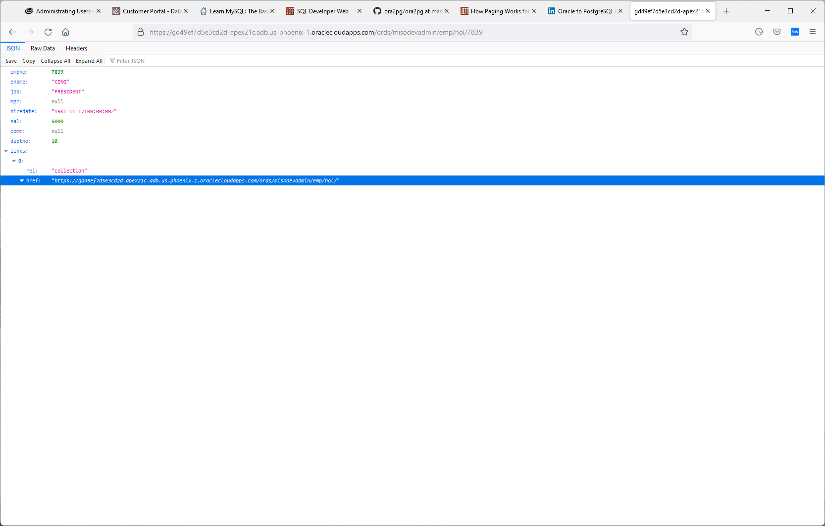

C:\Users\rmand>curl --location "https://gd49ef7d5e3cd2d-apex21c.adb.us-phoenix-1.oraclecloudapps.com/ords/misodevadmin/emp/hol/" --ssl-no-revoke

{"items":[{"empno":7839,"ename":"KING","job":"PRESIDENT","mgr":null,"hiredate":"1981-11-17T00:00:00Z","sal":5000,"comm":null,"deptno":10},{"empno":7698,"ename":"BLAKE","job":"MANAGER","mgr":7839,"hiredate":"1981-05-01T00:00:00Z","sal":2850,"comm":null,"deptno":30},{"empno":7782,"ename":"CLARK","job":"MANAGER","mgr":7839,"hiredate":"1981-06-09T00:00:00Z","sal":2450,"comm":null,"deptno":10},{"empno":7566,"ename":"JONES","job":"MANAGER","mgr":7839,"hiredate":"1981-04-02T00:00:00Z","sal":2975,"comm":null,"deptno":20},{"empno":7788,"ename":"SCOTT","job":"ANALYST","mgr":7566,"hiredate":"1982-12-09T00:00:00Z","sal":3000,"comm":null,"deptno":20},{"empno":7902,"ename":"FORD","job":"ANALYST","mgr":7566,"hiredate":"1981-12-03T00:00:00Z","sal":3000,"comm":null,"deptno":20},{"empno":7369,"ename":"SMITH","job":"CLERK","mgr":7902,"hiredate":"1980-12-17T00:00:00Z","sal":800,"comm":null,"deptno":20},{"empno":7499,"ename":"ALLEN","job":"SALESMAN","mgr":7698,"hiredate":"1981-02-20T00:00:00Z","sal":1600,"comm":300,"deptno":30},{"empno":7521,"ename":"WARD","job":"SALESMAN","mgr":7698,"hiredate":"1981-02-22T00:00:00Z","sal":1250,"comm":500,"deptno":30},{"empno":7654,"ename":"MARTIN","job":"SALESMAN","mgr":7698,"hiredate":"1981-09-28T00:00:00Z","sal":1250,"comm":1400,"deptno":30},{"empno":7844,"ename":"TURNER","job":"SALESMAN","mgr":7698,"hiredate":"1981-09-08T00:00:00Z","sal":1500,"comm":0,"deptno":30},{"empno":7876,"ename":"ADAMS","job":"CLERK","mgr":7788,"hiredate":"1983-01-12T00:00:00Z","sal":1100,"comm":null,"deptno":20},{"empno":7900,"ename":"JAMES","job":"CLERK","mgr":7698,"hiredate":"1981-12-03T00:00:00Z","sal":950,"comm":null,"deptno":30},{"empno":7934,"ename":"MILLER","job":"CLERK","mgr":7782,"hiredate":"1982-01-23T00:00:00Z","sal":1300,"comm":null,"deptno":10}],"hasMore":false,"limit":0,"offset":0,"count":14,"links":[{"rel":"self","href":"https://gd49ef7d5e3cd2d-apex21c.adb.us-phoenix-1.oraclecloudapps.com/ords/misodevadmin/emp/hol/"},{"rel":"edit","href":"https://gd49ef7d5e3cd2d-apex21c.adb.us-phoenix-1.oraclecloudapps.com/ords/misodevadmin/emp/hol/"},{"rel":"describedby","href":"https://gd49ef7d5e3cd2d-apex21c.adb.us-phoenix-1.oraclecloudapps.com/ords/misodevadmin/metadata-catalog/emp/hol/"}]}

C:\Users\rmand>curl --location "https://gd49ef7d5e3cd2d-apex21c.adb.us-phoenix-1.oraclecloudapps.com/ords/misodevadmin/emp/hol/7839" --ssl-no-revoke

{"empno":7839,"ename":"KING","job":"PRESIDENT","mgr":null,"hiredate":"1981-11-17T00:00:00Z","sal":5000,"comm":null,"deptno":10,"links":[{"rel":"collection","href":"https://gd49ef7d5e3cd2d-apex21c.adb.us-phoenix-1.oraclecloudapps.com/ords/misodevadmin/emp/hol/"}]}

If I click on GET, I can alter the API using any sql provided accordingly:

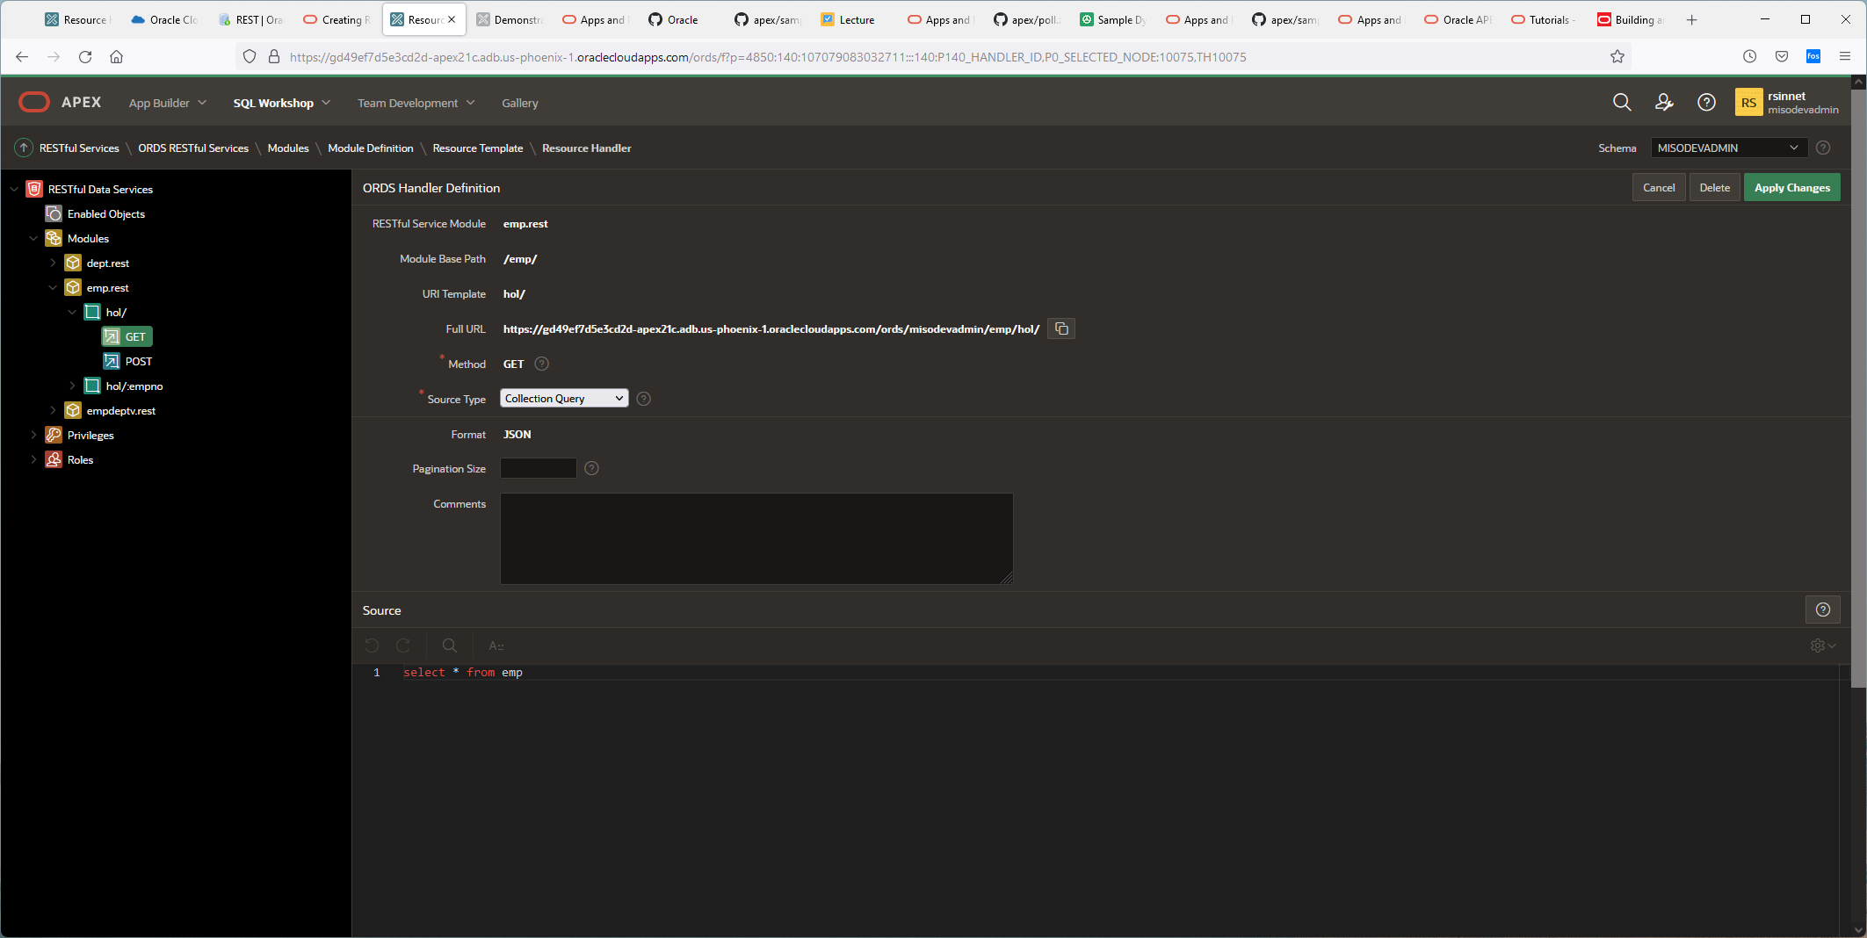

Enter the source implementation for the selected HTTP method. The implementation may be a simple SQL statement or a complex PL/SQL block. Source implementations may reference values from the URL, HTTP Headers or HTTP Body using standard bind variable syntax.   
  
For example, the implementation of a GET method with the following URI:

http://example.com/ords/mySchema/hr/employees/:id

might have the follwoing source implementation which references the ID passed on the URL:

select * from emp

where empno = :id

Alternatively, the implemantation of a PUT method with the same URI:

http://example.com/ords/mySchema/hr/employees/:id

along with the following Parameter definitions:

|  |  |  |  |  |
| --- | --- | --- | --- | --- |
| **Name** | **Bind Variable** | **Source Type** | **Access Method** | **Data Type** |
| ID | id | HTTP Header | IN | STRING |
| X-APEX-FORWARD | location | HTTP Header | OUT | STRING |
| X-APEX-STATUS-CODE | status | HTTP Header | out | INTEGER |

might have the follwoing source implementation:

begin

update emp set ename = :ename,

job = :job,

hiredate = :hiredate,

mgr = :mgr,

sal = :sal,

comm = :comm,

deptno = :deptno

where empno = :id;

--

:status := 200;

:location := :id;

--

exception

when others then

:status := 400;

end;

**Note:** Values referenced by bind variables that are not passed on the URL or in the HTTP header are passed across as part of the HTTP bodyin a format matching that designated in the method definition. For instance a JSON package as follows:

{ "empno": 7369,

"ename": "SMITH",

"job": "CLERK",

"hiredate": "1980-12-17T08:00:00Z",

"mgr": 7902,

"sal": 800,

"deptno": 20

}

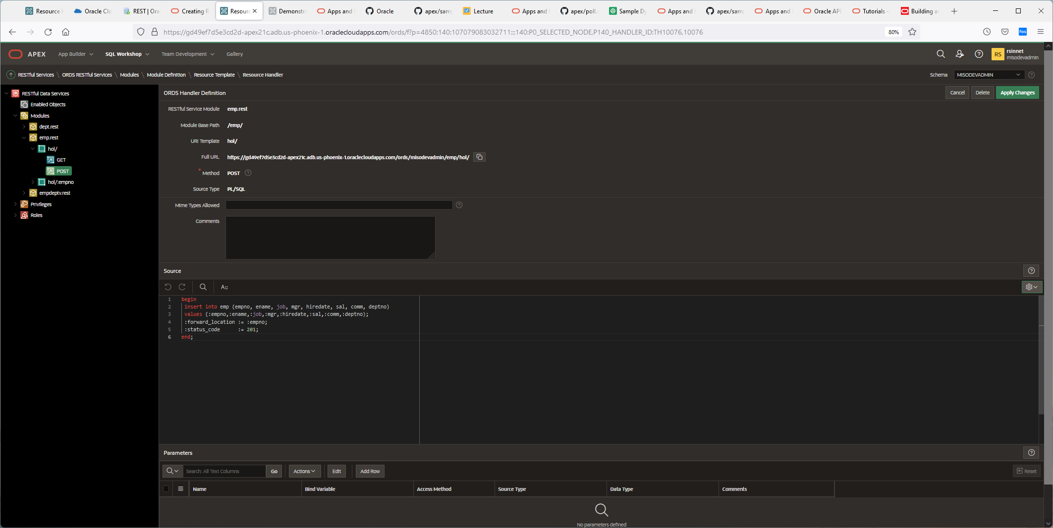

The parameters must be added into the header, body or URL.

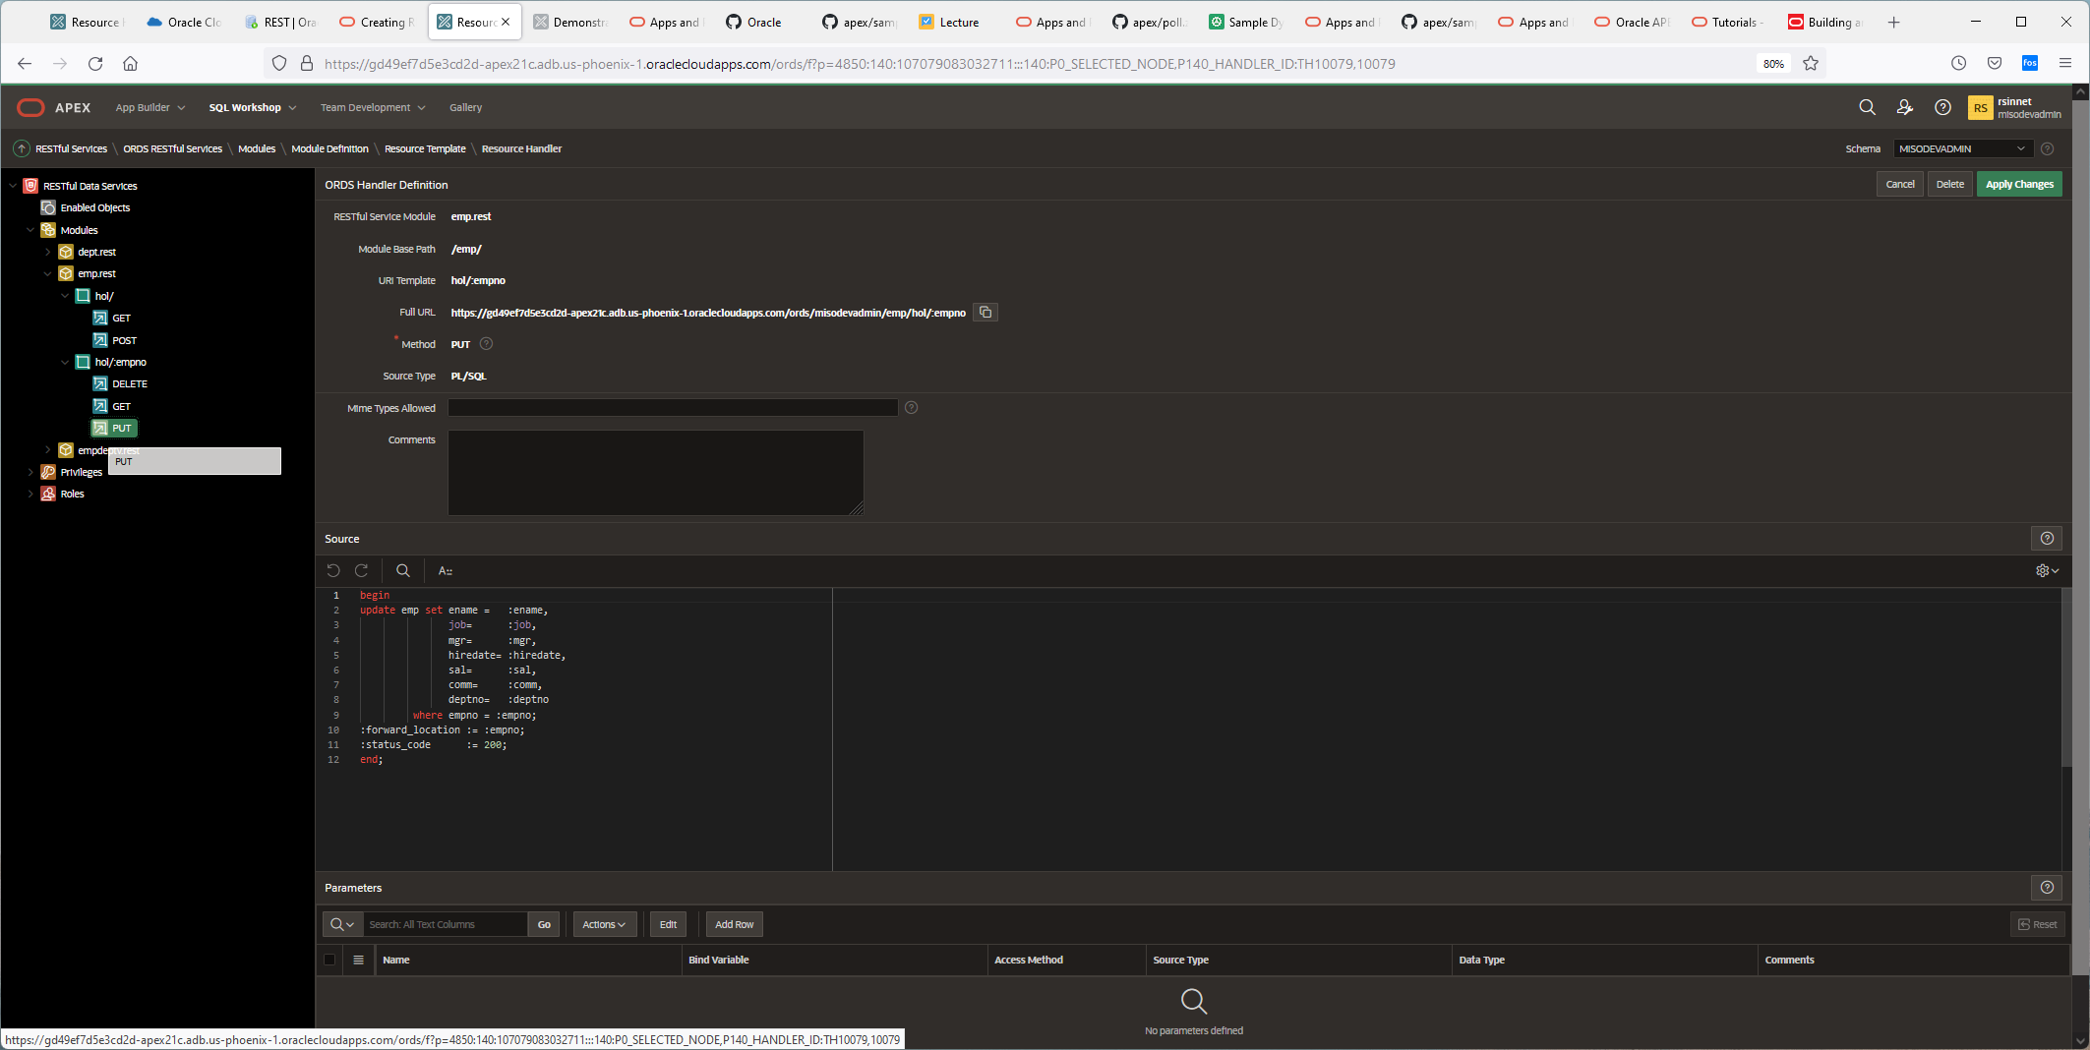

The API can be secured using privs and roles as seen below:

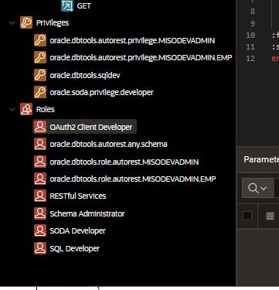

If we now create a new application that references those REST API’s, it looks like this.

• Create Application page, click **New Application**.

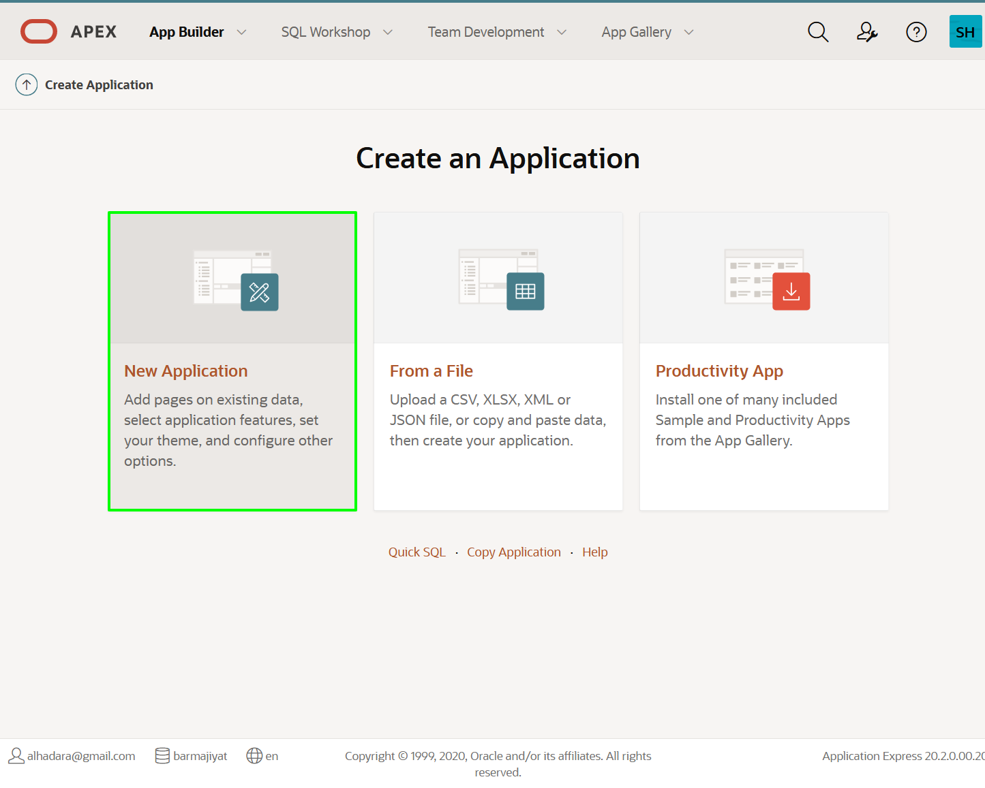

• On the Create an Application page, for Name, enter RYANS **REST Employees**.

Click **Create Application**.

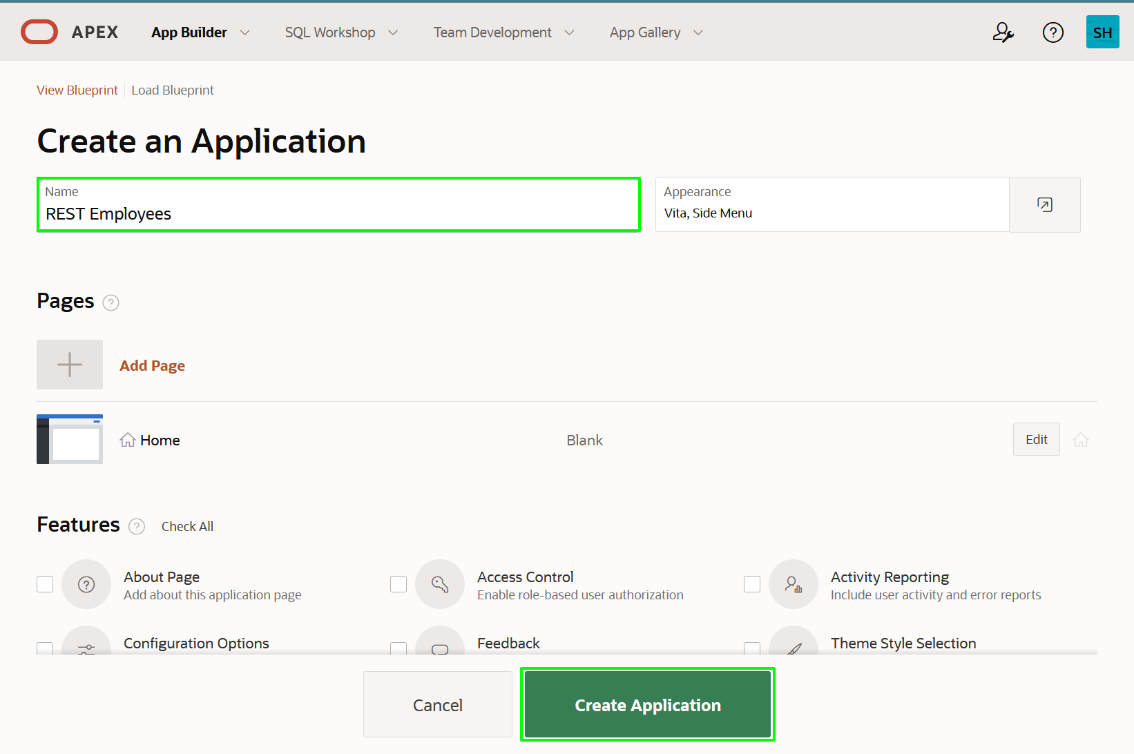

*Note: At this stage you do not want to add any pages as you have not yet defined the REST Data Source.*

Here is the first page, click on Shared Components.

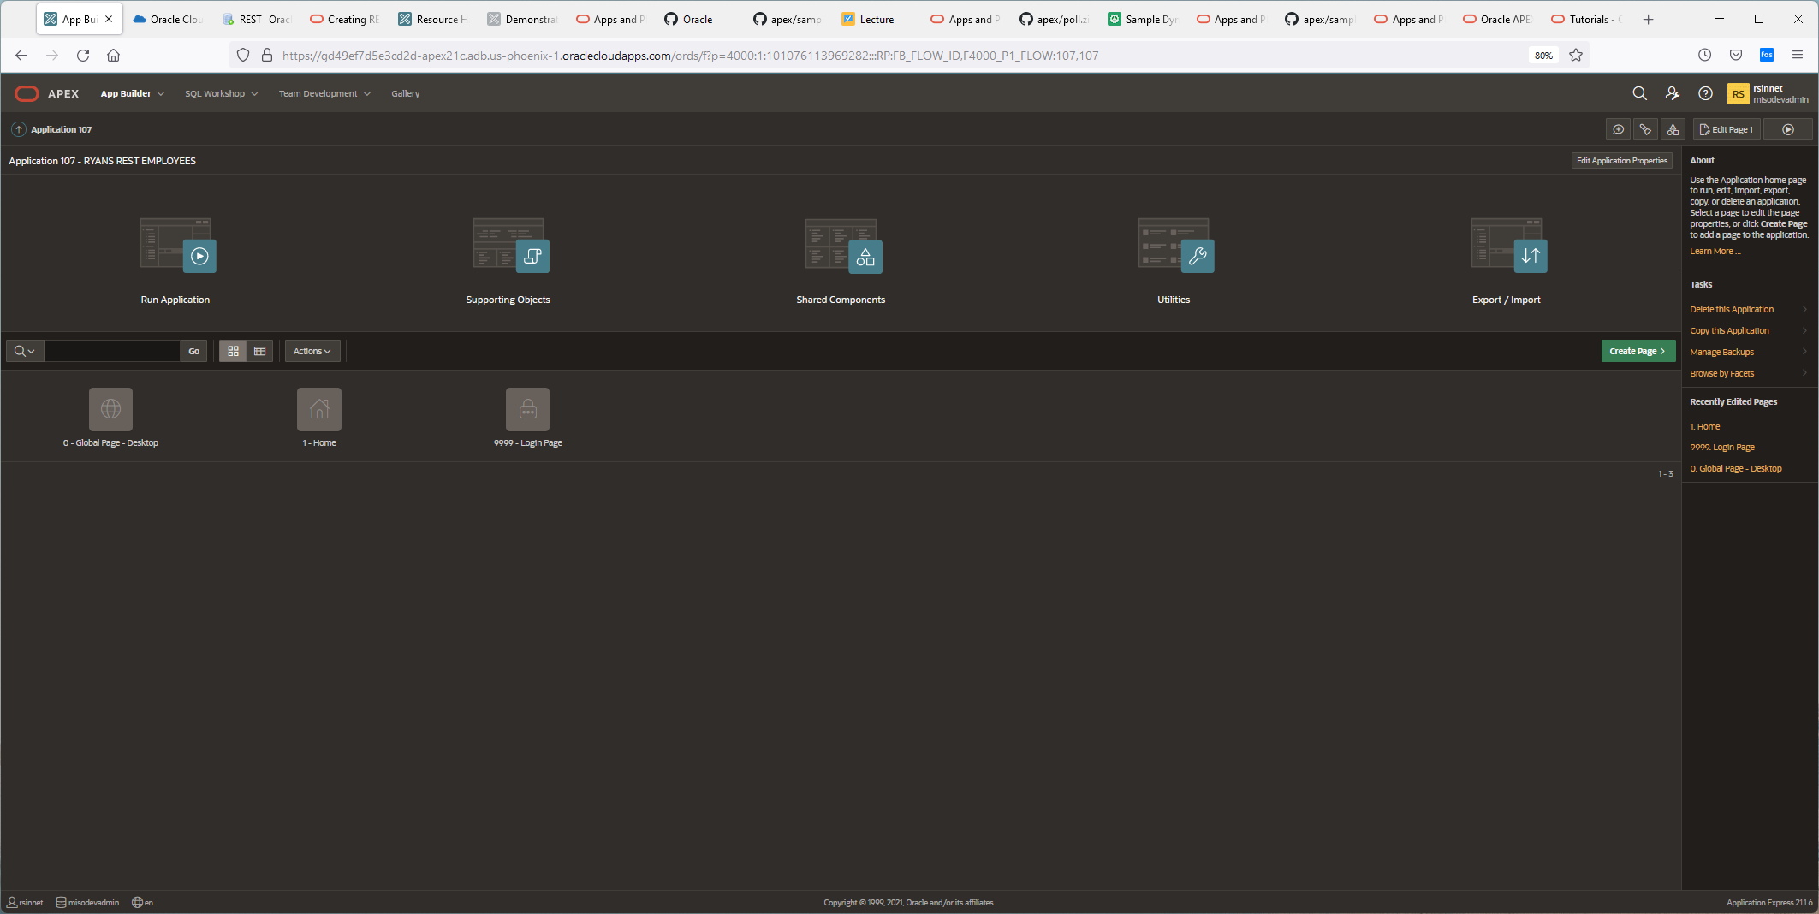

• Under **Data Sources**, click **REST Data Sources**.

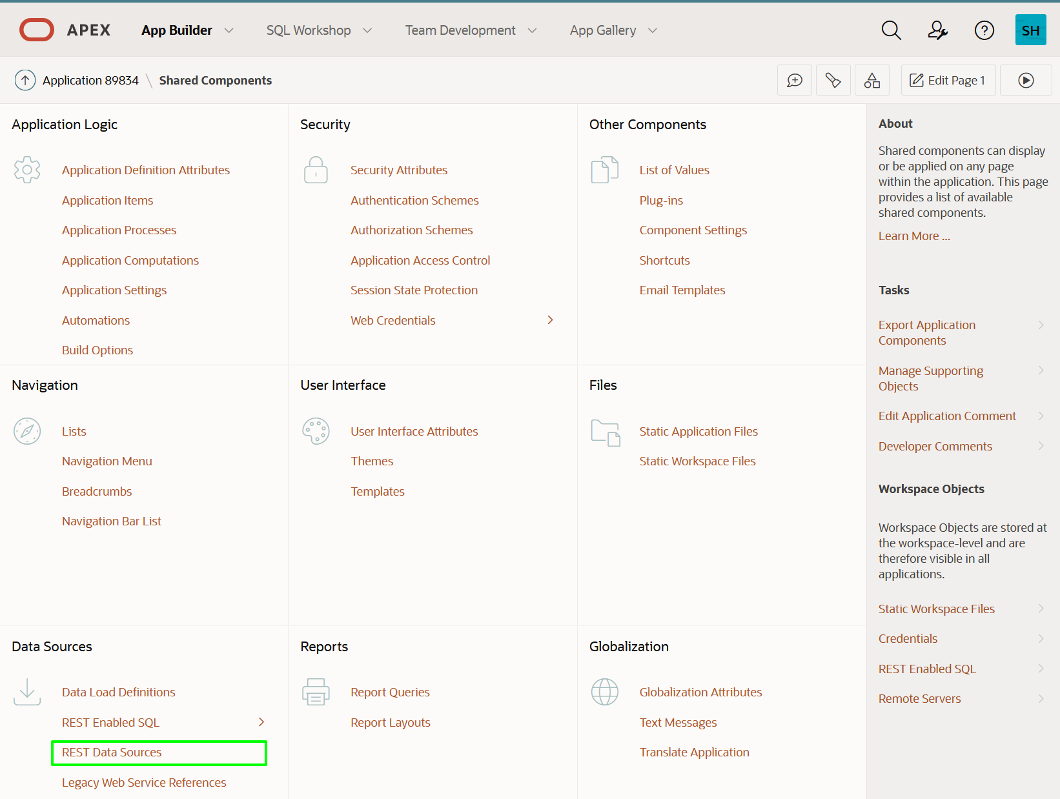

• On the REST Data Sources page, click **Create**.

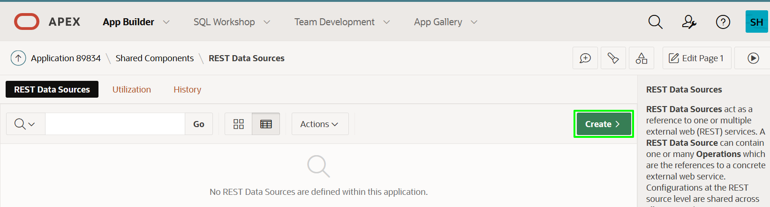

• For Method, click **Next**. *Default: From Scratch*

• *Scratch*

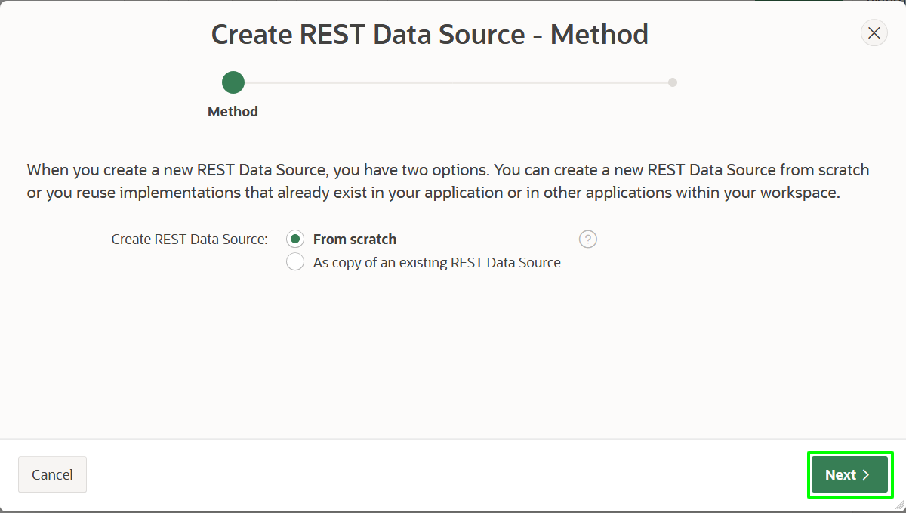

• In the Create REST Data Source wizard, on the General dialog, enter the following:

* **REST Data Source Type:** select **ORACLE REST Data Services**
* **Name:** enter **REST EMP Source**
* **URL Endpoint:** enter the REST URI you tested previously

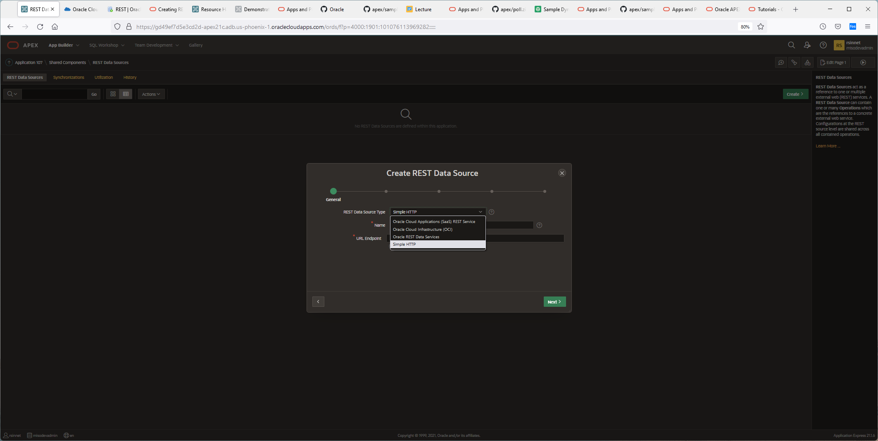

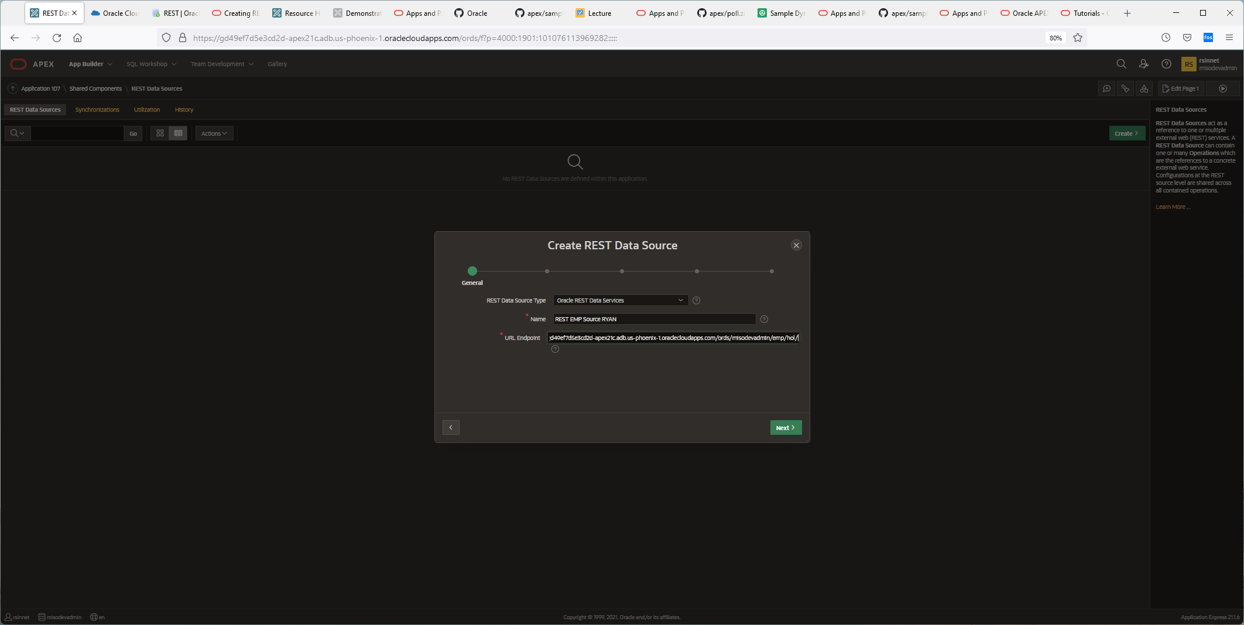

<https://gd49ef7d5e3cd2d-apex21c.adb.us-phoenix-1.oraclecloudapps.com/ords/misodevadmin/emp/hol/>

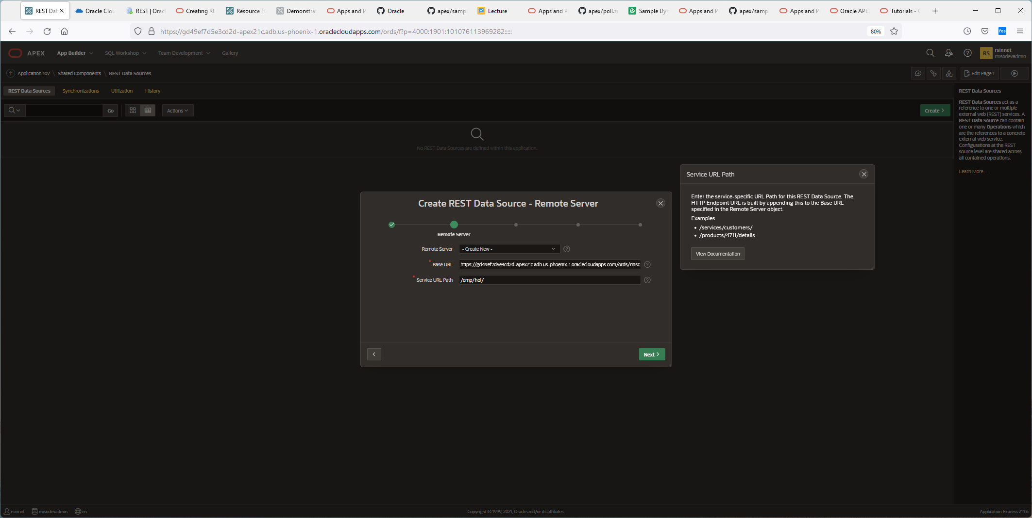

• On the Authentication dialog, click **Discover**.

* **Authentication Required:** Disabled/Grayed out

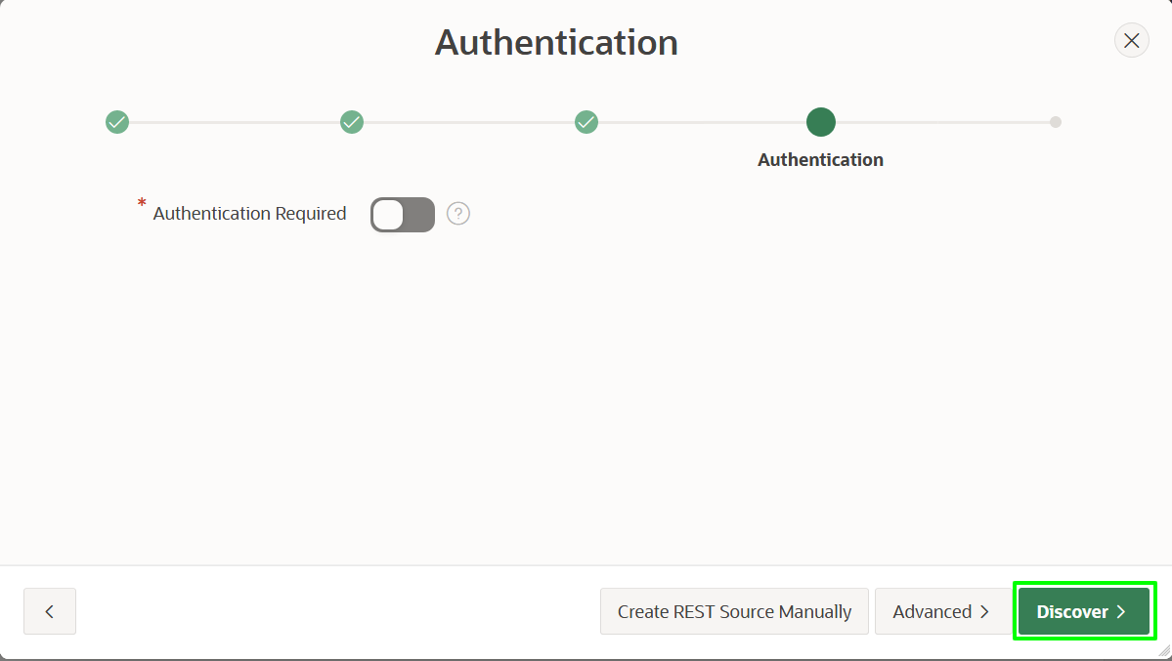

• On the Preview dialog, click **Create REST Data Source**.

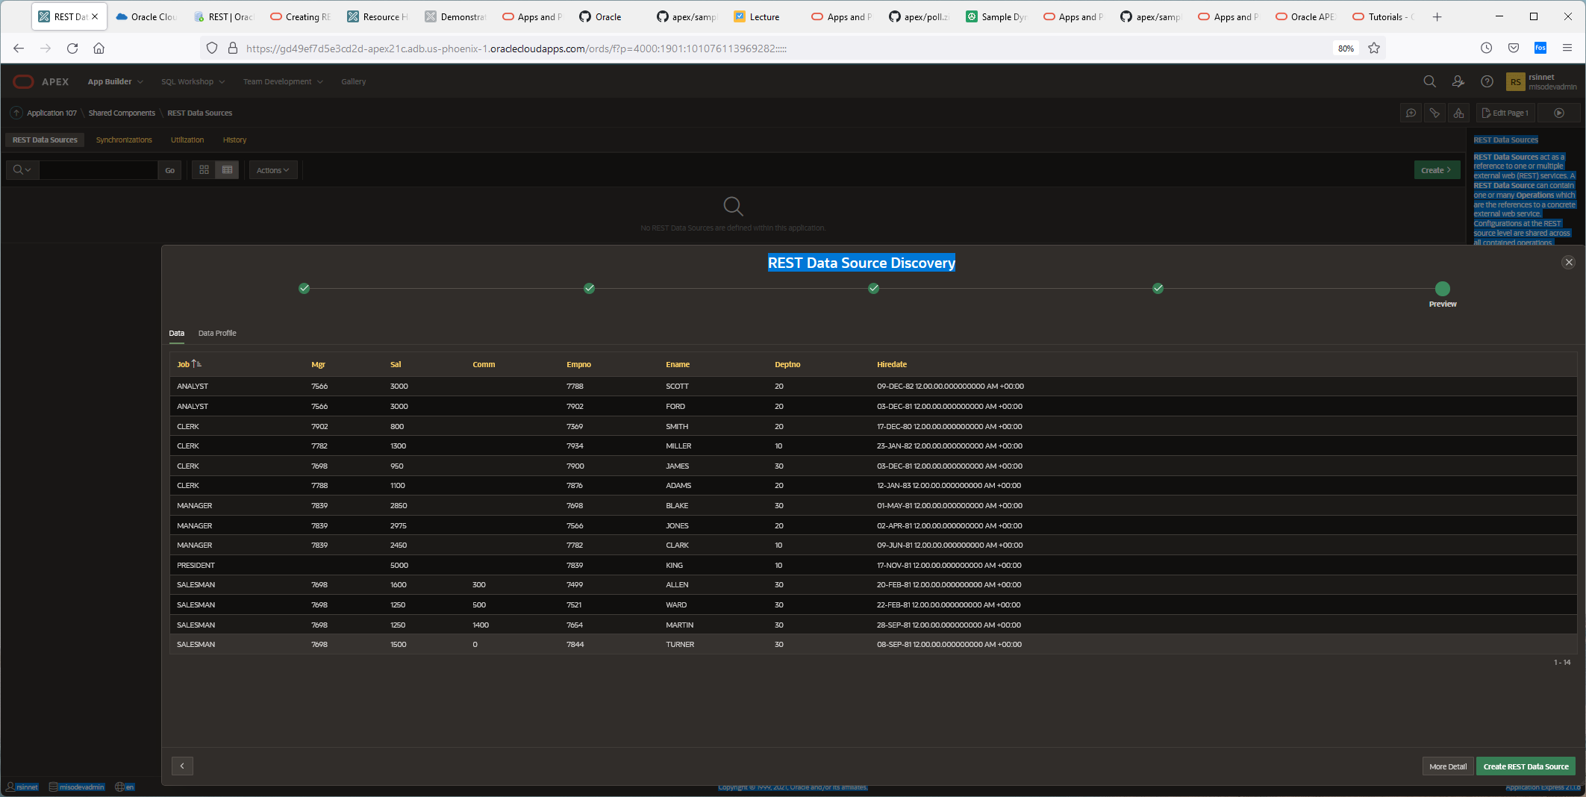

Click create button in green.

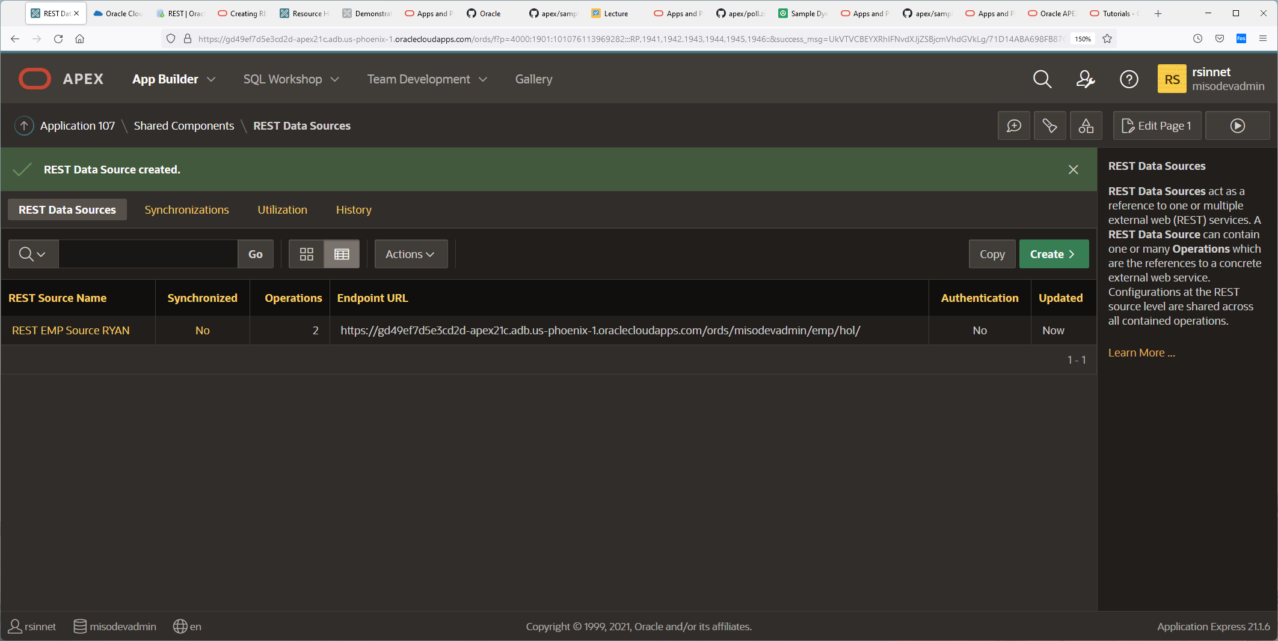

IF I click on REST SOURCE NAME in Yellow: [REST EMP Source RYAN](https://gd49ef7d5e3cd2d-apex21c.adb.us-phoenix-1.oraclecloudapps.com/ords/f?p=4000:1921:101076113969282::::P1921_WEB_SRC_MODULE_ID:10298625696251557)

## Adding Operations

Given the URL Endpoint used above, the **Create REST Data Source** operation determined that the **GET** and **POST** operations have been defined. You also defined handlers for **GET**, **PUT**, and **DELETE** for a specific employee record. Therefore, it is important to add additional operations for these handlers. If you do not add the operations then the relevant functionality will not be included, such as selecting a single record, updating a record, or deleting a record.

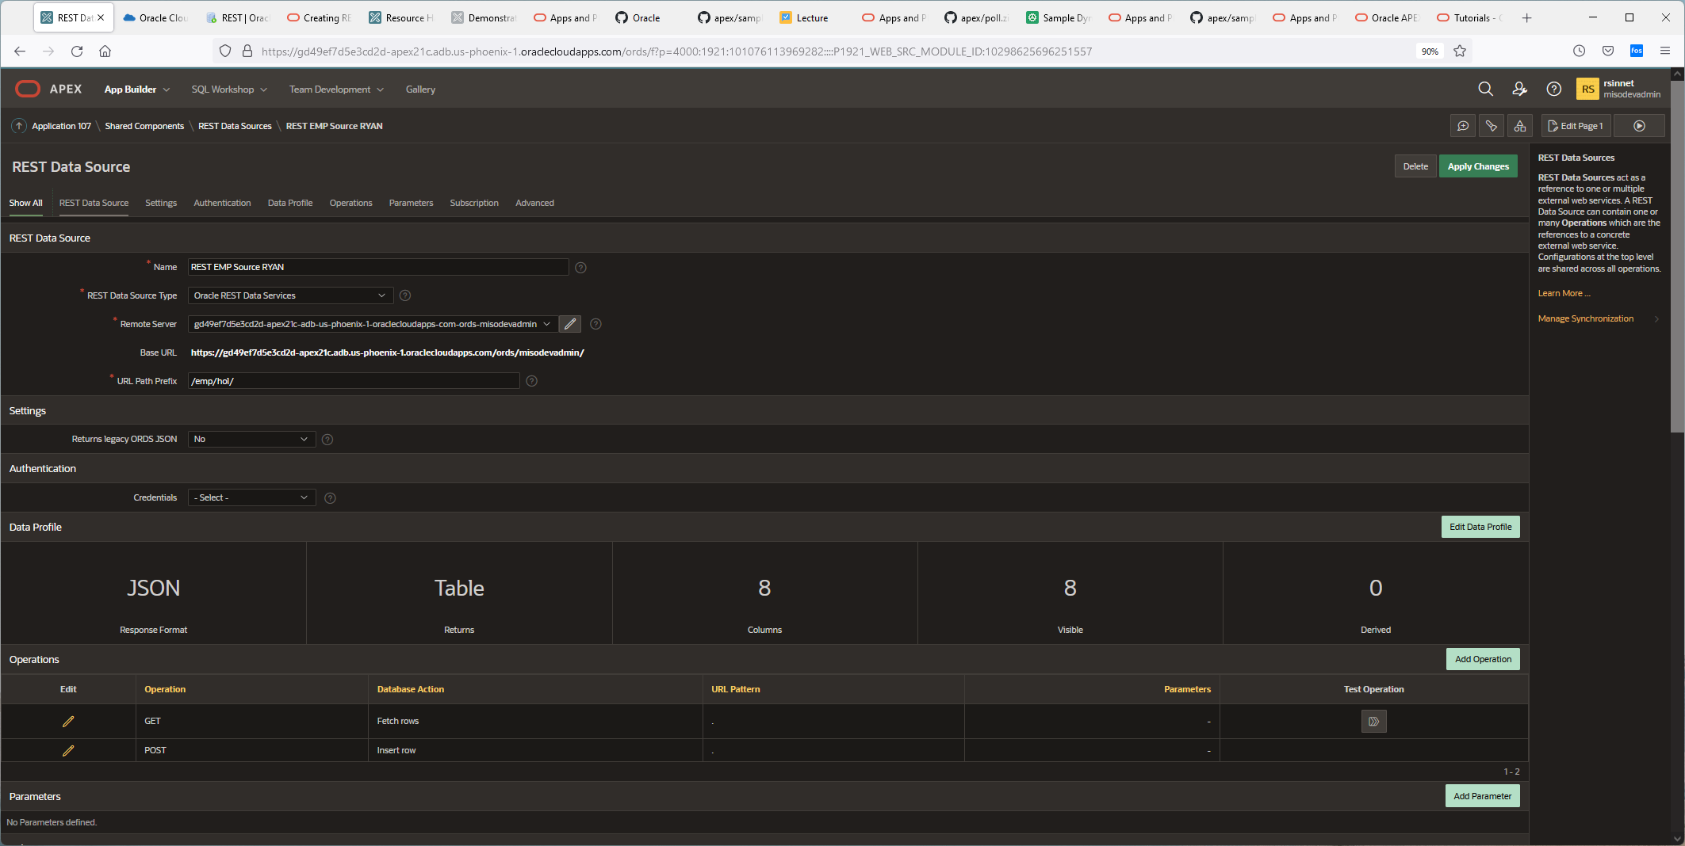

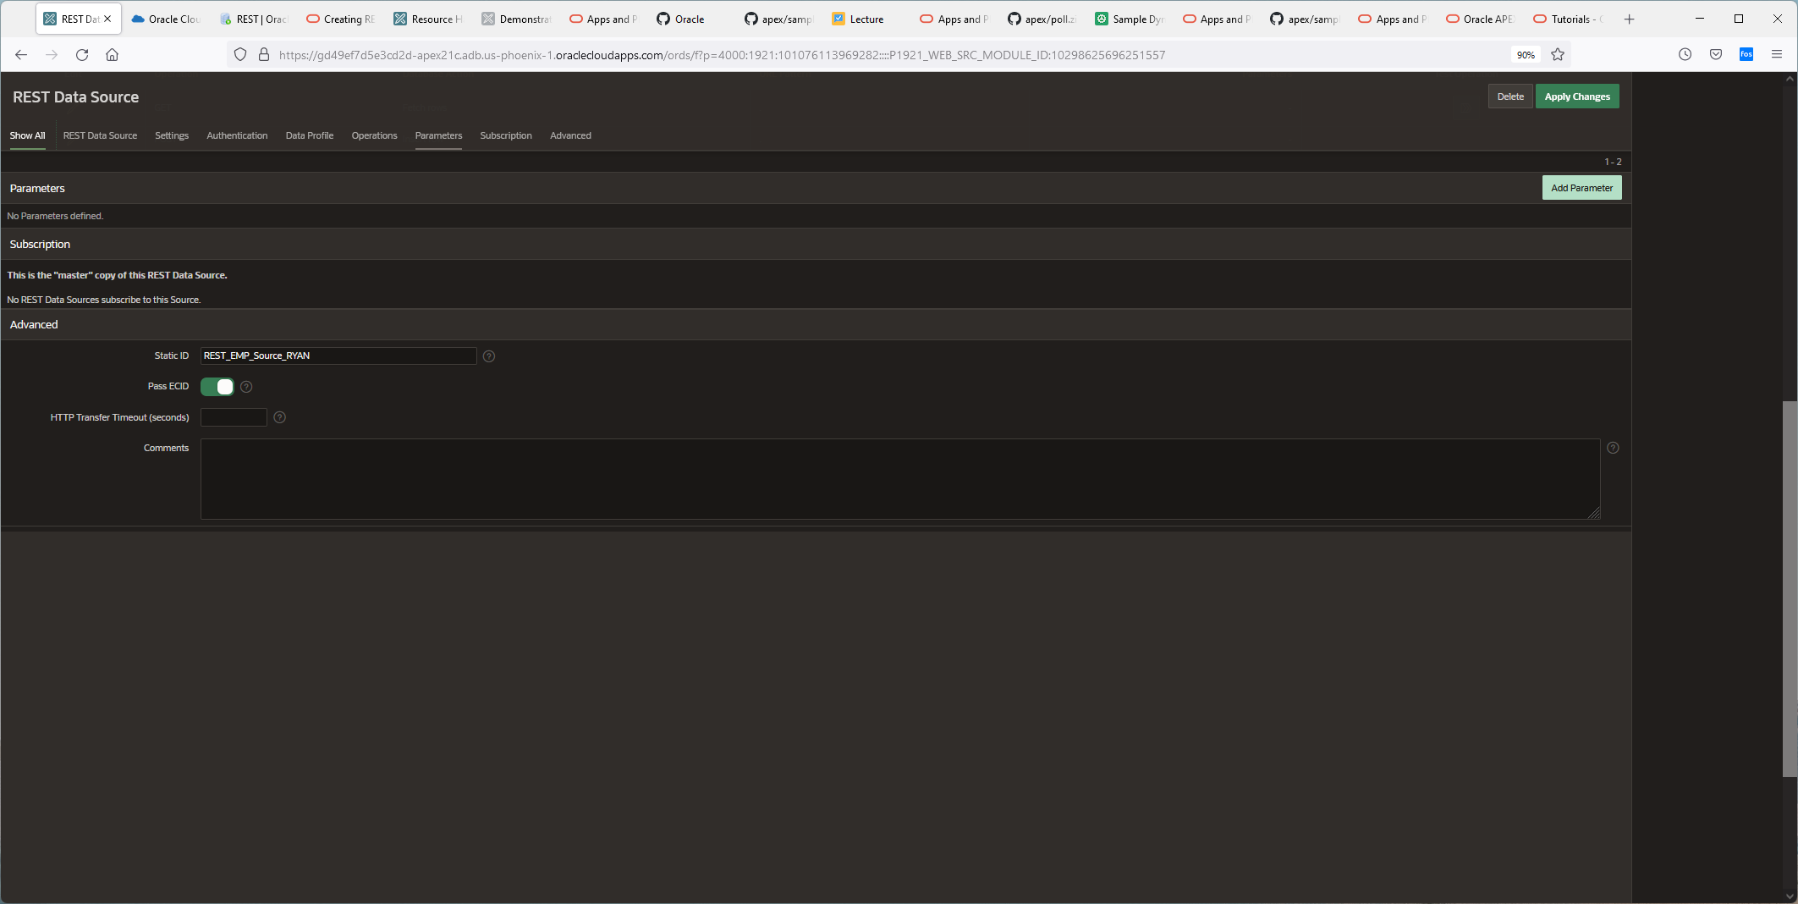

1. On REST EMP Source page, click **Add Operation**. You may need to scroll down to see operations.

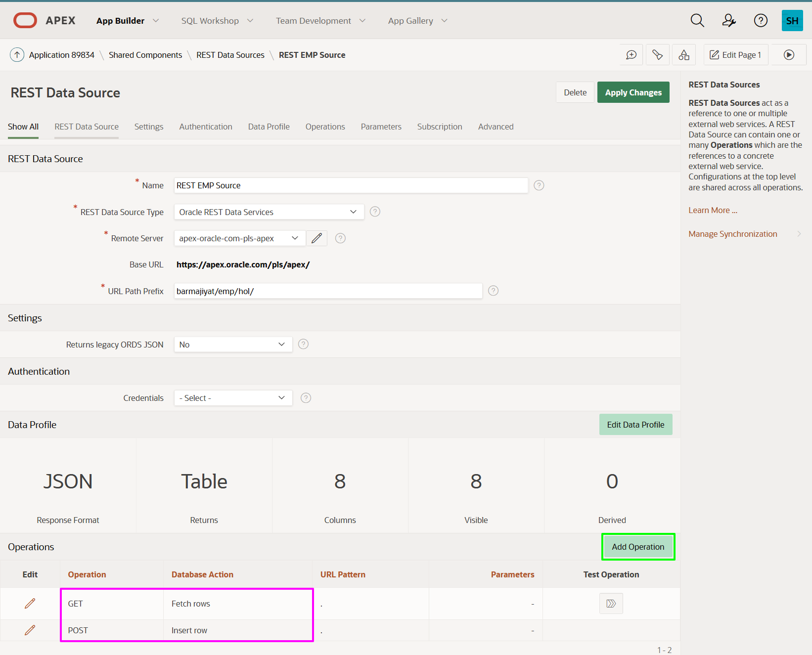

1. In the REST Source Operation page, enter the following.
   * **URL Pattern:** enter **:empno**
   * **HTTP Method:** select **GET**
   * **Database Operation:** select **Fetch single row**

Click **Create**.

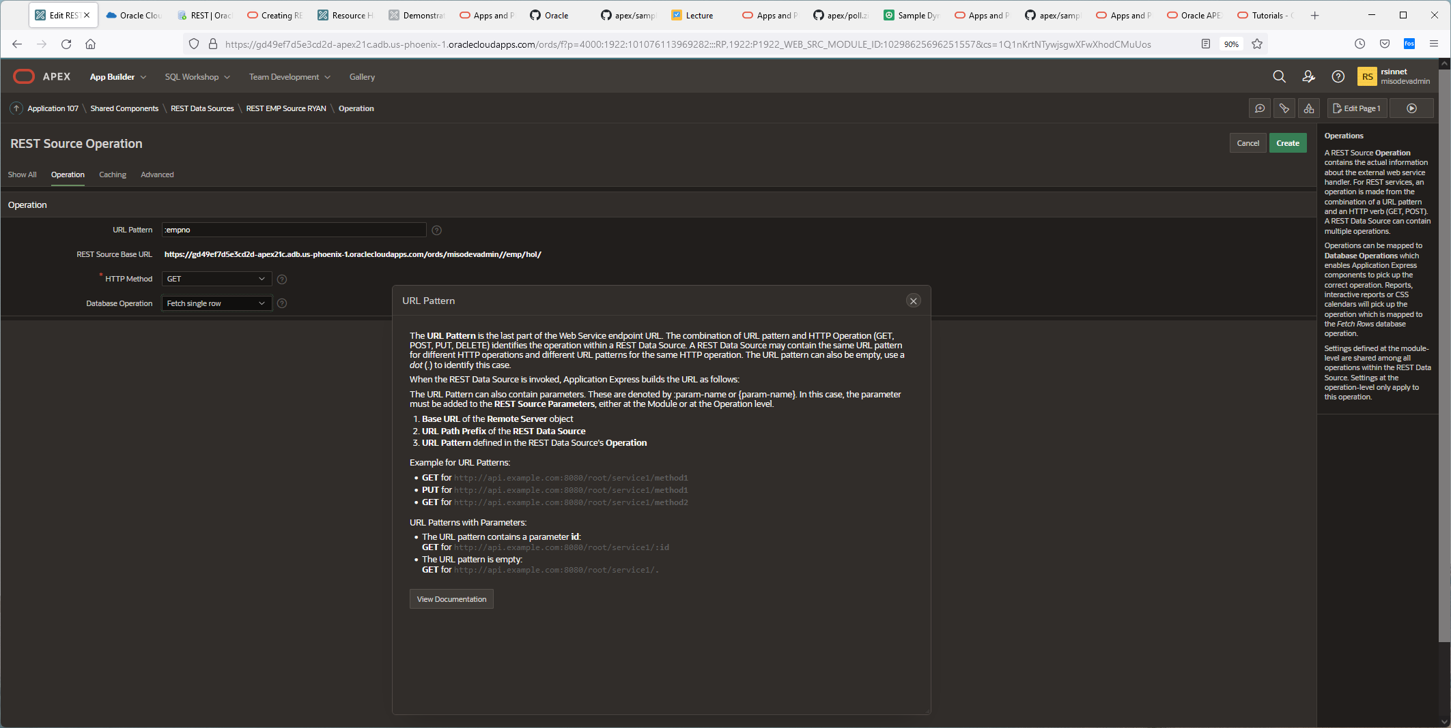

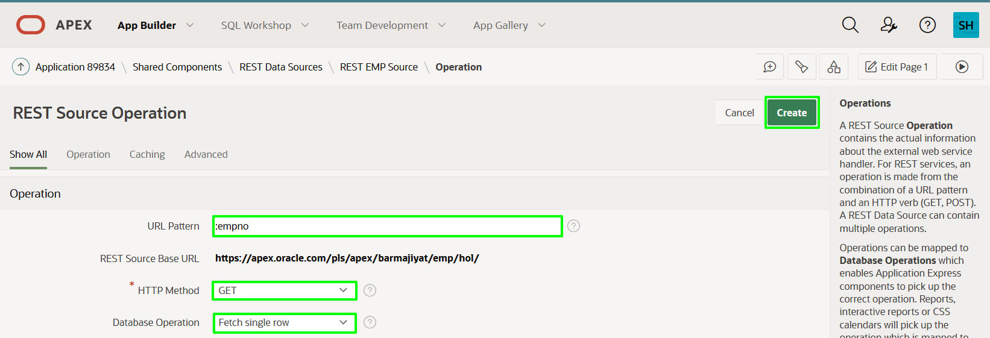

1. On REST EMP Source page, click **Add Operation**.

In the REST Source Operation page, enter the following.

* + **URL Pattern:** enter **:empno**
  + **HTTP Method:** select **PUT**
  + **Database Operation:** select **Update row**

Click **Create**.

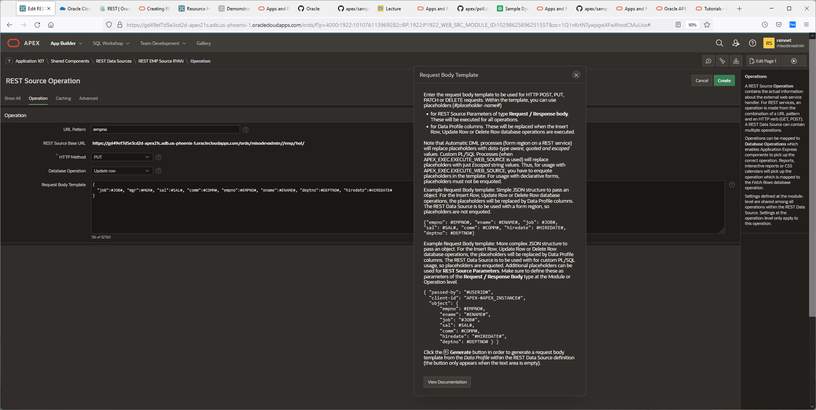

1. On REST EMP Source page, click **Add Operation**.

In the REST Source Operation page, enter the following.

* + **URL Pattern:** enter **:empno**
  + **HTTP Method:** select **DELETE**
  + **Database Operation:** select **Delete row**

Click **Create**.

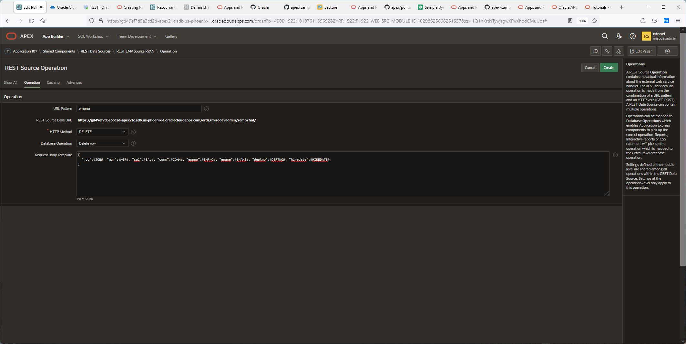

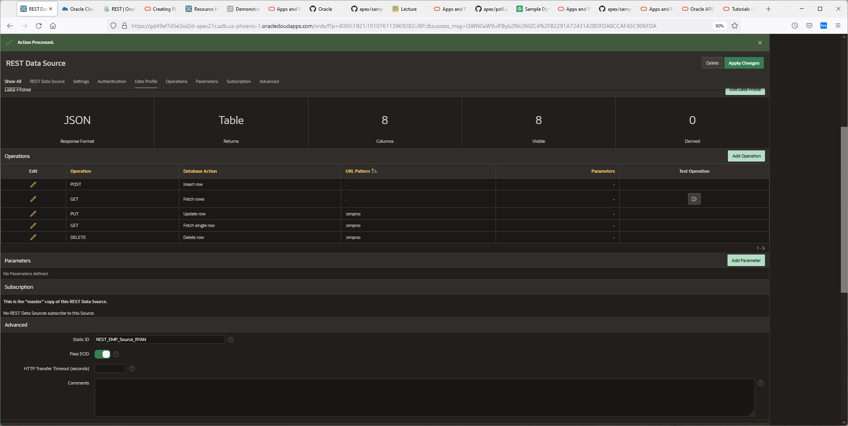

**Click on the application Ryans Rest Employees:**

**Use the Create Page Wizard**

1. Return to the Application Home Page.  
   Click **Create Page**.

On the Create a Page dialog, click **Report**.

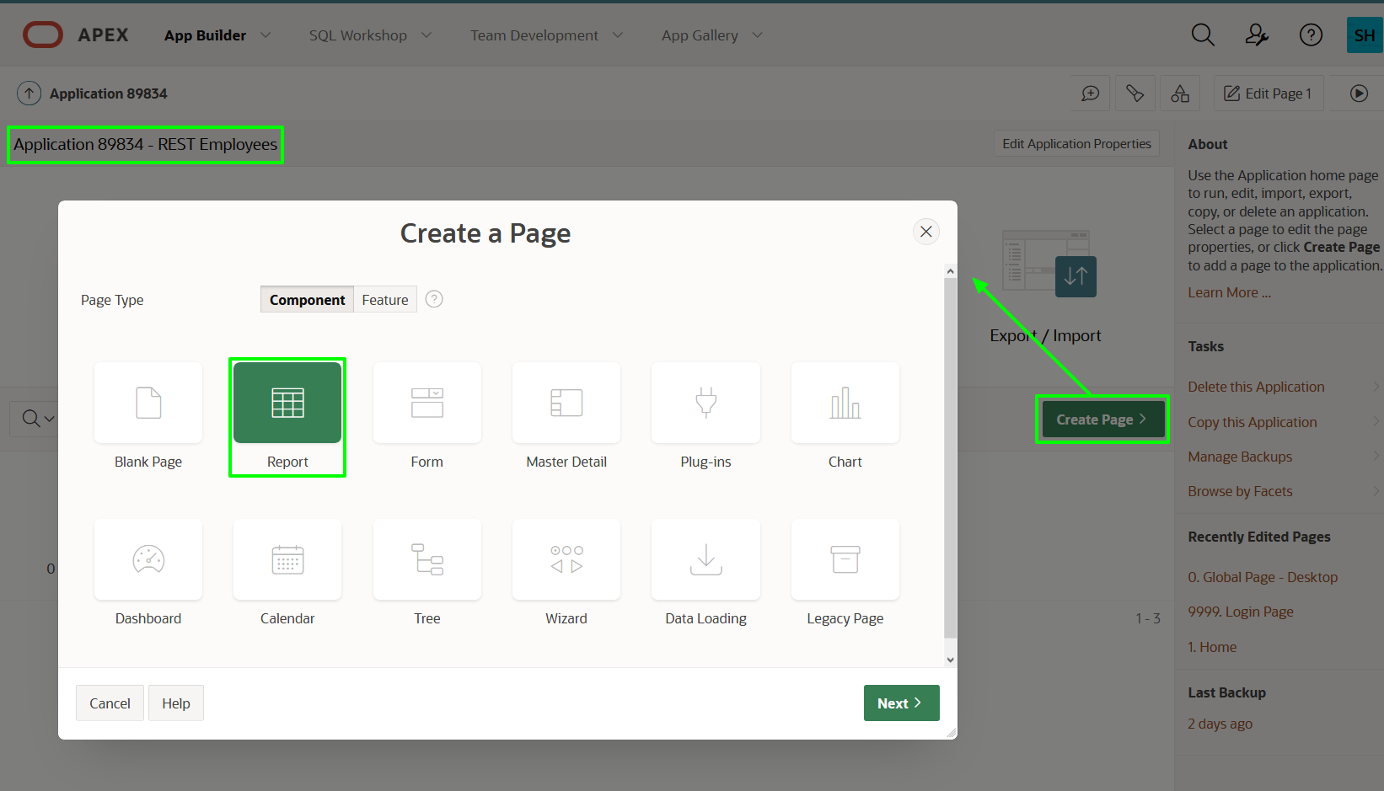

1. On the Create Page dialog, click **Report and Form**.

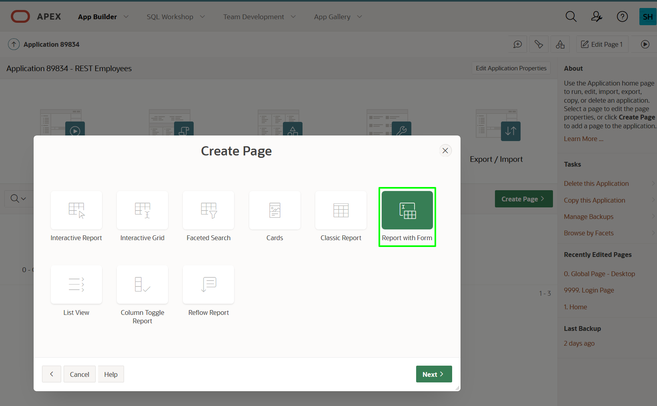

1. In the Create Report with Form dialog, for Page Attributes, enter the following.
   * **Report Page Name:** enter **Employees**
   * **Form Page Name:** enter **Maintain Employee**
   * **Form Page Mode:** click **Modal Dialog**
   * **Breadcrumb:** select **Breadcrumb**

Click **Next**.

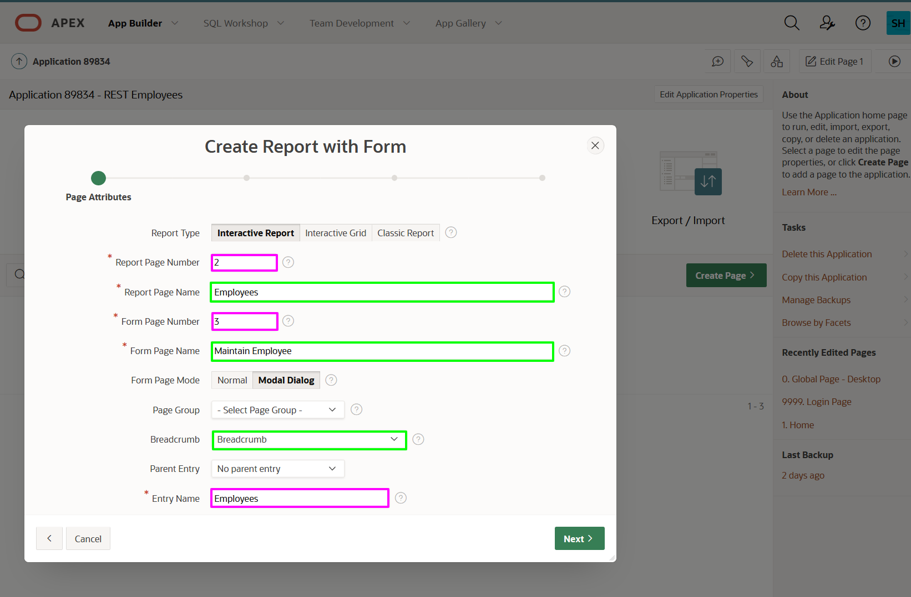

1. On the Navigation Menu dialog, click **Create a new navigation menu entry**.  
   Click **Next**.

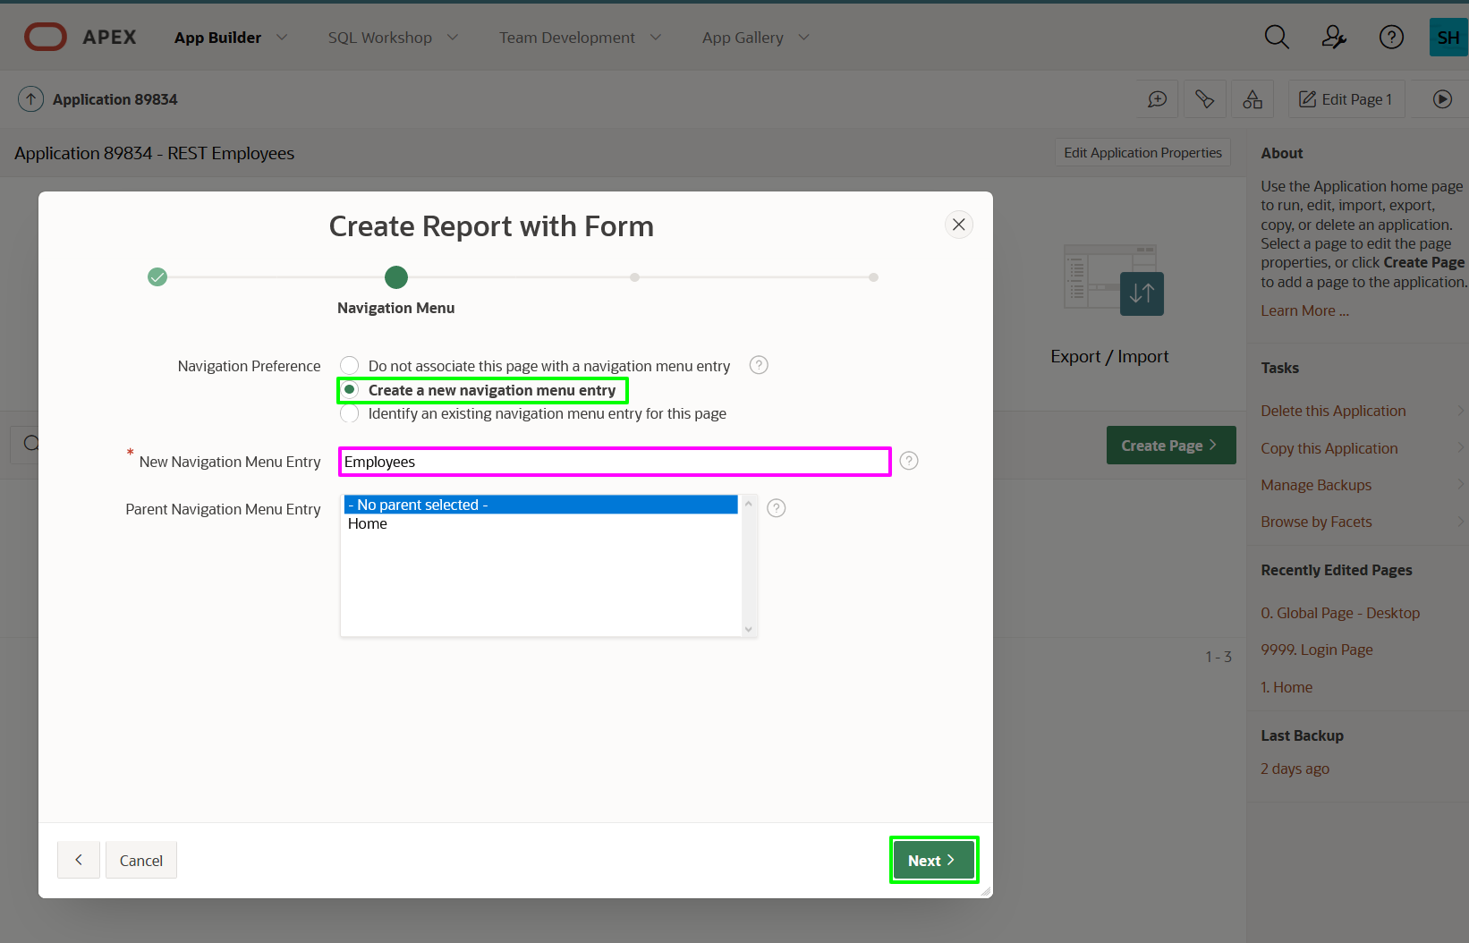

1. On the Data Source dialog, enter the following.
   * **Data Source:** click **REST Data Source**
   * **REST Data Source:** select **REST EMP Source**

Click **Next**.

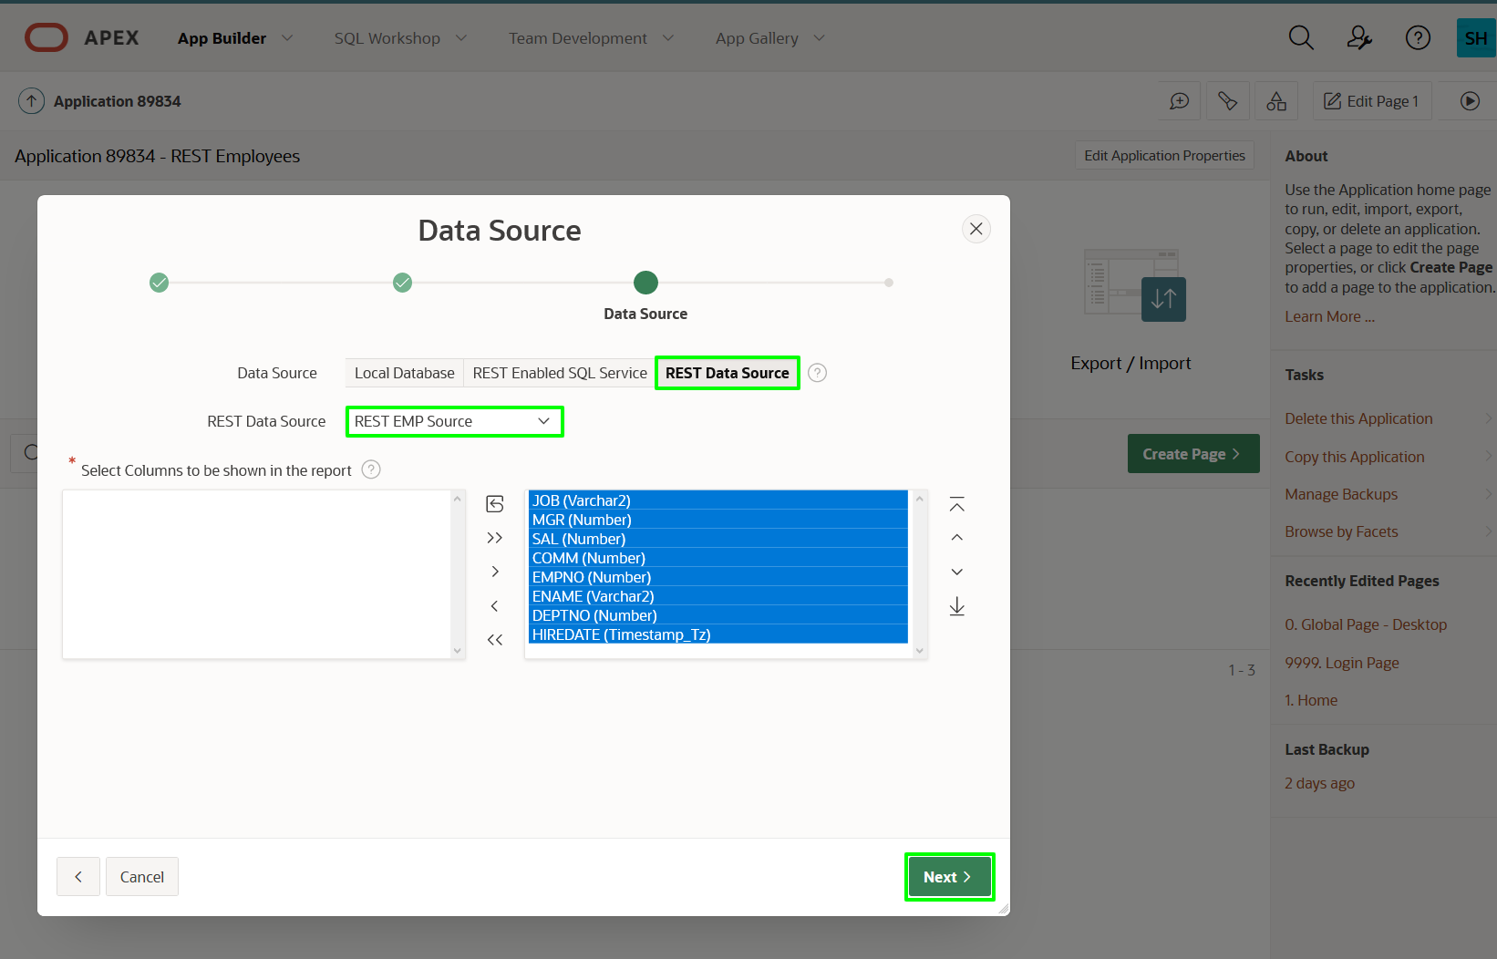

1. On the Form Page dialog, for Primary Key Column, select **EMPNO (Number)**.  
   Click **Create**.

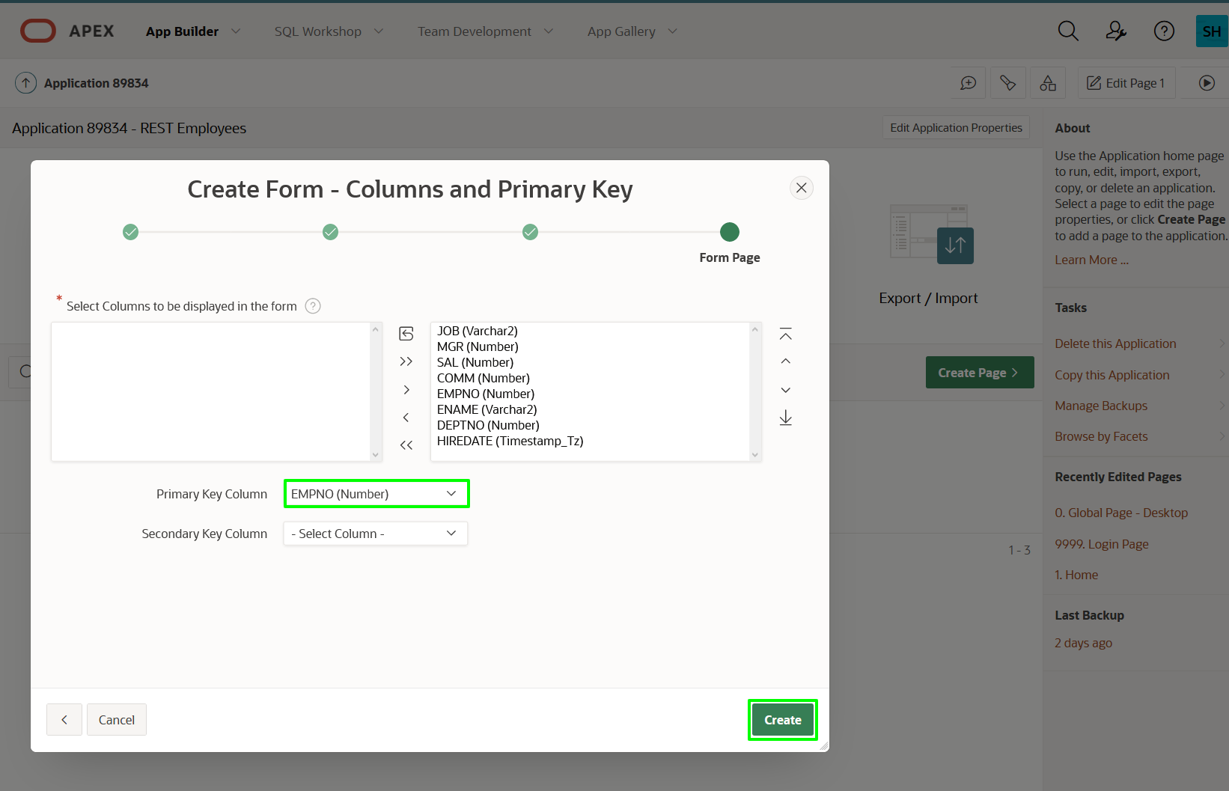

**Task 2: Improve the Report**

The default column order will not be optimal when the page is generated. You can readily reorder the columns and save the report layout.

1. From Page Designer, click the **Save and Run** button in the top right.

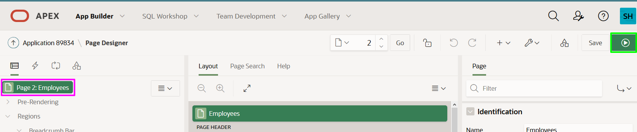

1. On the Login Page, enter your user credentials.
   * **Username:** DEMO
   * **Password:** SecretPassw0rd
2. Review the Employees.

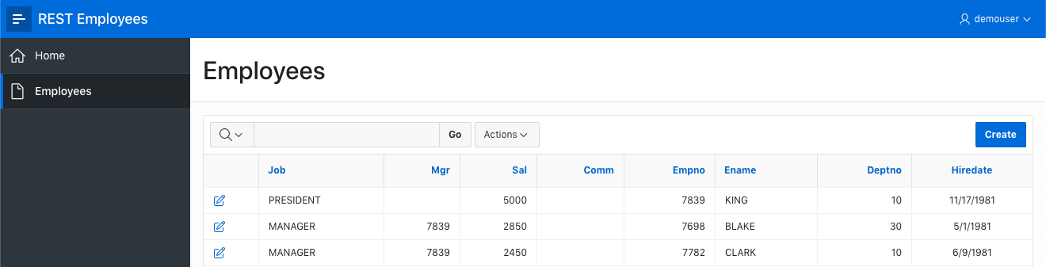

1. On the Employees report page, click **Actions**, click **Columns**.

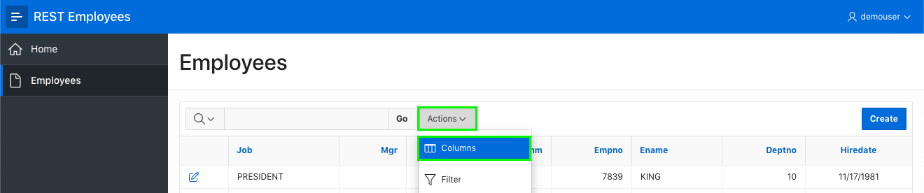

1. On the Select Columns dialog, shuffle the columns such that EMPNO, ENAME, and DEPTNO are the first three columns, by selecting the columns and using the **Top** arrow. Click **Apply**.

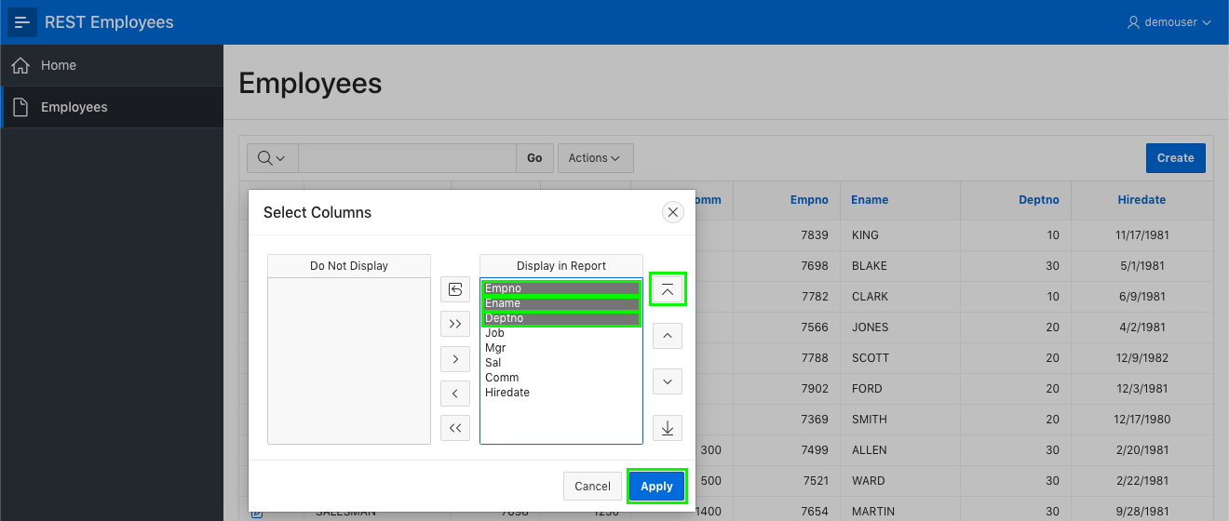

1. You need to save the report layout so that it displays this way for all users.

Click **Actions**, select **Report**, click **Save Report**.

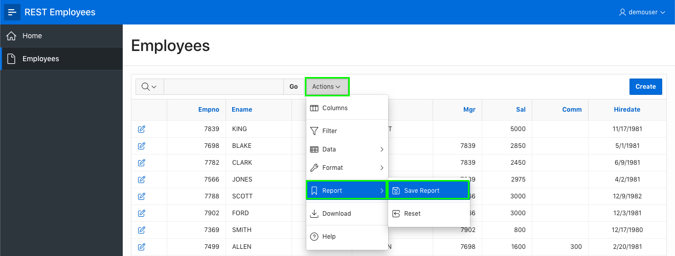

1. On the Save Report dialog, for Save (Only displayed for developers), select **As Default Report Settings**.

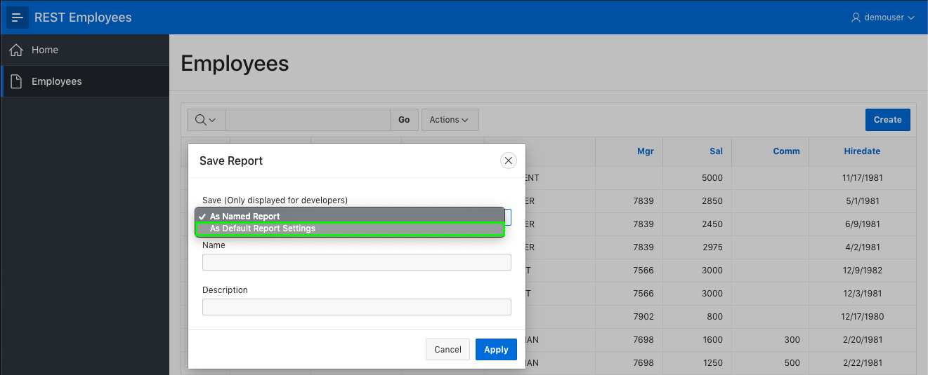

1. On the Save Default Report dialog, select **Primary** and click **Apply**.

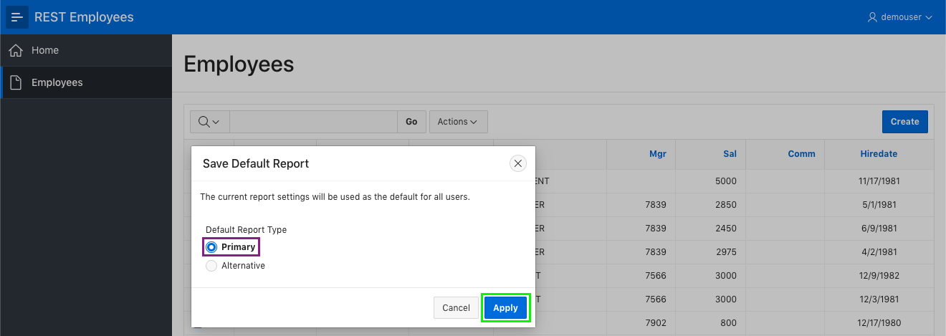

**Task 3: Update the Form Page**

The form page for editing records also needs some improvement.

1. Click the edit icon on a row. The Form Page is displayed.

In the Developer Toolbar, click **Edit Page 3**.  
Page Designer will be displayed for the current page.

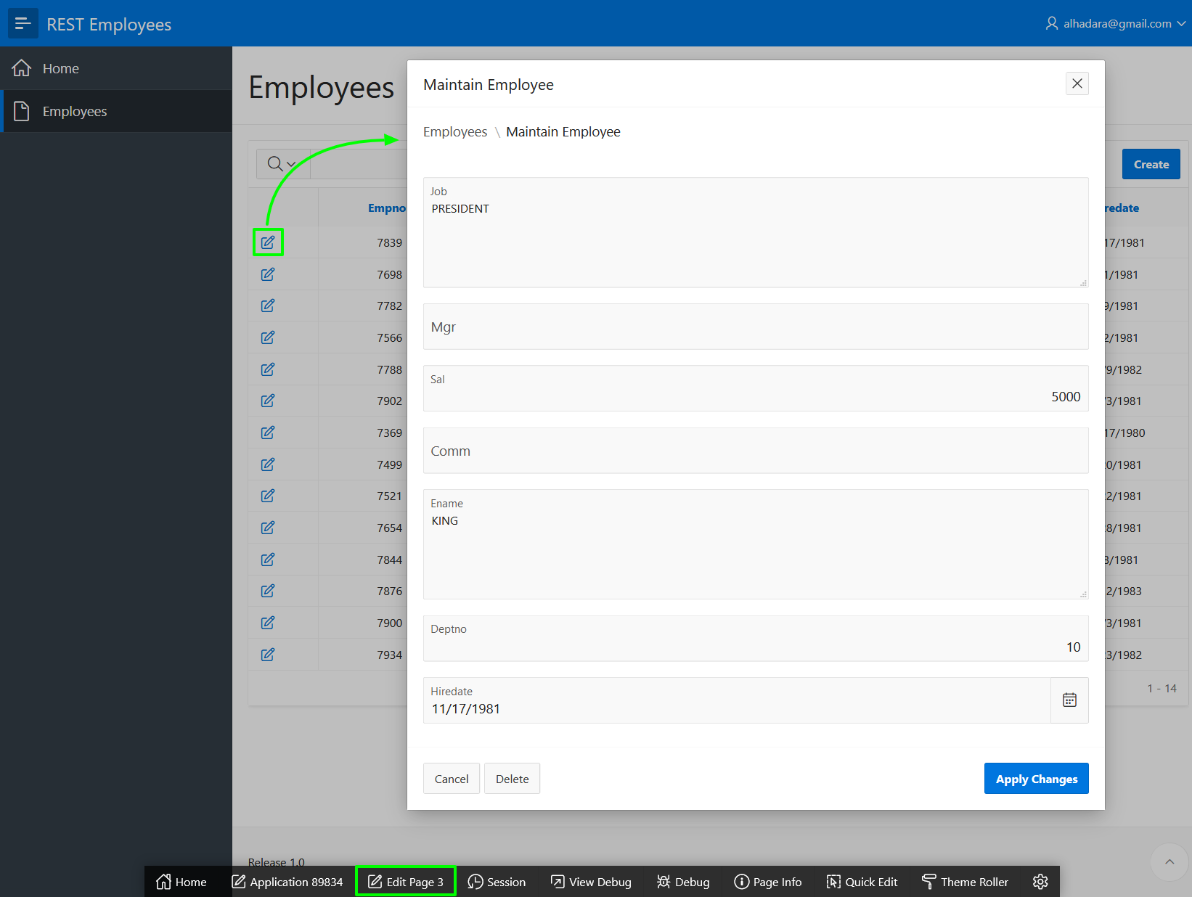

*Note: The Developer Toolbar is only displayed when you run apps from App Builder, so is never visible to end users.*

1. The Employee Number (EMPNO) item is currently hidden, as it is defined as the primary key for the table. However, users should be able to enter a value when inserting a record.

Within Page Designer, in the Rendering tab (left pane), click item **P3_EMPNO**.

In the Property Editor (right pane), enter the following.

* + **Identification > Type:** select **Number Field**
  + **Label > Label:** enter **Employee Number**

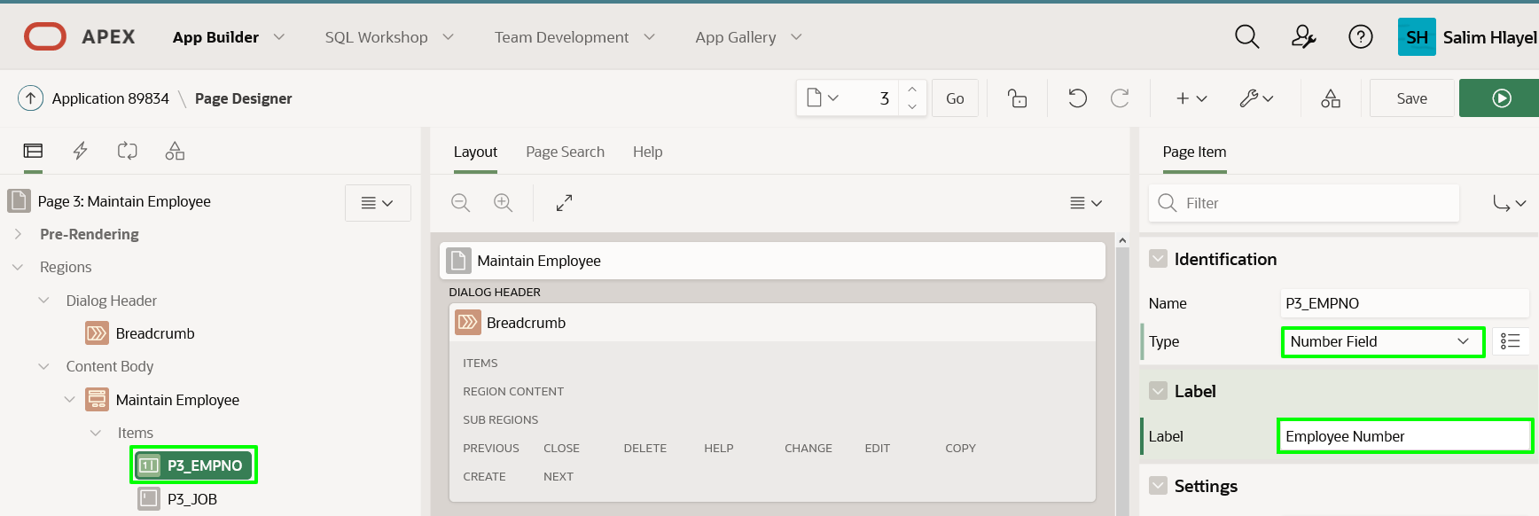

1. Employee Number should only be entered and should not be updated, as it is the primary key for the table. Therefore, you should make the item read only if displaying an existing record.

In the Property Editor (right pane), with **P3_EMPNO** selected, enter the following.

* + **Read Only > Type:** select **Item is NOT NULL**
  + **Read Only > Item:** select **P3_EMPNO**

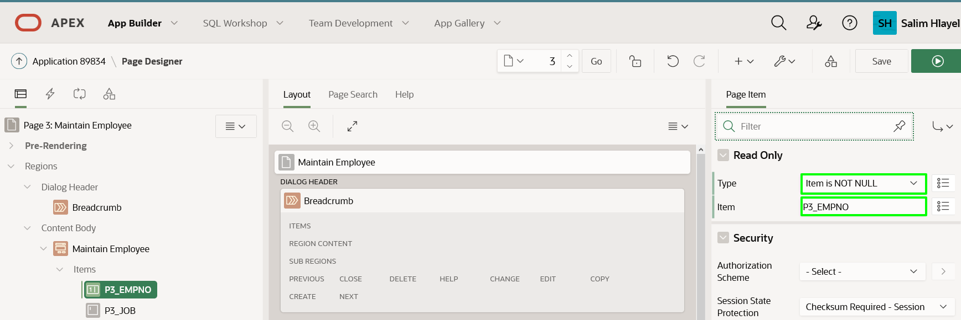

1. The Job and Name items are currently defined as a Textarea, yet neither will be that large a value. Therefore, they should be changed to be a Text Field.

In the Rendering tab (left pane), click item **P3_JOB**.  
Hold the {Control} Key and click **P3_NAME**.

In the Property Editor (right pane), for Identification > Type, select **Text Field**.

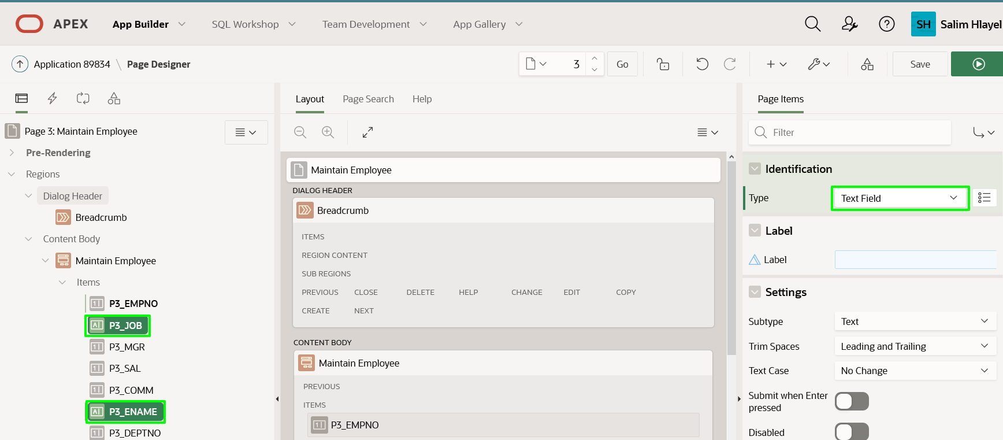

1. The order of the items should be improved. This can easily be achieved by dragging and dropping items in either the Rendering tree or the Layout.

In the Rendering tree, click item **P3_ENAME**.  
Drag **P3_ENAME** up to be under **P3_EMPNO**.

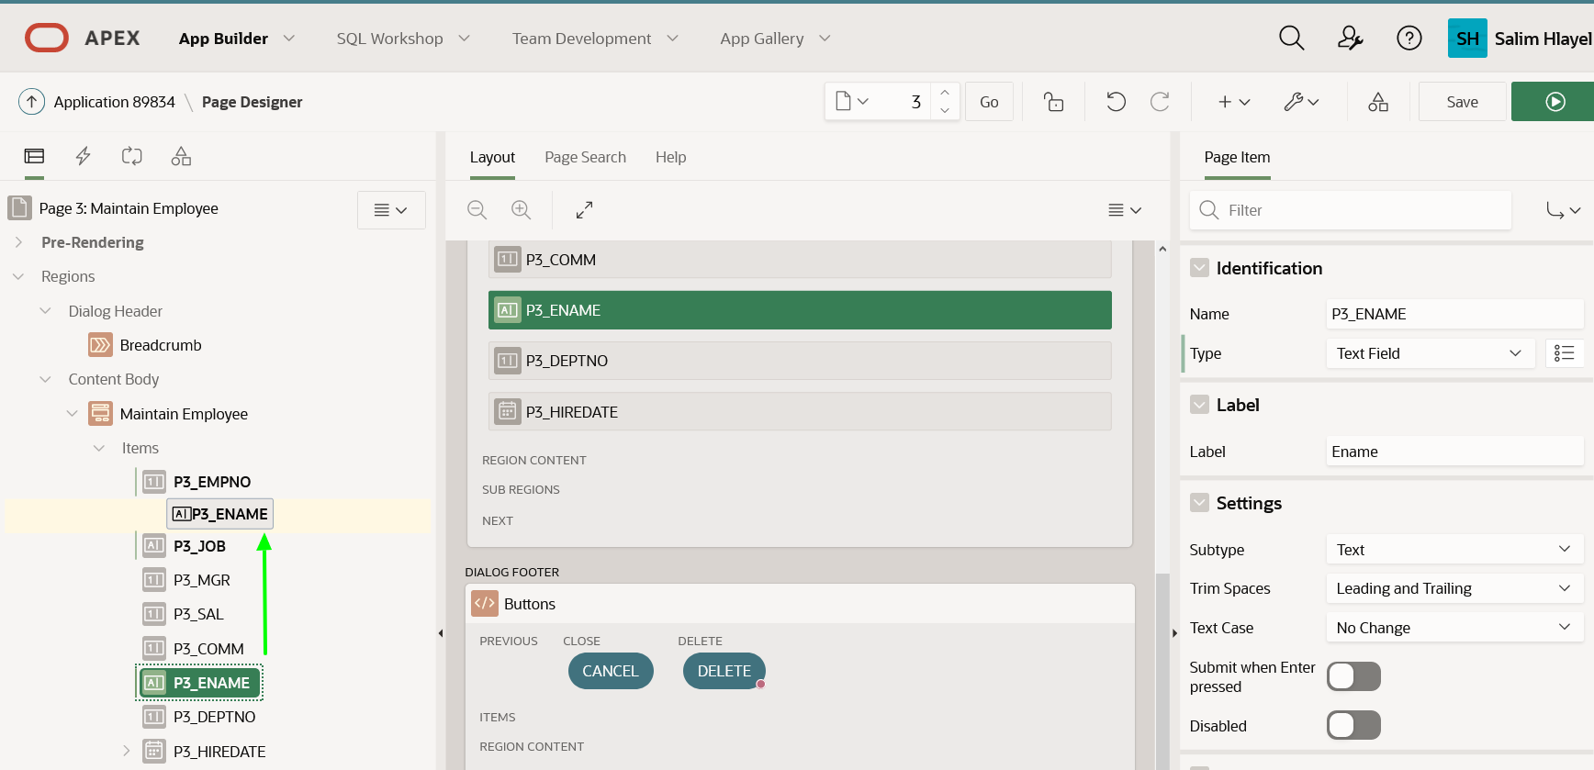

1. In the Rendering tab (left pane), click item **P3_DEPTNO**.  
   Drag **P3_DEPTNO** up to be under **P3_ENAME**.
2. The Commission (COMM) item should be placed on the same line as Salary (SAL).

In Layout (middle pane), select **P3_COMM**.  
Drag it up next to **P3_SAL**.

*Note: Do not drop the item until a large dark yellow box appears to the right of the existing items.*

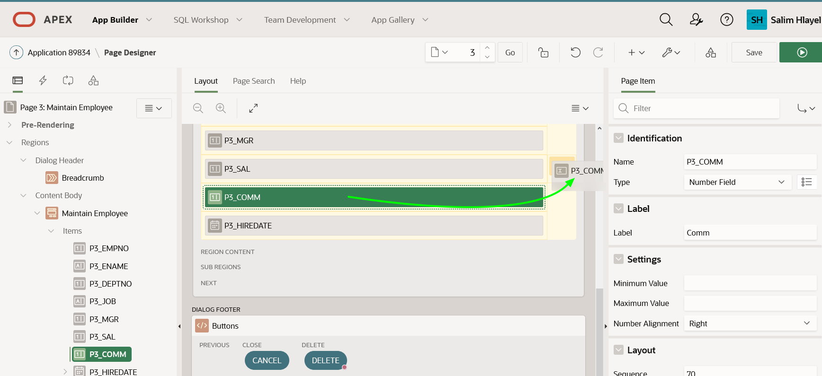

1. In the Toolbar, click **Save**.

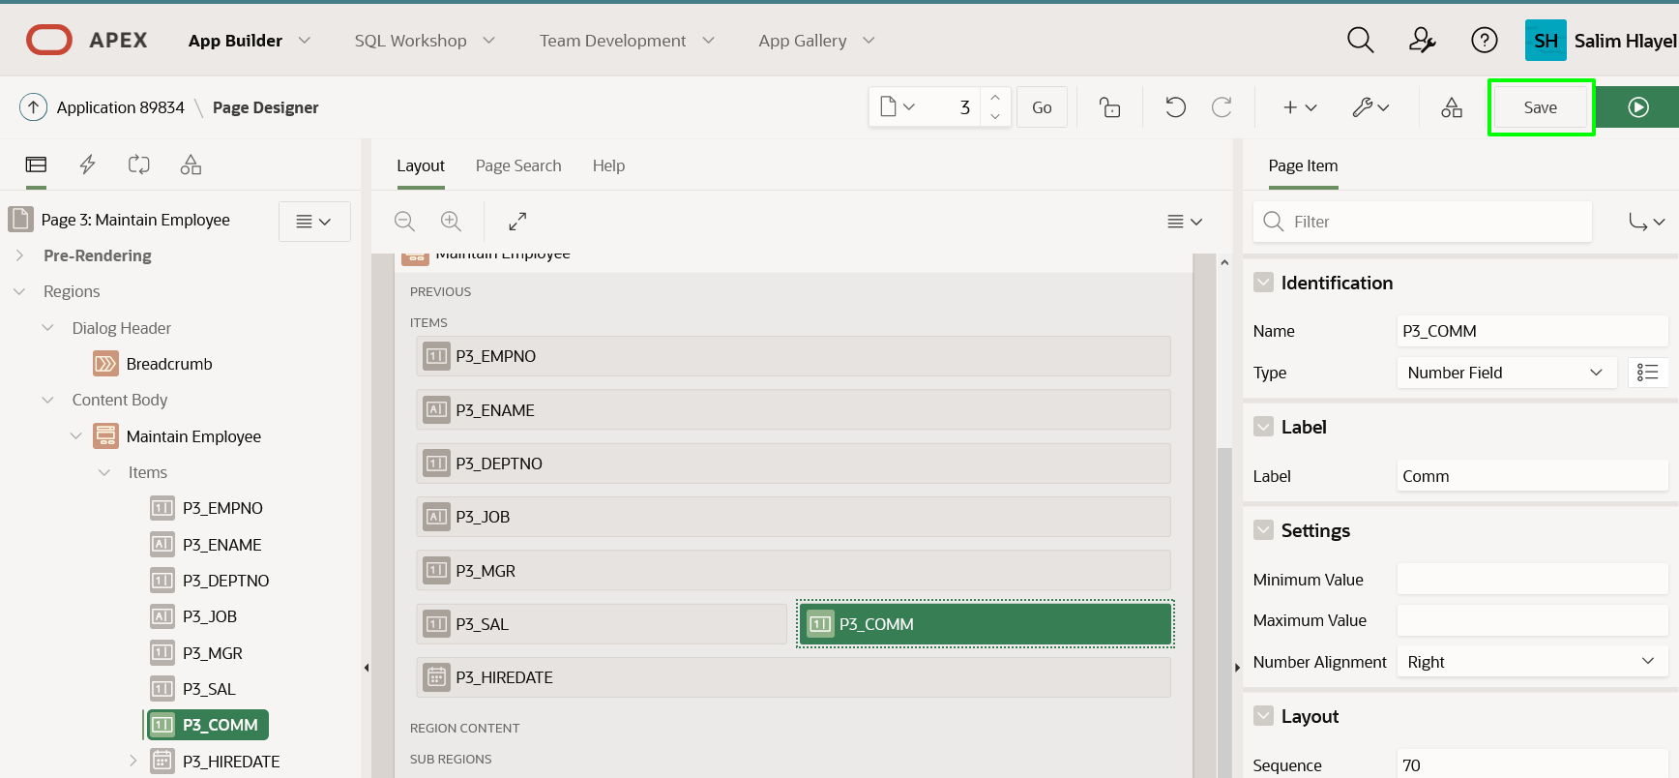

**Task 4: Insert a Record**

1. Navigate back to the Runtime environment.



1. Refresh the browser.
2. On the Employees report page, click **Create**.

On the Maintain Employee page, enter the following.

* + **Employee Number:** enter **1234**
  + **Ename:** enter **PETERS**
  + **Deptno:** enter **10**
  + **Job:** enter **SALESMAN**
  + **Mgr:** enter **7839**
  + **Sal:** enter **1500**
  + **Comm:** enter **500**
  + **Hiredate:** select any date

Click **Create**.

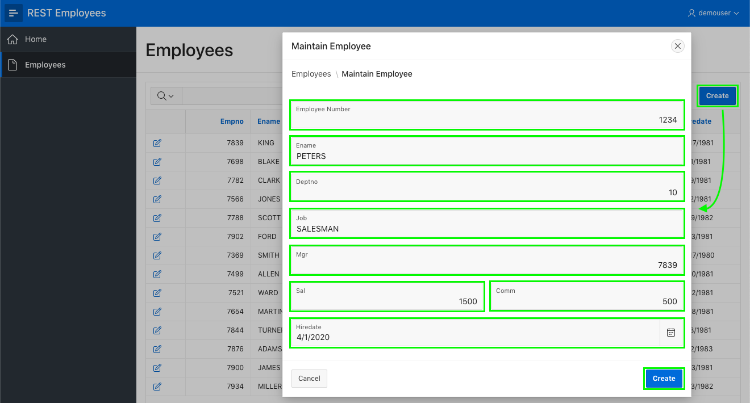

1. On the Employees report page, find the new record.

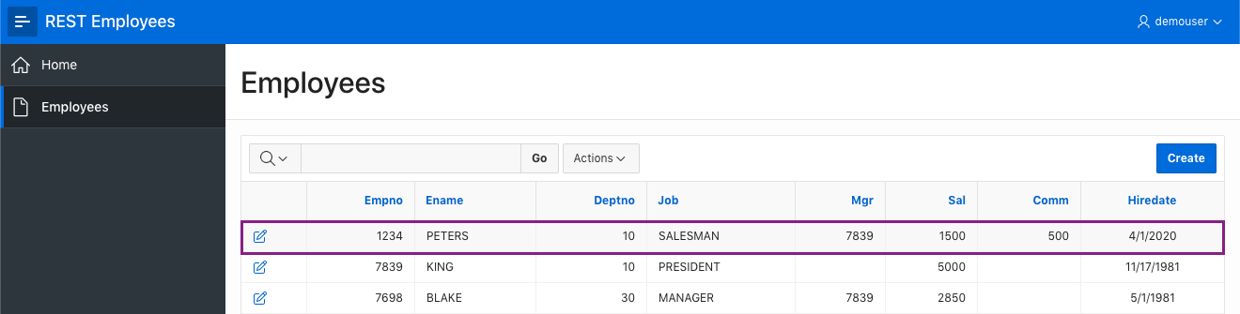

**Task 5: Update a Record**

1. On the Employees report page, find **BLAKE**, and click the edit icon.

On the Maintain Employee dialog, update the following.

* + **Deptno:** enter **40**
  + **Sal:** enter **3500**

Click **Apply Changes**.

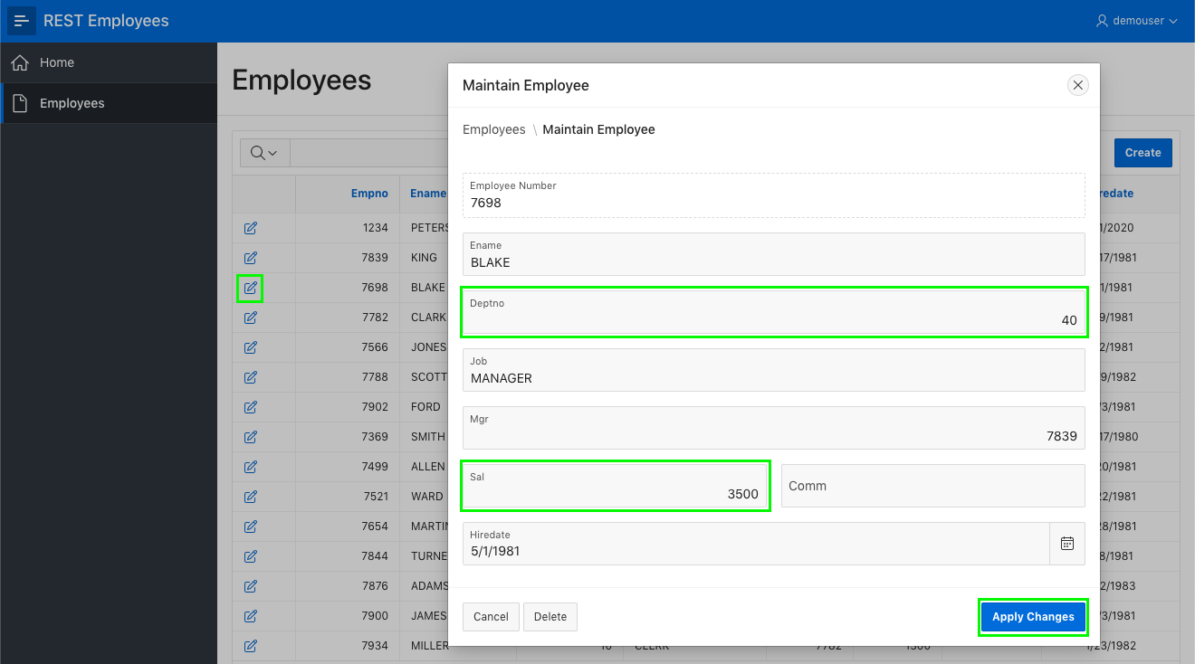

1. On the Employees report page, review BLAKE's **Deptno** and **Sal**.

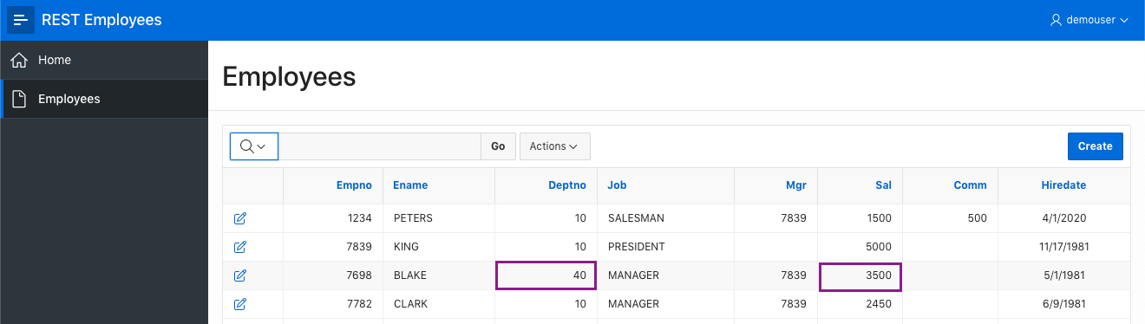

**Task 6: Delete a Record**

1. On the Employees report page, find **TURNER**, and click the edit icon.

On the Maintain Employee dialog, click **Delete**. On the delete confirmation dialog, click **Ok**.

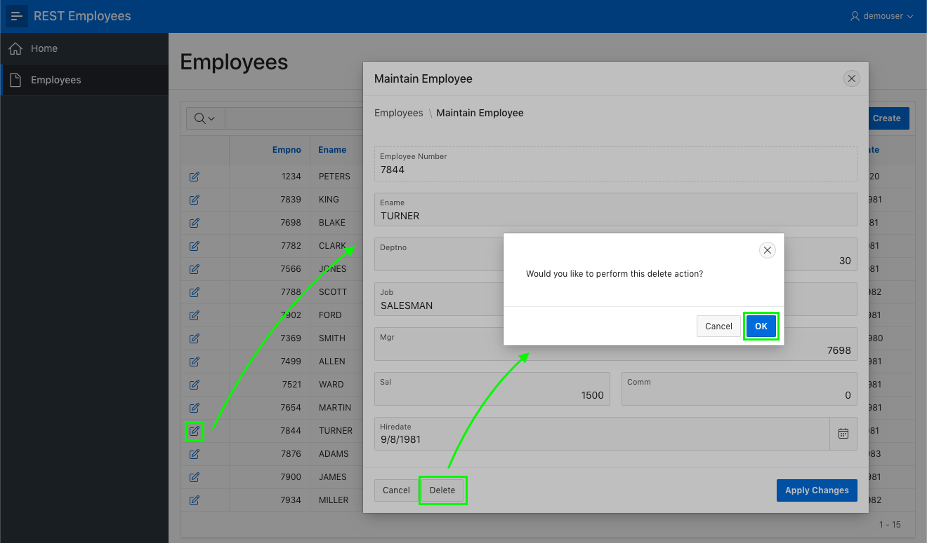

1. On the Employees report page, review the records to ensure TURNER is no longer visible.

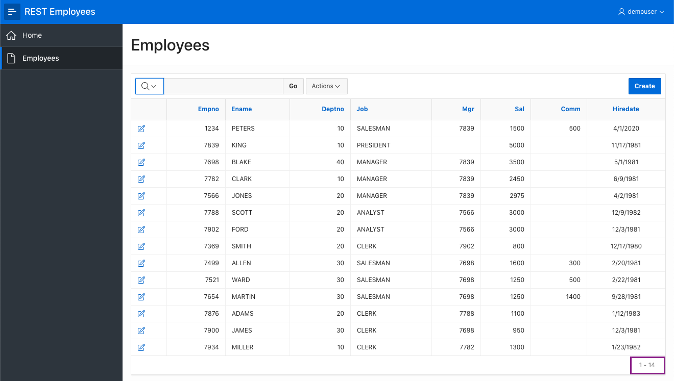

The system does not know that the RESTAPI exists locally, it doesn’t matter, what matters is that its use REST to maintain that dataset.

**Task 1: Add REST Data Source for DEPT**

1. Return to the Application Builder.
2. Go to the App Builder Home Page.
3. Select your application.
4. On the application home page, click **Shared Components**.

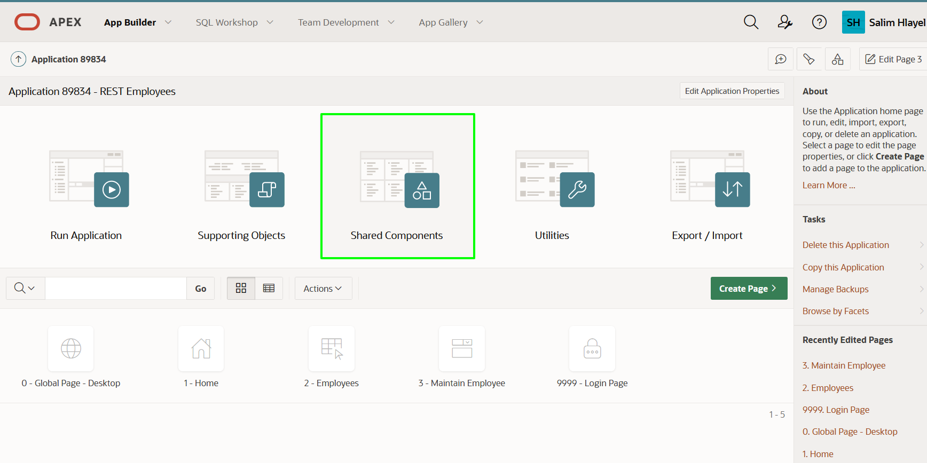

1. On the Shared Components page, under Data Sources, click **REST Data Sources**.

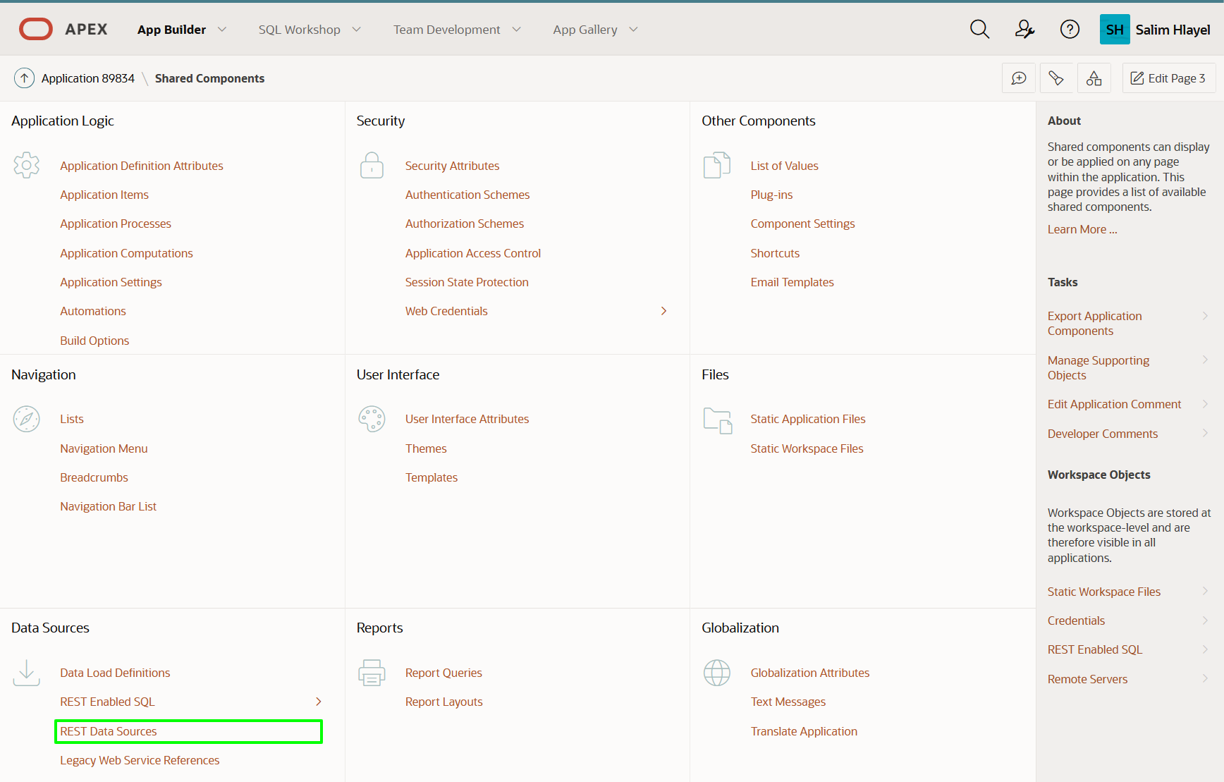

1. On the REST Data Sources page, click **Create**.

On the Create REST Data Source - Method dialog, click **Next**. *Default: From Scratch*

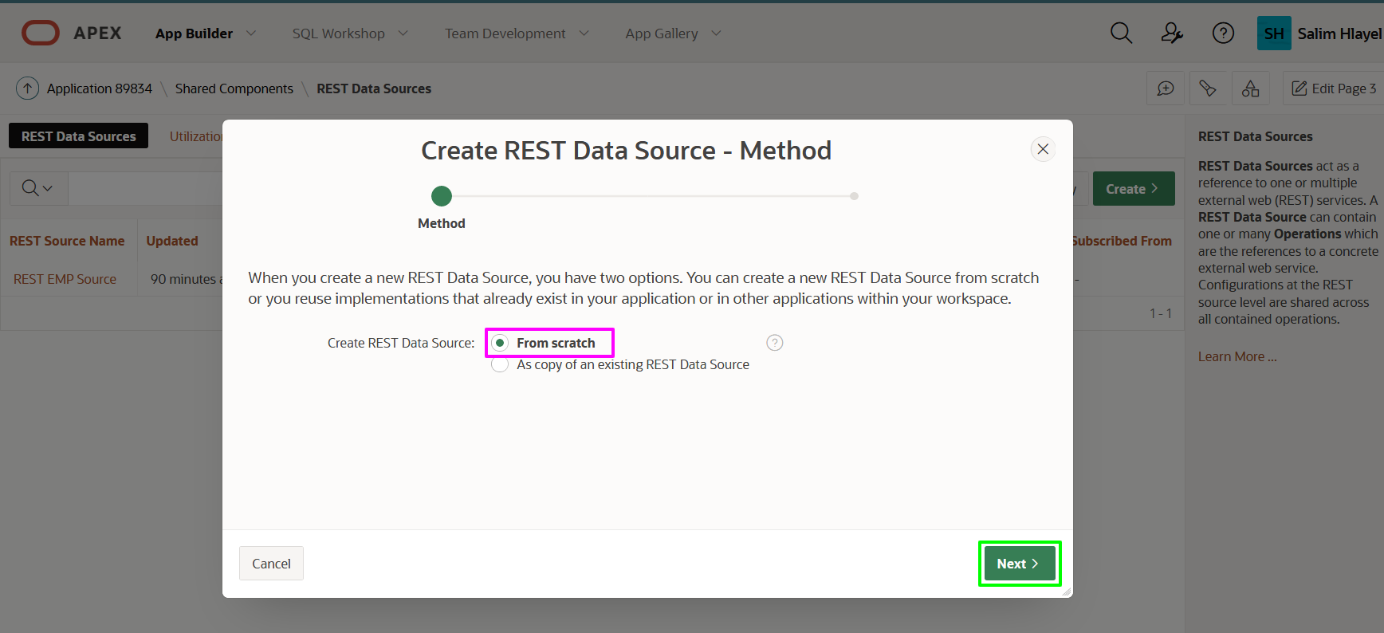

1. On the Create REST Data Source - General dialog, enter the following.
   * **REST Data Source Type:** select **ORACLE REST Data Services**
   * **Name:** enter **REST DEPT Source**
   * **URL Endpoint:** enter the REST URI for the dept.rest handler Similar to https://{cloud_url}/ords/{your_workspace}/**dept**/hol/

The URL Endpoint is the same URL you entered in Lab 2 Step 3 exept emp is replaced with dept.

Click **Next**.

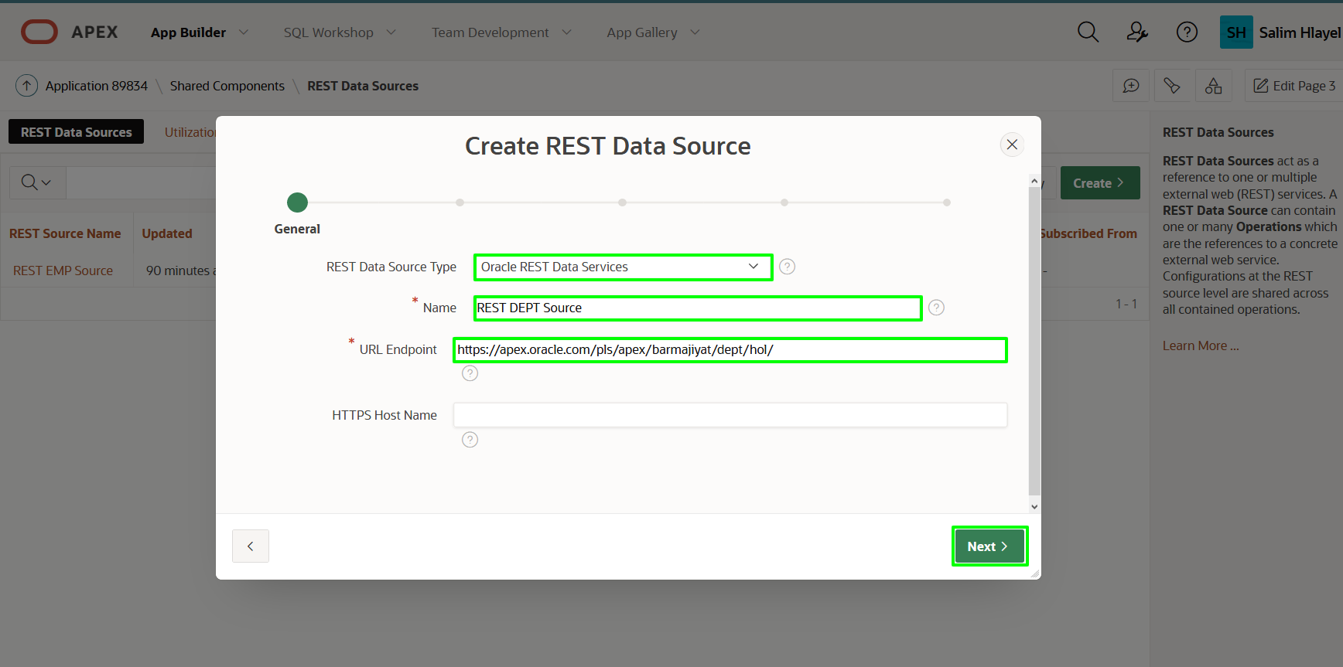

1. On the Remote Server dialog, review the Base URL and Service URL Path. Click **Next**.

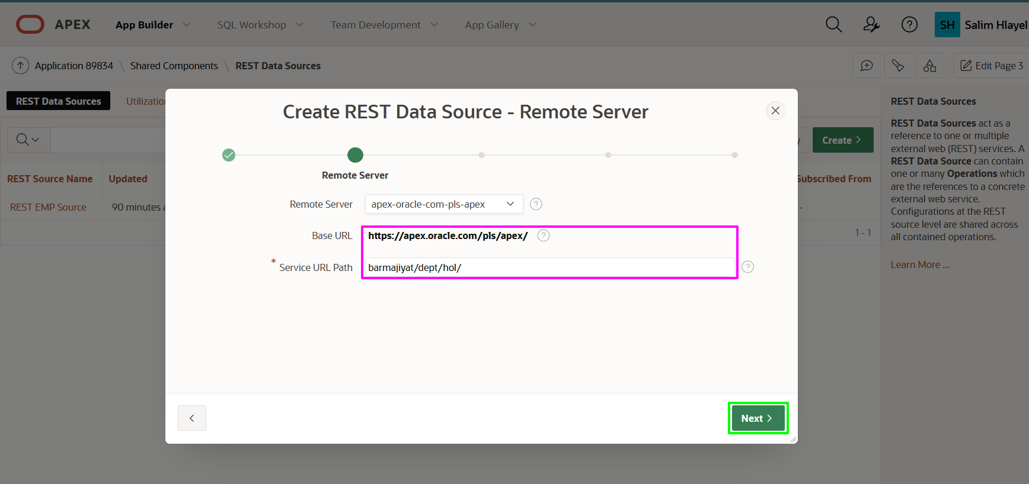

*Note: As you have already defined a REST Data Source with the same base path, for the REST EMP Source, then the Base URL is not updateable.*

1. On the Authentication dialog, click **Discover**. Authentication Required = No
2. On the Preview dialog, click **Create REST Data Source**

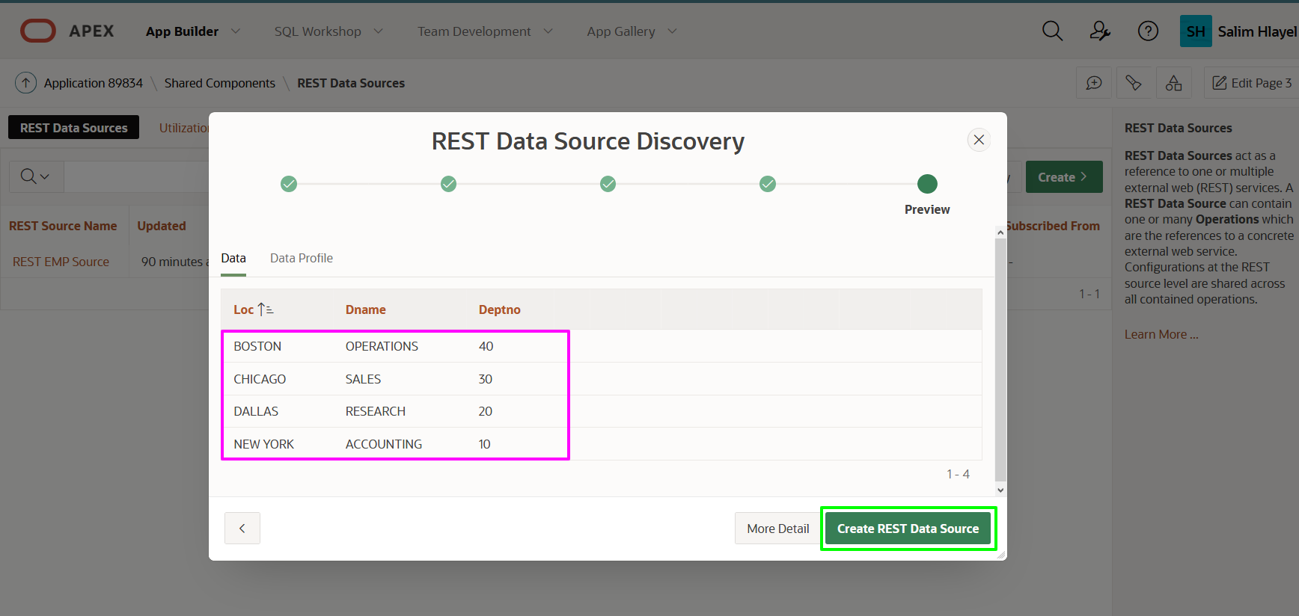

**Task 2: Creating List of Values**

You now have the REST Data Sources which can be used as the basis for List of Values.

1. From the REST Data Sources page, in the breadcrumbs, click **Shared Components**.

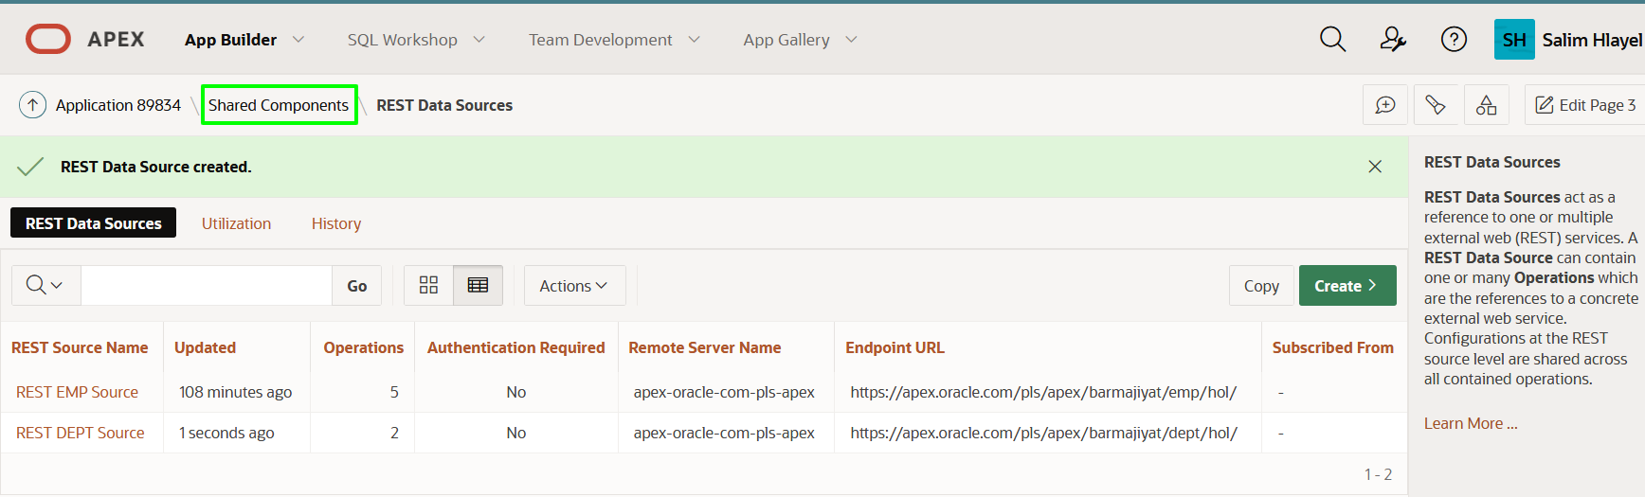

1. On the Shared Components page, under Other Components, click **List of Values**.

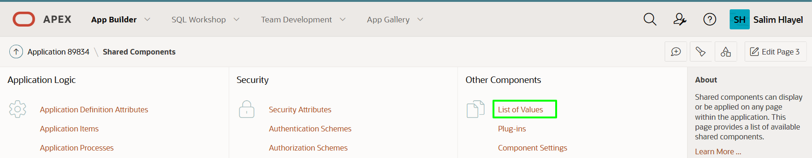

1. On the List of Values page, click **Create**.

On the Create List of Values - Source dialog, click **Next**.  
*Default: From Scratch*

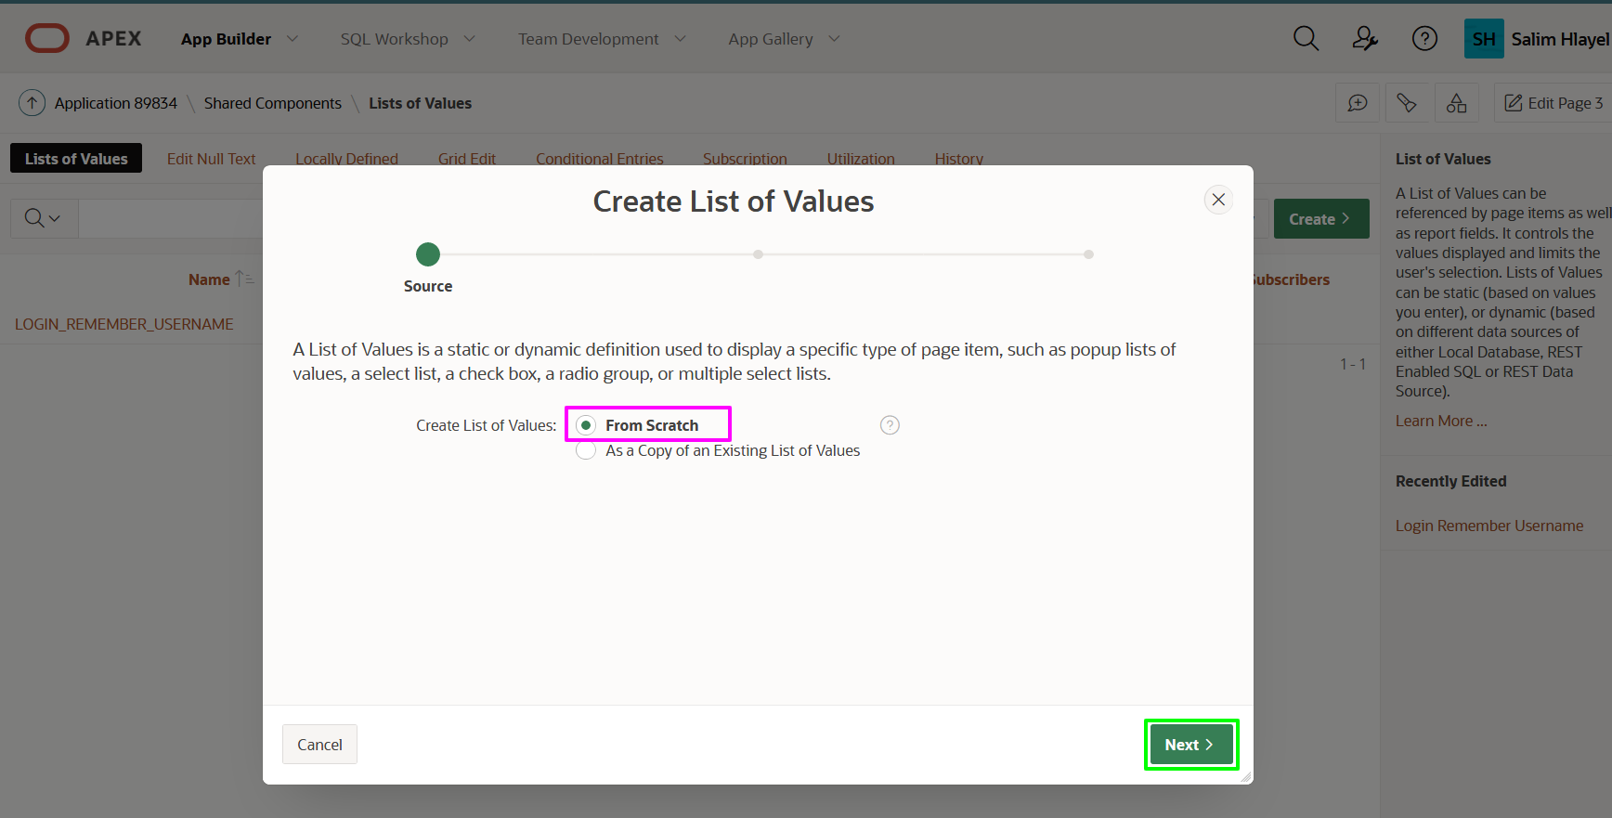

1. On the Name and Type dialog, for Name, enter **REST EMP LOV**.  
   Click **Next**.

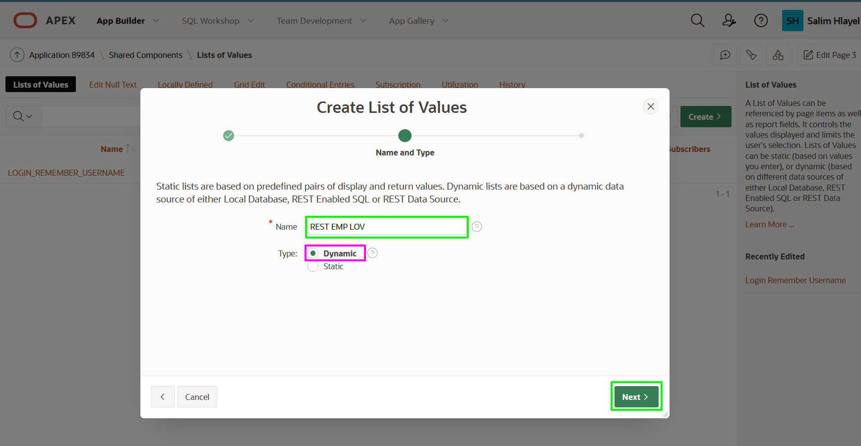

1. On the List of Values Source dialog, enter the following.
   * **Data Source:** click **REST Data Source**
   * **REST Data Source:** select **REST EMP Source**

Click **Next**.

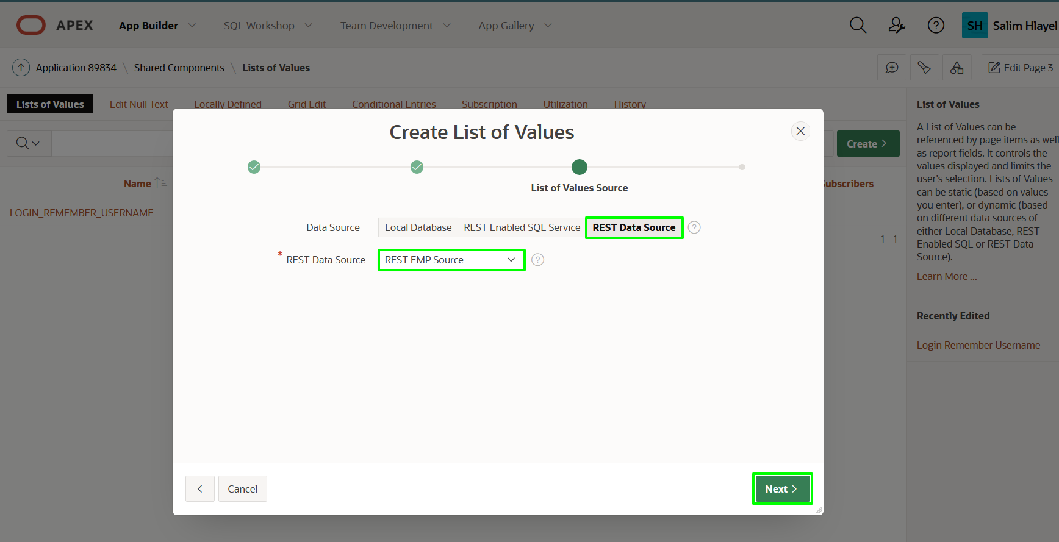

1. On the Column Mappings dialog, enter the following.
   * **Return Column:** select **EMPNO**
   * **Display Column:** select **ENAME**

Click **Create**.

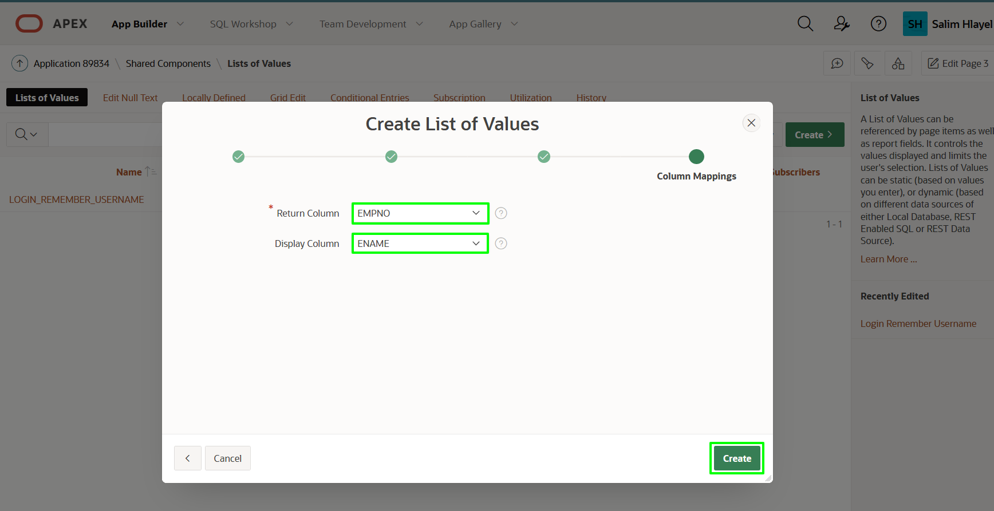

1. To create the List of Values for Departments is the same as above.

On the List of Values page, click **Create**.  
On the Create List of Values - Source dialog, click **Next**.  
*Default: From Scratch*

1. On the Name and Type dialog, for Name, enter **REST DEPT LOV**.  
   Click **Next**.
2. On the List of Values Source dialog, enter the following.
   * **Data Source:** click **REST Data Source**
   * **REST Data Source**: select **REST DEPT Source**

Click **Next**.

1. On the Column Mappings dialog, enter the following.
   * **Return Column:** select **DEPTNO**
   * **Display Column:** select **DNAME**

Click **Create**.

**Task 3: Update the Form**

If you review the Maintain Employee form page more closely you will see that the Department Number (DEPTNO) and the Manager (MGR) item are both numeric items and expect the end user to know the relevant numbers, rather than select from a list of names.

1. From the Lists of Values page, in the Application Builder toolbar, click **Edit Page 3**.

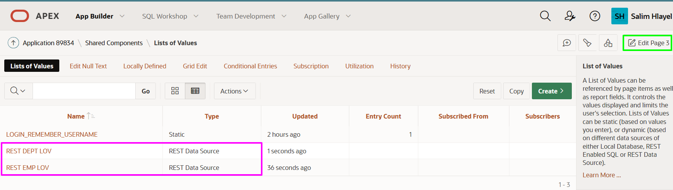

1. From Page Designer, in the Rendering tree (left pane), click **P3_DEPTNO**.

In the Property Editor (right pane), enter the following.

* + **Identification > Type:** select **Select List**
  + **List of Values > Type:** select **Shared Component**
  + **List of Values > List of Values:** select **REST DEPT LOV**
  + **List of Values > Display Extra Values:** Uncheck

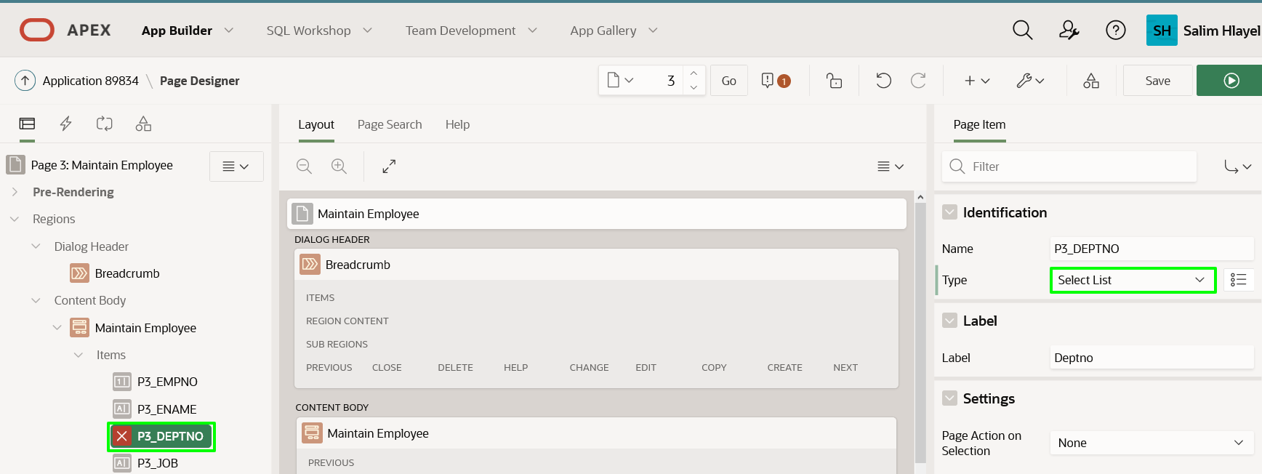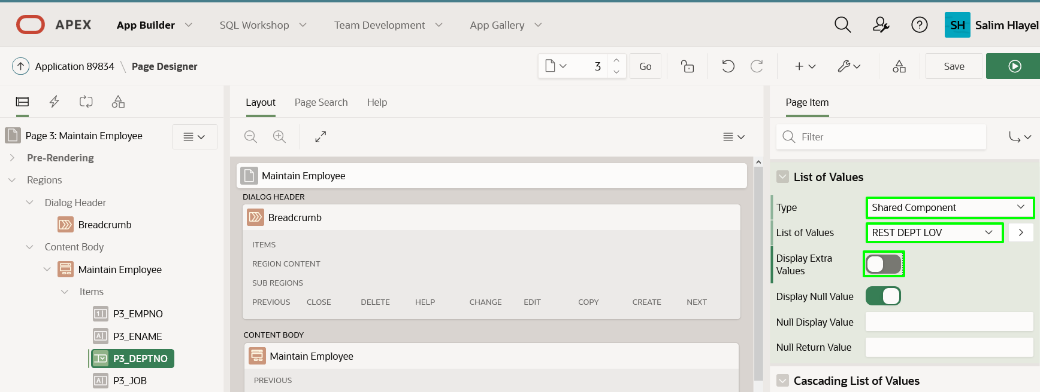

1. From Page Designer, in the Rendering tree (left pane), click **P3_MGR**.

In the Property Editor (right pane), enter the following.

* + **Identification > Type:** select **Select List**
  + **List of Values > Type:** select **Shared Component**
  + **List of Values > List of Values:** select **REST EMP LOV**
  + **List of Values > Display Extra Values:** Uncheck

1. In the Page Designer toolbar, click **Save**.

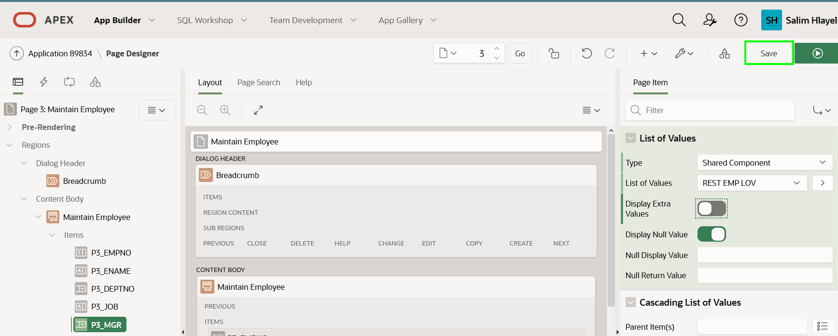

**Task 4: Update the Report**

Similarly, the Employees report shows numerical values rather than names.

1. Navigate to Page 2 in Page Designer.  
   In the Page Designer toolbar, use the Page Selector or the down arrow next to the page number.

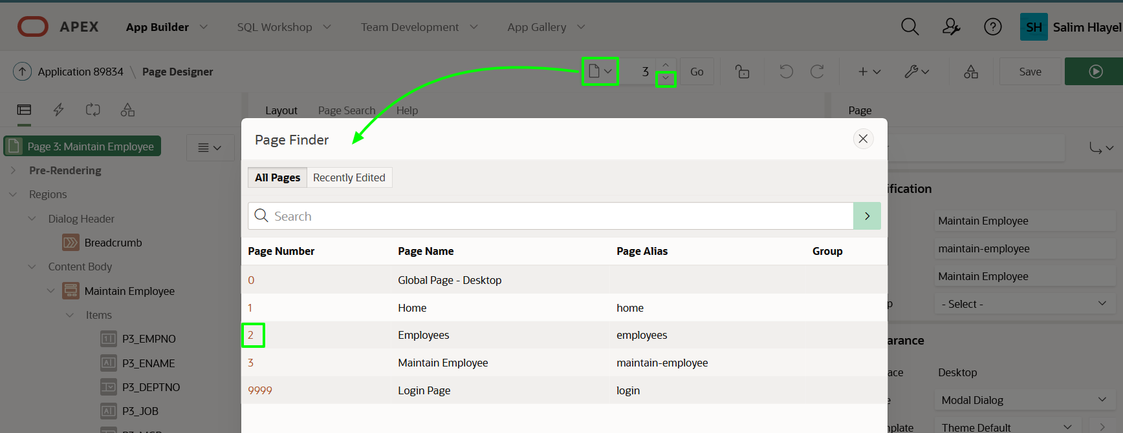

1. Given this is a report you will need to modify columns instead of items.

In the Rendering tree (left pane), click Columns, click **MGR**.

In the Property Editor (right pane), enter the following.

* + **Type:** select **Plain Text (based on List of Values)**
  + **List of Values:** select **REST EMP LOV**
  + **Heading > Alignment:** click **Align Left**
  + **Layout > Column Alignment:** click **Align Left**

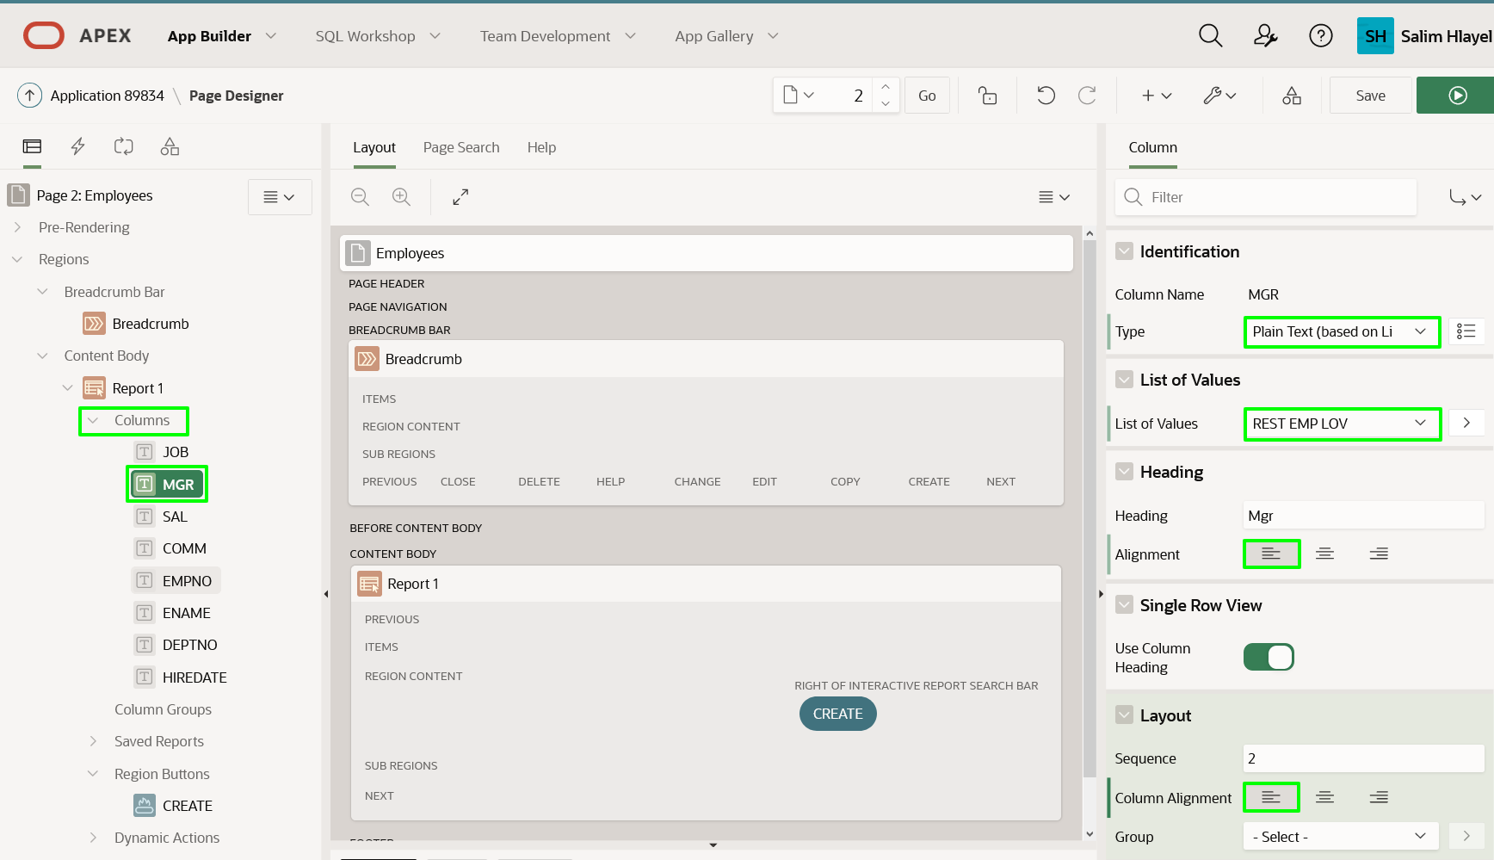

1. In the Rendering tree (left pane), under Columns, click **DEPTNO**.

In the Property Editor (right pane), enter the following.

* + **Type:** select **Plain Text (based on List of Values)**
  + **List of Values:** select **REST DEPT LOV**
  + **Heading > Alignment:** click **Align Left**
  + **Layout > Column Alignment:** click **Align Left**

Click **Save**.

1. Navigate to the application Runtime Environment.
2. Refresh your browser.

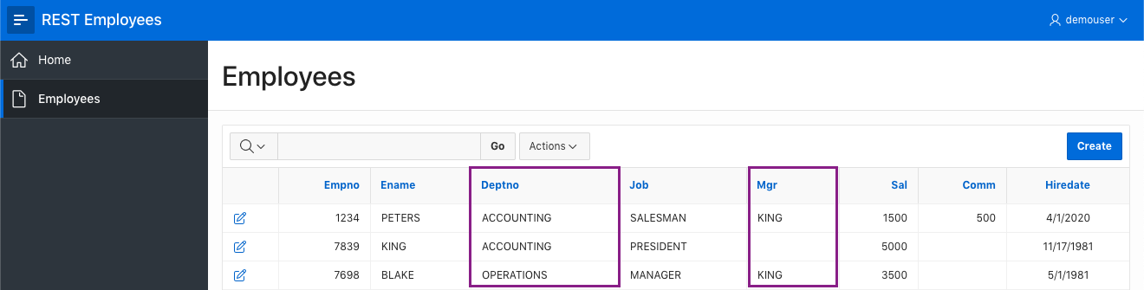

1. Click on the edit icon for any record.  
   Select a department.  
   Select a manager.

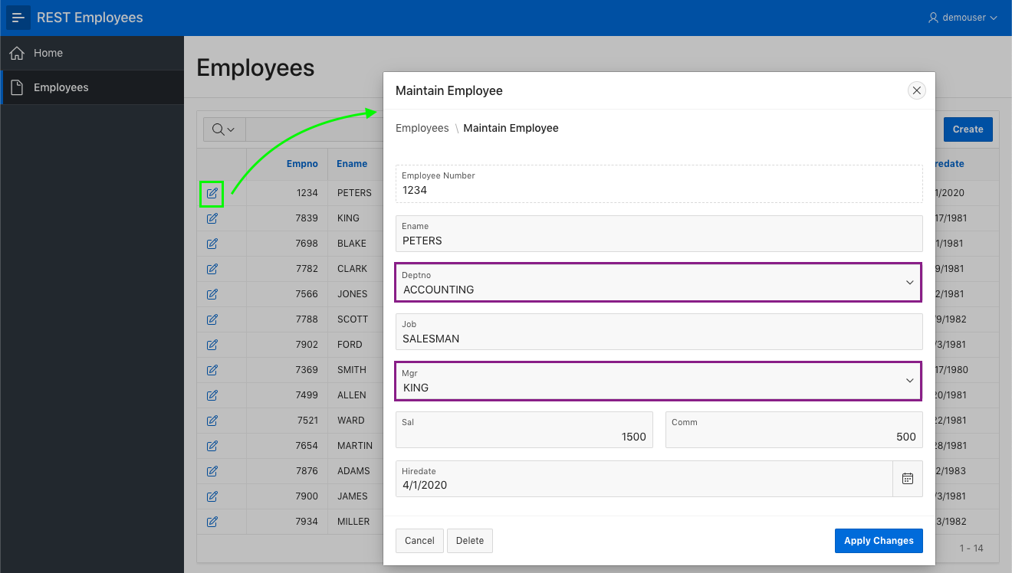

**Summary**

Whala, IF you read this far , I applaud you Ryan S. !!